CANStream User Guide

**Table des matières**

Introduction 5

General overview 9

Getting started 13

Computer requirements 15

License agreement 19

GNU Free Documentation License 31

Installation 40

PEAK USB CAN adapter driver 47

Main interface 54

CAN Controller panel 58

CAN controller modes 62

Spy & Manual mode 66

Cycle mode 70

CAN controller panel tool bar 74

Menu strip 78

CAN Configuration 82

Cycle 86

Recording 90

Tools 94

View 98

Help 102

Status bar 106

About form 110

Keyboard shortcuts 114

CAN Frames configuration 117

CAN Configuration form 121

Single bus configuration 126

Bus properties 129

CAN message properties 133

CAN signal properties 137

CAN Configuration tree view 141

Multiplexed parameter 145

Message map 149

Virtual CAN signal 153

Vector CAN data base (dbc) import 158

Multiple buses configuration 163

CAN Bus information 169

Configuration import & export 173

Spy & Manual mode 177

Data Reception 181

Raw format data Reception 185

Engineering format data Reception 189

Virtual data Reception 193

Received data graphic 197

Data Transmission 202

Raw format data Transmission 206

Engineering format data Transmission 210

Virtual data Transmission 214

Cycle mode 218

Cycle playing 222

Cycle Reception data panel 227

Cycle starting and ending points setting 231

Cycle loop number setting 236

Virtual CAN signals in cycle 240

Cycle creation 244

Easy cycle creation 248

Cycle data association 253

Association type 258

Advanced cycle creation 262

Advanced cycle creation tool bar 267

Cycle parts setting 271

Cycle definition 275

Record replay 281

Record replay configuration 285

CAN controller appearance options 289

Control layout  293

Manual control layout 297

Cycle control layout 301

Grids contents control 305

Grid rows 309

Grid columns 313

Manual control grid columns 317

Cycle player grid columns 322

Data logging 326

Data logging start & stop 330

Automatic recording 334

Data file formats 338

Peak PCAN trace file 342

Record data file 346

Logging file conversion 350

Manual conversion 354

Automatic conversion 358

Conversion process control 362

Data file storage structure 366

Recording event & Recording session 370

Recording event creation & edition 374

Recording event selection 379

Recording session creation & edition 383

Recording session selection 388

User information 392

Data analysis 396

Analysis window 400

Data viewer page creation 404

Data viewer Toolbar 409

Data set information 413

Data browser 419

Root folder tree 423

Events & sessions list 427

Logging data list 432

Data browser tool bar 437

Graphic window 441

Graphic window tool bar 445

Shortcut keys 449

Data file 453

Analysis functions 457

Main cursor 461

Reference cursor 466

Zoom 471

Statistics 477

Legend 481

Snapshot 487

Print 491

Graphic window settings 496

Channel list 500

Graphic layout 505

Graphic configuration 510

Generic series properties 514

General properties 519

Graphic grids properties 525

Abscisse properties 529

Cursors properties 534

Graphic serie detailed configuration window 539

Serie general properties 543

Serie format 549

Serie Y Axis 554

Serie custom grid 559

Serie reference lines 565

Line styles 571

Virtual Channels 575

Virtual channel edition 579

Virtual channel library properties 584

Virtual channel properties 588

Virtual channel testing 593

Virtual channel built-in functions 598

Built-in signals 603

Built-in signals edition 607

Built-in signals library 612

Built-in signals properties 616

Built-in signals types 620

Sinus 623

Pulses 627

Triangle 631

Slopes 635

Ramp 639

Step 643

Random 647

**Introduction**

First of all, thanks for using CANStream !

This document is dedicated to the countless lost hours of both people having to search for simple answers, and people having to answer questions that shouldn't have to be asked in the first place. Documentation is always hard to get, good documentation nearly impossible.

This markup is based in the default appearance of Microsoft Windows. This can be different on your own system, but the names (text) should be always the same. This is especially important on the screen shots. They are only for reference, your appearance of CANStream can be quite different.

Also, when talking about the left and right mouse buttons, the logical left and right is meant. These are the same as the physical left and right mouse buttons in the case of a right-handed setup. However, if you have a left-handed setup you will probably have the buttons swapped so act accordingly. This means in general you do what you normally do for most actions, CANStream mostly follows the standard Windows application behavior.

Likewise, the layout is discussed as it is displayed in a left-to-right order.

*Created with the Personal Edition of HelpNDoc:* [*Generate EPub eBooks with ease*](http://www.helpndoc.com/create-epub-ebooks)

**General overview**

CANStream is a .NET application intended to be used for CAN (Controller Area Network) bus communication development, testing and validation. CANStream allows to extensively test any system using CAN communication by sending and receiving CAN frames. Thanks to its powerful built-in mathematical expression evaluator, CANStream can also behave as a real control system feeding back the test device or commanding a third party device with context sensible data. Extended data logging and data analysis features of CANStream provide a comprehensive solution for testing and results analysis.

CANStream extensively uses the PCAN-Basic API developed by PEAK System for the PCAN-USB adapter

For more information about PEAK System: <http://www.peak-system.com>

You will therefore need to have PCAN-USB adapter and at least one free USB port available to make a complete use of CANStream.

CANStream can manage up to eight PCAN-USB adapters at the same time, thus you will need eight USB ports available.

As any .NET application, CANStream needs a Microsoft .NET framework to operate. You might need to install or upgrade your .NET framework.

If so, please visit <http://www.microsoft.com/net> to download the latest version of the Microsoft .NET framework.

*Created with the Personal Edition of HelpNDoc:* [*Full-featured Documentation generator*](http://www.helpndoc.com)

**Getting started**

*Created with the Personal Edition of HelpNDoc:* [*Full-featured Help generator*](http://www.helpndoc.com/feature-tour)

**Computer requirements**

|  |  |
| --- | --- |
| **Hardware** | |
| **CPU** | Pentium 4 1.2 GHz |
| **RAM** | 1 GB |
| **Hard drive** | 25 MB free space |
| **USB port** | 1 minimum |
| **Operating system** | |
| **Any of those Windows versions** | 2000, XP (32/64 bits), Vista (32/64 bits), Seven (32/64 bits), 8 (32/64 bits) |
| **.NET Framework** | 4.0 |

*Created with the Personal Edition of HelpNDoc:* [*Free help authoring tool*](http://www.helpndoc.com/help-authoring-tool)

**License agreement**

GNU GENERAL PUBLIC LICENSE

Version 3, 29 June 2007

Copyright (C) 2007 Free Software Foundation, Inc. <<http://fsf.org/>>

Everyone is permitted to copy and distribute verbatim copies

of this license document, but changing it is not allowed.

Preamble

The GNU General Public License is a free, copyleft license for

software and other kinds of works.

The licenses for most software and other practical works are designed

to take away your freedom to share and change the works. By contrast,

the GNU General Public License is intended to guarantee your freedom to

share and change all versions of a program--to make sure it remains free

software for all its users. We, the Free Software Foundation, use the

GNU General Public License for most of our software; it applies also to

any other work released this way by its authors. You can apply it to

your programs, too.

When we speak of free software, we are referring to freedom, not

price. Our General Public Licenses are designed to make sure that you

have the freedom to distribute copies of free software (and charge for

them if you wish), that you receive source code or can get it if you

want it, that you can change the software or use pieces of it in new

free programs, and that you know you can do these things.

To protect your rights, we need to prevent others from denying you

these rights or asking you to surrender the rights. Therefore, you have

certain responsibilities if you distribute copies of the software, or if

you modify it: responsibilities to respect the freedom of others.

For example, if you distribute copies of such a program, whether

gratis or for a fee, you must pass on to the recipients the same

freedoms that you received. You must make sure that they, too, receive

or can get the source code. And you must show them these terms so they

know their rights.

Developers that use the GNU GPL protect your rights with two steps:

(1) assert copyright on the software, and (2) offer you this License

giving you legal permission to copy, distribute and/or modify it.

For the developers' and authors' protection, the GPL clearly explains

that there is no warranty for this free software. For both users' and

authors' sake, the GPL requires that modified versions be marked as

changed, so that their problems will not be attributed erroneously to

authors of previous versions.

Some devices are designed to deny users access to install or run

modified versions of the software inside them, although the manufacturer

can do so. This is fundamentally incompatible with the aim of

protecting users' freedom to change the software. The systematic

pattern of such abuse occurs in the area of products for individuals to

use, which is precisely where it is most unacceptable. Therefore, we

have designed this version of the GPL to prohibit the practice for those

products. If such problems arise substantially in other domains, we

stand ready to extend this provision to those domains in future versions

of the GPL, as needed to protect the freedom of users.

Finally, every program is threatened constantly by software patents.

States should not allow patents to restrict development and use of

software on general-purpose computers, but in those that do, we wish to

avoid the special danger that patents applied to a free program could

make it effectively proprietary. To prevent this, the GPL assures that

patents cannot be used to render the program non-free.

The precise terms and conditions for copying, distribution and

modification follow.

TERMS AND CONDITIONS

0. Definitions.

"This License" refers to version 3 of the GNU General Public License.

"Copyright" also means copyright-like laws that apply to other kinds of

works, such as semiconductor masks.

"The Program" refers to any copyrightable work licensed under this

License. Each licensee is addressed as "you". "Licensees" and

"recipients" may be individuals or organizations.

To "modify" a work means to copy from or adapt all or part of the work

in a fashion requiring copyright permission, other than the making of an

exact copy. The resulting work is called a "modified version" of the

earlier work or a work "based on" the earlier work.

A "covered work" means either the unmodified Program or a work based

on the Program.

To "propagate" a work means to do anything with it that, without

permission, would make you directly or secondarily liable for

infringement under applicable copyright law, except executing it on a

computer or modifying a private copy. Propagation includes copying,

distribution (with or without modification), making available to the

public, and in some countries other activities as well.

To "convey" a work means any kind of propagation that enables other

parties to make or receive copies. Mere interaction with a user through

a computer network, with no transfer of a copy, is not conveying.

An interactive user interface displays "Appropriate Legal Notices"

to the extent that it includes a convenient and prominently visible

feature that (1) displays an appropriate copyright notice, and (2)

tells the user that there is no warranty for the work (except to the

extent that warranties are provided), that licensees may convey the

work under this License, and how to view a copy of this License. If

the interface presents a list of user commands or options, such as a

menu, a prominent item in the list meets this criterion.

1. Source Code.

The "source code" for a work means the preferred form of the work

for making modifications to it. "Object code" means any non-source

form of a work.

A "Standard Interface" means an interface that either is an official

standard defined by a recognized standards body, or, in the case of

interfaces specified for a particular programming language, one that

is widely used among developers working in that language.

The "System Libraries" of an executable work include anything, other

than the work as a whole, that (a) is included in the normal form of

packaging a Major Component, but which is not part of that Major

Component, and (b) serves only to enable use of the work with that

Major Component, or to implement a Standard Interface for which an

implementation is available to the public in source code form. A

"Major Component", in this context, means a major essential component

(kernel, window system, and so on) of the specific operating system

(if any) on which the executable work runs, or a compiler used to

produce the work, or an object code interpreter used to run it.

The "Corresponding Source" for a work in object code form means all

the source code needed to generate, install, and (for an executable

work) run the object code and to modify the work, including scripts to

control those activities. However, it does not include the work's

System Libraries, or general-purpose tools or generally available free

programs which are used unmodified in performing those activities but

which are not part of the work. For example, Corresponding Source

includes interface definition files associated with source files for

the work, and the source code for shared libraries and dynamically

linked subprograms that the work is specifically designed to require,

such as by intimate data communication or control flow between those

subprograms and other parts of the work.

The Corresponding Source need not include anything that users

can regenerate automatically from other parts of the Corresponding

Source.

The Corresponding Source for a work in source code form is that

same work.

2. Basic Permissions.

All rights granted under this License are granted for the term of

copyright on the Program, and are irrevocable provided the stated

conditions are met. This License explicitly affirms your unlimited

permission to run the unmodified Program. The output from running a

covered work is covered by this License only if the output, given its

content, constitutes a covered work. This License acknowledges your

rights of fair use or other equivalent, as provided by copyright law.

You may make, run and propagate covered works that you do not

convey, without conditions so long as your license otherwise remains

in force. You may convey covered works to others for the sole purpose

of having them make modifications exclusively for you, or provide you

with facilities for running those works, provided that you comply with

the terms of this License in conveying all material for which you do

not control copyright. Those thus making or running the covered works

for you must do so exclusively on your behalf, under your direction

and control, on terms that prohibit them from making any copies of

your copyrighted material outside their relationship with you.

Conveying under any other circumstances is permitted solely under

the conditions stated below. Sublicensing is not allowed; section 10

makes it unnecessary.

3. Protecting Users' Legal Rights From Anti-Circumvention Law.

No covered work shall be deemed part of an effective technological

measure under any applicable law fulfilling obligations under article

11 of the WIPO copyright treaty adopted on 20 December 1996, or

similar laws prohibiting or restricting circumvention of such

measures.

When you convey a covered work, you waive any legal power to forbid

circumvention of technological measures to the extent such circumvention

is effected by exercising rights under this License with respect to

the covered work, and you disclaim any intention to limit operation or

modification of the work as a means of enforcing, against the work's

users, your or third parties' legal rights to forbid circumvention of

technological measures.

4. Conveying Verbatim Copies.

You may convey verbatim copies of the Program's source code as you

receive it, in any medium, provided that you conspicuously and

appropriately publish on each copy an appropriate copyright notice;

keep intact all notices stating that this License and any

non-permissive terms added in accord with section 7 apply to the code;

keep intact all notices of the absence of any warranty; and give all

recipients a copy of this License along with the Program.

You may charge any price or no price for each copy that you convey,

and you may offer support or warranty protection for a fee.

5. Conveying Modified Source Versions.

You may convey a work based on the Program, or the modifications to

produce it from the Program, in the form of source code under the

terms of section 4, provided that you also meet all of these conditions:

a) The work must carry prominent notices stating that you modified

it, and giving a relevant date.

b) The work must carry prominent notices stating that it is

released under this License and any conditions added under section

7. This requirement modifies the requirement in section 4 to

"keep intact all notices".

c) You must license the entire work, as a whole, under this

License to anyone who comes into possession of a copy. This

License will therefore apply, along with any applicable section 7

additional terms, to the whole of the work, and all its parts,

regardless of how they are packaged. This License gives no

permission to license the work in any other way, but it does not

invalidate such permission if you have separately received it.

d) If the work has interactive user interfaces, each must display

Appropriate Legal Notices; however, if the Program has interactive

interfaces that do not display Appropriate Legal Notices, your

work need not make them do so.

A compilation of a covered work with other separate and independent

works, which are not by their nature extensions of the covered work,

and which are not combined with it such as to form a larger program,

in or on a volume of a storage or distribution medium, is called an

"aggregate" if the compilation and its resulting copyright are not

used to limit the access or legal rights of the compilation's users

beyond what the individual works permit. Inclusion of a covered work

in an aggregate does not cause this License to apply to the other

parts of the aggregate.

6. Conveying Non-Source Forms.

You may convey a covered work in object code form under the terms

of sections 4 and 5, provided that you also convey the

machine-readable Corresponding Source under the terms of this License,

in one of these ways:

a) Convey the object code in, or embodied in, a physical product

(including a physical distribution medium), accompanied by the

Corresponding Source fixed on a durable physical medium

customarily used for software interchange.

b) Convey the object code in, or embodied in, a physical product

(including a physical distribution medium), accompanied by a

written offer, valid for at least three years and valid for as

long as you offer spare parts or customer support for that product

model, to give anyone who possesses the object code either (1) a

copy of the Corresponding Source for all the software in the

product that is covered by this License, on a durable physical

medium customarily used for software interchange, for a price no

more than your reasonable cost of physically performing this

conveying of source, or (2) access to copy the

Corresponding Source from a network server at no charge.

c) Convey individual copies of the object code with a copy of the

written offer to provide the Corresponding Source. This

alternative is allowed only occasionally and noncommercially, and

only if you received the object code with such an offer, in accord

with subsection 6b.

d) Convey the object code by offering access from a designated

place (gratis or for a charge), and offer equivalent access to the

Corresponding Source in the same way through the same place at no

further charge. You need not require recipients to copy the

Corresponding Source along with the object code. If the place to

copy the object code is a network server, the Corresponding Source

may be on a different server (operated by you or a third party)

that supports equivalent copying facilities, provided you maintain

clear directions next to the object code saying where to find the

Corresponding Source. Regardless of what server hosts the

Corresponding Source, you remain obligated to ensure that it is

available for as long as needed to satisfy these requirements.

e) Convey the object code using peer-to-peer transmission, provided

you inform other peers where the object code and Corresponding

Source of the work are being offered to the general public at no

charge under subsection 6d.

A separable portion of the object code, whose source code is excluded

from the Corresponding Source as a System Library, need not be

included in conveying the object code work.

A "User Product" is either (1) a "consumer product", which means any

tangible personal property which is normally used for personal, family,

or household purposes, or (2) anything designed or sold for incorporation

into a dwelling. In determining whether a product is a consumer product,

doubtful cases shall be resolved in favor of coverage. For a particular

product received by a particular user, "normally used" refers to a

typical or common use of that class of product, regardless of the status

of the particular user or of the way in which the particular user

actually uses, or expects or is expected to use, the product. A product

is a consumer product regardless of whether the product has substantial

commercial, industrial or non-consumer uses, unless such uses represent

the only significant mode of use of the product.

"Installation Information" for a User Product means any methods,

procedures, authorization keys, or other information required to install

and execute modified versions of a covered work in that User Product from

a modified version of its Corresponding Source. The information must

suffice to ensure that the continued functioning of the modified object

code is in no case prevented or interfered with solely because

modification has been made.

If you convey an object code work under this section in, or with, or

specifically for use in, a User Product, and the conveying occurs as

part of a transaction in which the right of possession and use of the

User Product is transferred to the recipient in perpetuity or for a

fixed term (regardless of how the transaction is characterized), the

Corresponding Source conveyed under this section must be accompanied

by the Installation Information. But this requirement does not apply

if neither you nor any third party retains the ability to install

modified object code on the User Product (for example, the work has

been installed in ROM).

The requirement to provide Installation Information does not include a

requirement to continue to provide support service, warranty, or updates

for a work that has been modified or installed by the recipient, or for

the User Product in which it has been modified or installed. Access to a

network may be denied when the modification itself materially and

adversely affects the operation of the network or violates the rules and

protocols for communication across the network.

Corresponding Source conveyed, and Installation Information provided,

in accord with this section must be in a format that is publicly

documented (and with an implementation available to the public in

source code form), and must require no special password or key for

unpacking, reading or copying.

7. Additional Terms.

"Additional permissions" are terms that supplement the terms of this

License by making exceptions from one or more of its conditions.

Additional permissions that are applicable to the entire Program shall

be treated as though they were included in this License, to the extent

that they are valid under applicable law. If additional permissions

apply only to part of the Program, that part may be used separately

under those permissions, but the entire Program remains governed by

this License without regard to the additional permissions.

When you convey a copy of a covered work, you may at your option

remove any additional permissions from that copy, or from any part of

it. (Additional permissions may be written to require their own

removal in certain cases when you modify the work.) You may place

additional permissions on material, added by you to a covered work,

for which you have or can give appropriate copyright permission.

Notwithstanding any other provision of this License, for material you

add to a covered work, you may (if authorized by the copyright holders of

that material) supplement the terms of this License with terms:

a) Disclaiming warranty or limiting liability differently from the

terms of sections 15 and 16 of this License; or

b) Requiring preservation of specified reasonable legal notices or

author attributions in that material or in the Appropriate Legal

Notices displayed by works containing it; or

c) Prohibiting misrepresentation of the origin of that material, or

requiring that modified versions of such material be marked in

reasonable ways as different from the original version; or

d) Limiting the use for publicity purposes of names of licensors or

authors of the material; or

e) Declining to grant rights under trademark law for use of some

trade names, trademarks, or service marks; or

f) Requiring indemnification of licensors and authors of that

material by anyone who conveys the material (or modified versions of

it) with contractual assumptions of liability to the recipient, for

any liability that these contractual assumptions directly impose on

those licensors and authors.

All other non-permissive additional terms are considered "further

restrictions" within the meaning of section 10. If the Program as you

received it, or any part of it, contains a notice stating that it is

governed by this License along with a term that is a further

restriction, you may remove that term. If a license document contains

a further restriction but permits relicensing or conveying under this

License, you may add to a covered work material governed by the terms

of that license document, provided that the further restriction does

not survive such relicensing or conveying.

If you add terms to a covered work in accord with this section, you

must place, in the relevant source files, a statement of the

additional terms that apply to those files, or a notice indicating

where to find the applicable terms.

Additional terms, permissive or non-permissive, may be stated in the

form of a separately written license, or stated as exceptions;

the above requirements apply either way.

8. Termination.

You may not propagate or modify a covered work except as expressly

provided under this License. Any attempt otherwise to propagate or

modify it is void, and will automatically terminate your rights under

this License (including any patent licenses granted under the third

paragraph of section 11).

However, if you cease all violation of this License, then your

license from a particular copyright holder is reinstated (a)

provisionally, unless and until the copyright holder explicitly and

finally terminates your license, and (b) permanently, if the copyright

holder fails to notify you of the violation by some reasonable means

prior to 60 days after the cessation.

Moreover, your license from a particular copyright holder is

reinstated permanently if the copyright holder notifies you of the

violation by some reasonable means, this is the first time you have

received notice of violation of this License (for any work) from that

copyright holder, and you cure the violation prior to 30 days after

your receipt of the notice.

Termination of your rights under this section does not terminate the

licenses of parties who have received copies or rights from you under

this License. If your rights have been terminated and not permanently

reinstated, you do not qualify to receive new licenses for the same

material under section 10.

9. Acceptance Not Required for Having Copies.

You are not required to accept this License in order to receive or

run a copy of the Program. Ancillary propagation of a covered work

occurring solely as a consequence of using peer-to-peer transmission

to receive a copy likewise does not require acceptance. However,

nothing other than this License grants you permission to propagate or

modify any covered work. These actions infringe copyright if you do

not accept this License. Therefore, by modifying or propagating a

covered work, you indicate your acceptance of this License to do so.

10. Automatic Licensing of Downstream Recipients.

Each time you convey a covered work, the recipient automatically

receives a license from the original licensors, to run, modify and

propagate that work, subject to this License. You are not responsible

for enforcing compliance by third parties with this License.

An "entity transaction" is a transaction transferring control of an

organization, or substantially all assets of one, or subdividing an

organization, or merging organizations. If propagation of a covered

work results from an entity transaction, each party to that

transaction who receives a copy of the work also receives whatever

licenses to the work the party's predecessor in interest had or could

give under the previous paragraph, plus a right to possession of the

Corresponding Source of the work from the predecessor in interest, if

the predecessor has it or can get it with reasonable efforts.

You may not impose any further restrictions on the exercise of the

rights granted or affirmed under this License. For example, you may

not impose a license fee, royalty, or other charge for exercise of

rights granted under this License, and you may not initiate litigation

(including a cross-claim or counterclaim in a lawsuit) alleging that

any patent claim is infringed by making, using, selling, offering for

sale, or importing the Program or any portion of it.

11. Patents.

A "contributor" is a copyright holder who authorizes use under this

License of the Program or a work on which the Program is based. The

work thus licensed is called the contributor's "contributor version".

A contributor's "essential patent claims" are all patent claims

owned or controlled by the contributor, whether already acquired or

hereafter acquired, that would be infringed by some manner, permitted

by this License, of making, using, or selling its contributor version,

but do not include claims that would be infringed only as a

consequence of further modification of the contributor version. For

purposes of this definition, "control" includes the right to grant

patent sublicenses in a manner consistent with the requirements of

this License.

Each contributor grants you a non-exclusive, worldwide, royalty-free

patent license under the contributor's essential patent claims, to

make, use, sell, offer for sale, import and otherwise run, modify and

propagate the contents of its contributor version.

In the following three paragraphs, a "patent license" is any express

agreement or commitment, however denominated, not to enforce a patent

(such as an express permission to practice a patent or covenant not to

sue for patent infringement). To "grant" such a patent license to a

party means to make such an agreement or commitment not to enforce a

patent against the party.

If you convey a covered work, knowingly relying on a patent license,

and the Corresponding Source of the work is not available for anyone

to copy, free of charge and under the terms of this License, through a

publicly available network server or other readily accessible means,

then you must either (1) cause the Corresponding Source to be so

available, or (2) arrange to deprive yourself of the benefit of the

patent license for this particular work, or (3) arrange, in a manner

consistent with the requirements of this License, to extend the patent

license to downstream recipients. "Knowingly relying" means you have

actual knowledge that, but for the patent license, your conveying the

covered work in a country, or your recipient's use of the covered work

in a country, would infringe one or more identifiable patents in that

country that you have reason to believe are valid.

If, pursuant to or in connection with a single transaction or

arrangement, you convey, or propagate by procuring conveyance of, a

covered work, and grant a patent license to some of the parties

receiving the covered work authorizing them to use, propagate, modify

or convey a specific copy of the covered work, then the patent license

you grant is automatically extended to all recipients of the covered

work and works based on it.

A patent license is "discriminatory" if it does not include within

the scope of its coverage, prohibits the exercise of, or is

conditioned on the non-exercise of one or more of the rights that are

specifically granted under this License. You may not convey a covered

work if you are a party to an arrangement with a third party that is

in the business of distributing software, under which you make payment

to the third party based on the extent of your activity of conveying

the work, and under which the third party grants, to any of the

parties who would receive the covered work from you, a discriminatory

patent license (a) in connection with copies of the covered work

conveyed by you (or copies made from those copies), or (b) primarily

for and in connection with specific products or compilations that

contain the covered work, unless you entered into that arrangement,

or that patent license was granted, prior to 28 March 2007.

Nothing in this License shall be construed as excluding or limiting

any implied license or other defenses to infringement that may

otherwise be available to you under applicable patent law.

12. No Surrender of Others' Freedom.

If conditions are imposed on you (whether by court order, agreement or

otherwise) that contradict the conditions of this License, they do not

excuse you from the conditions of this License. If you cannot convey a

covered work so as to satisfy simultaneously your obligations under this

License and any other pertinent obligations, then as a consequence you may

not convey it at all. For example, if you agree to terms that obligate you

to collect a royalty for further conveying from those to whom you convey

the Program, the only way you could satisfy both those terms and this

License would be to refrain entirely from conveying the Program.

13. Use with the GNU Affero General Public License.

Notwithstanding any other provision of this License, you have

permission to link or combine any covered work with a work licensed

under version 3 of the GNU Affero General Public License into a single

combined work, and to convey the resulting work. The terms of this

License will continue to apply to the part which is the covered work,

but the special requirements of the GNU Affero General Public License,

section 13, concerning interaction through a network will apply to the

combination as such.

14. Revised Versions of this License.

The Free Software Foundation may publish revised and/or new versions of

the GNU General Public License from time to time. Such new versions will

be similar in spirit to the present version, but may differ in detail to

address new problems or concerns.

Each version is given a distinguishing version number. If the

Program specifies that a certain numbered version of the GNU General

Public License "or any later version" applies to it, you have the

option of following the terms and conditions either of that numbered

version or of any later version published by the Free Software

Foundation. If the Program does not specify a version number of the

GNU General Public License, you may choose any version ever published

by the Free Software Foundation.

If the Program specifies that a proxy can decide which future

versions of the GNU General Public License can be used, that proxy's

public statement of acceptance of a version permanently authorizes you

to choose that version for the Program.

Later license versions may give you additional or different

permissions. However, no additional obligations are imposed on any

author or copyright holder as a result of your choosing to follow a

later version.

15. Disclaimer of Warranty.

THERE IS NO WARRANTY FOR THE PROGRAM, TO THE EXTENT PERMITTED BY

APPLICABLE LAW. EXCEPT WHEN OTHERWISE STATED IN WRITING THE COPYRIGHT

HOLDERS AND/OR OTHER PARTIES PROVIDE THE PROGRAM "AS IS" WITHOUT WARRANTY

OF ANY KIND, EITHER EXPRESSED OR IMPLIED, INCLUDING, BUT NOT LIMITED TO,

THE IMPLIED WARRANTIES OF MERCHANTABILITY AND FITNESS FOR A PARTICULAR

PURPOSE. THE ENTIRE RISK AS TO THE QUALITY AND PERFORMANCE OF THE PROGRAM

IS WITH YOU. SHOULD THE PROGRAM PROVE DEFECTIVE, YOU ASSUME THE COST OF

ALL NECESSARY SERVICING, REPAIR OR CORRECTION.

16. Limitation of Liability.

IN NO EVENT UNLESS REQUIRED BY APPLICABLE LAW OR AGREED TO IN WRITING

WILL ANY COPYRIGHT HOLDER, OR ANY OTHER PARTY WHO MODIFIES AND/OR CONVEYS

THE PROGRAM AS PERMITTED ABOVE, BE LIABLE TO YOU FOR DAMAGES, INCLUDING ANY

GENERAL, SPECIAL, INCIDENTAL OR CONSEQUENTIAL DAMAGES ARISING OUT OF THE

USE OR INABILITY TO USE THE PROGRAM (INCLUDING BUT NOT LIMITED TO LOSS OF

DATA OR DATA BEING RENDERED INACCURATE OR LOSSES SUSTAINED BY YOU OR THIRD

PARTIES OR A FAILURE OF THE PROGRAM TO OPERATE WITH ANY OTHER PROGRAMS),

EVEN IF SUCH HOLDER OR OTHER PARTY HAS BEEN ADVISED OF THE POSSIBILITY OF

SUCH DAMAGES.

17. Interpretation of Sections 15 and 16.

If the disclaimer of warranty and limitation of liability provided

above cannot be given local legal effect according to their terms,

reviewing courts shall apply local law that most closely approximates

an absolute waiver of all civil liability in connection with the

Program, unless a warranty or assumption of liability accompanies a

copy of the Program in return for a fee.

END OF TERMS AND CONDITIONS

How to Apply These Terms to Your New Programs

If you develop a new program, and you want it to be of the greatest

possible use to the public, the best way to achieve this is to make it

free software which everyone can redistribute and change under these terms.

To do so, attach the following notices to the program. It is safest

to attach them to the start of each source file to most effectively

state the exclusion of warranty; and each file should have at least

the "copyright" line and a pointer to where the full notice is found.

<one line to give the program's name and a brief idea of what it does.>

Copyright (C) <year> <name of author>

This program is free software: you can redistribute it and/or modify

it under the terms of the GNU General Public License as published by

the Free Software Foundation, either version 3 of the License, or

(at your option) any later version.

This program is distributed in the hope that it will be useful,

but WITHOUT ANY WARRANTY; without even the implied warranty of

MERCHANTABILITY or FITNESS FOR A PARTICULAR PURPOSE. See the

GNU General Public License for more details.

You should have received a copy of the GNU General Public License

along with this program. If not, see <<http://www.gnu.org/licenses/>>.

Also add information on how to contact you by electronic and paper mail.

If the program does terminal interaction, make it output a short

notice like this when it starts in an interactive mode:

<program> Copyright (C) <year> <name of author>

This program comes with ABSOLUTELY NO WARRANTY; for details type `show w'.

This is free software, and you are welcome to redistribute it

under certain conditions; type `show c' for details.

The hypothetical commands `show w' and `show c' should show the appropriate

parts of the General Public License. Of course, your program's commands

might be different; for a GUI interface, you would use an "about box".

You should also get your employer (if you work as a programmer) or school,

if any, to sign a "copyright disclaimer" for the program, if necessary.

For more information on this, and how to apply and follow the GNU GPL, see

<http://www.gnu.org/licenses/>.

The GNU General Public License does not permit incorporating your program

into proprietary programs. If your program is a subroutine library, you

may consider it more useful to permit linking proprietary applications with

the library. If this is what you want to do, use the GNU Lesser General

Public License instead of this License. But first, please read

<http://www.gnu.org/philosophy/why-not-lgpl.html>.

*Created with the Personal Edition of HelpNDoc:* [*Easy EPub and documentation editor*](http://www.helpndoc.com)

**GNU Free Documentation License**

GNU Free Documentation License

Version 1.3, 3 November 2008

Copyright (C) 2000, 2001, 2002, 2007, 2008 Free Software Foundation, Inc.

<<http://fsf.org/>>

Everyone is permitted to copy and distribute verbatim copies

of this license document, but changing it is not allowed.

0. PREAMBLE

The purpose of this License is to make a manual, textbook, or other

functional and useful document "free" in the sense of freedom: to

assure everyone the effective freedom to copy and redistribute it,

with or without modifying it, either commercially or noncommercially.

Secondarily, this License preserves for the author and publisher a way

to get credit for their work, while not being considered responsible

for modifications made by others.

This License is a kind of "copyleft", which means that derivative

works of the document must themselves be free in the same sense. It

complements the GNU General Public License, which is a copyleft

license designed for free software.

We have designed this License in order to use it for manuals for free

software, because free software needs free documentation: a free

program should come with manuals providing the same freedoms that the

software does. But this License is not limited to software manuals;

it can be used for any textual work, regardless of subject matter or

whether it is published as a printed book. We recommend this License

principally for works whose purpose is instruction or reference.

1. APPLICABILITY AND DEFINITIONS

This License applies to any manual or other work, in any medium, that

contains a notice placed by the copyright holder saying it can be

distributed under the terms of this License. Such a notice grants a

world-wide, royalty-free license, unlimited in duration, to use that

work under the conditions stated herein. The "Document", below,

refers to any such manual or work. Any member of the public is a

licensee, and is addressed as "you". You accept the license if you

copy, modify or distribute the work in a way requiring permission

under copyright law.

A "Modified Version" of the Document means any work containing the

Document or a portion of it, either copied verbatim, or with

modifications and/or translated into another language.

A "Secondary Section" is a named appendix or a front-matter section of

the Document that deals exclusively with the relationship of the

publishers or authors of the Document to the Document's overall

subject (or to related matters) and contains nothing that could fall

directly within that overall subject. (Thus, if the Document is in

part a textbook of mathematics, a Secondary Section may not explain

any mathematics.) The relationship could be a matter of historical

connection with the subject or with related matters, or of legal,

commercial, philosophical, ethical or political position regarding

them.

The "Invariant Sections" are certain Secondary Sections whose titles

are designated, as being those of Invariant Sections, in the notice

that says that the Document is released under this License. If a

section does not fit the above definition of Secondary then it is not

allowed to be designated as Invariant. The Document may contain zero

Invariant Sections. If the Document does not identify any Invariant

Sections then there are none.

The "Cover Texts" are certain short passages of text that are listed,

as Front-Cover Texts or Back-Cover Texts, in the notice that says that

the Document is released under this License. A Front-Cover Text may

be at most 5 words, and a Back-Cover Text may be at most 25 words.

A "Transparent" copy of the Document means a machine-readable copy,

represented in a format whose specification is available to the

general public, that is suitable for revising the document

straightforwardly with generic text editors or (for images composed of

pixels) generic paint programs or (for drawings) some widely available

drawing editor, and that is suitable for input to text formatters or

for automatic translation to a variety of formats suitable for input

to text formatters. A copy made in an otherwise Transparent file

format whose markup, or absence of markup, has been arranged to thwart

or discourage subsequent modification by readers is not Transparent.

An image format is not Transparent if used for any substantial amount

of text. A copy that is not "Transparent" is called "Opaque".

Examples of suitable formats for Transparent copies include plain

ASCII without markup, Texinfo input format, LaTeX input format, SGML

or XML using a publicly available DTD, and standard-conforming simple

HTML, PostScript or PDF designed for human modification. Examples of

transparent image formats include PNG, XCF and JPG. Opaque formats

include proprietary formats that can be read and edited only by

proprietary word processors, SGML or XML for which the DTD and/or

processing tools are not generally available, and the

machine-generated HTML, PostScript or PDF produced by some word

processors for output purposes only.

The "Title Page" means, for a printed book, the title page itself,

plus such following pages as are needed to hold, legibly, the material

this License requires to appear in the title page. For works in

formats which do not have any title page as such, "Title Page" means

the text near the most prominent appearance of the work's title,

preceding the beginning of the body of the text.

The "publisher" means any person or entity that distributes copies of

the Document to the public.

A section "Entitled XYZ" means a named subunit of the Document whose

title either is precisely XYZ or contains XYZ in parentheses following

text that translates XYZ in another language. (Here XYZ stands for a

specific section name mentioned below, such as "Acknowledgements",

"Dedications", "Endorsements", or "History".) To "Preserve the Title"

of such a section when you modify the Document means that it remains a

section "Entitled XYZ" according to this definition.

The Document may include Warranty Disclaimers next to the notice which

states that this License applies to the Document. These Warranty

Disclaimers are considered to be included by reference in this

License, but only as regards disclaiming warranties: any other

implication that these Warranty Disclaimers may have is void and has

no effect on the meaning of this License.

2. VERBATIM COPYING

You may copy and distribute the Document in any medium, either

commercially or noncommercially, provided that this License, the

copyright notices, and the license notice saying this License applies

to the Document are reproduced in all copies, and that you add no

other conditions whatsoever to those of this License. You may not use

technical measures to obstruct or control the reading or further

copying of the copies you make or distribute. However, you may accept

compensation in exchange for copies. If you distribute a large enough

number of copies you must also follow the conditions in section 3.

You may also lend copies, under the same conditions stated above, and

you may publicly display copies.

3. COPYING IN QUANTITY

If you publish printed copies (or copies in media that commonly have

printed covers) of the Document, numbering more than 100, and the

Document's license notice requires Cover Texts, you must enclose the

copies in covers that carry, clearly and legibly, all these Cover

Texts: Front-Cover Texts on the front cover, and Back-Cover Texts on

the back cover. Both covers must also clearly and legibly identify

you as the publisher of these copies. The front cover must present

the full title with all words of the title equally prominent and

visible. You may add other material on the covers in addition.

Copying with changes limited to the covers, as long as they preserve

the title of the Document and satisfy these conditions, can be treated

as verbatim copying in other respects.

If the required texts for either cover are too voluminous to fit

legibly, you should put the first ones listed (as many as fit

reasonably) on the actual cover, and continue the rest onto adjacent

pages.

If you publish or distribute Opaque copies of the Document numbering

more than 100, you must either include a machine-readable Transparent

copy along with each Opaque copy, or state in or with each Opaque copy

a computer-network location from which the general network-using

public has access to download using public-standard network protocols

a complete Transparent copy of the Document, free of added material.

If you use the latter option, you must take reasonably prudent steps,

when you begin distribution of Opaque copies in quantity, to ensure

that this Transparent copy will remain thus accessible at the stated

location until at least one year after the last time you distribute an

Opaque copy (directly or through your agents or retailers) of that

edition to the public.

It is requested, but not required, that you contact the authors of the

Document well before redistributing any large number of copies, to

give them a chance to provide you with an updated version of the

Document.

4. MODIFICATIONS

You may copy and distribute a Modified Version of the Document under

the conditions of sections 2 and 3 above, provided that you release

the Modified Version under precisely this License, with the Modified

Version filling the role of the Document, thus licensing distribution

and modification of the Modified Version to whoever possesses a copy

of it. In addition, you must do these things in the Modified Version:

A. Use in the Title Page (and on the covers, if any) a title distinct

from that of the Document, and from those of previous versions

(which should, if there were any, be listed in the History section

of the Document). You may use the same title as a previous version

if the original publisher of that version gives permission.

B. List on the Title Page, as authors, one or more persons or entities

responsible for authorship of the modifications in the Modified

Version, together with at least five of the principal authors of the

Document (all of its principal authors, if it has fewer than five),

unless they release you from this requirement.

C. State on the Title page the name of the publisher of the

Modified Version, as the publisher.

D. Preserve all the copyright notices of the Document.

E. Add an appropriate copyright notice for your modifications

adjacent to the other copyright notices.

F. Include, immediately after the copyright notices, a license notice

giving the public permission to use the Modified Version under the

terms of this License, in the form shown in the Addendum below.

G. Preserve in that license notice the full lists of Invariant Sections

and required Cover Texts given in the Document's license notice.

H. Include an unaltered copy of this License.

I. Preserve the section Entitled "History", Preserve its Title, and add

to it an item stating at least the title, year, new authors, and

publisher of the Modified Version as given on the Title Page. If

there is no section Entitled "History" in the Document, create one

stating the title, year, authors, and publisher of the Document as

given on its Title Page, then add an item describing the Modified

Version as stated in the previous sentence.

J. Preserve the network location, if any, given in the Document for

public access to a Transparent copy of the Document, and likewise

the network locations given in the Document for previous versions

it was based on. These may be placed in the "History" section.

You may omit a network location for a work that was published at

least four years before the Document itself, or if the original

publisher of the version it refers to gives permission.

K. For any section Entitled "Acknowledgements" or "Dedications",

Preserve the Title of the section, and preserve in the section all

the substance and tone of each of the contributor acknowledgements

and/or dedications given therein.

L. Preserve all the Invariant Sections of the Document,

unaltered in their text and in their titles. Section numbers

or the equivalent are not considered part of the section titles.

M. Delete any section Entitled "Endorsements". Such a section

may not be included in the Modified Version.

N. Do not retitle any existing section to be Entitled "Endorsements"

or to conflict in title with any Invariant Section.

O. Preserve any Warranty Disclaimers.

If the Modified Version includes new front-matter sections or

appendices that qualify as Secondary Sections and contain no material

copied from the Document, you may at your option designate some or all

of these sections as invariant. To do this, add their titles to the

list of Invariant Sections in the Modified Version's license notice.

These titles must be distinct from any other section titles.

You may add a section Entitled "Endorsements", provided it contains

nothing but endorsements of your Modified Version by various

parties--for example, statements of peer review or that the text has

been approved by an organization as the authoritative definition of a

standard.

You may add a passage of up to five words as a Front-Cover Text, and a

passage of up to 25 words as a Back-Cover Text, to the end of the list

of Cover Texts in the Modified Version. Only one passage of

Front-Cover Text and one of Back-Cover Text may be added by (or

through arrangements made by) any one entity. If the Document already

includes a cover text for the same cover, previously added by you or

by arrangement made by the same entity you are acting on behalf of,

you may not add another; but you may replace the old one, on explicit

permission from the previous publisher that added the old one.

The author(s) and publisher(s) of the Document do not by this License

give permission to use their names for publicity for or to assert or

imply endorsement of any Modified Version.

5. COMBINING DOCUMENTS

You may combine the Document with other documents released under this

License, under the terms defined in section 4 above for modified

versions, provided that you include in the combination all of the

Invariant Sections of all of the original documents, unmodified, and

list them all as Invariant Sections of your combined work in its

license notice, and that you preserve all their Warranty Disclaimers.

The combined work need only contain one copy of this License, and

multiple identical Invariant Sections may be replaced with a single

copy. If there are multiple Invariant Sections with the same name but

different contents, make the title of each such section unique by

adding at the end of it, in parentheses, the name of the original

author or publisher of that section if known, or else a unique number.

Make the same adjustment to the section titles in the list of

Invariant Sections in the license notice of the combined work.

In the combination, you must combine any sections Entitled "History"

in the various original documents, forming one section Entitled

"History"; likewise combine any sections Entitled "Acknowledgements",

and any sections Entitled "Dedications". You must delete all sections

Entitled "Endorsements".

6. COLLECTIONS OF DOCUMENTS

You may make a collection consisting of the Document and other

documents released under this License, and replace the individual

copies of this License in the various documents with a single copy

that is included in the collection, provided that you follow the rules

of this License for verbatim copying of each of the documents in all

other respects.

You may extract a single document from such a collection, and

distribute it individually under this License, provided you insert a

copy of this License into the extracted document, and follow this

License in all other respects regarding verbatim copying of that

document.

7. AGGREGATION WITH INDEPENDENT WORKS

A compilation of the Document or its derivatives with other separate

and independent documents or works, in or on a volume of a storage or

distribution medium, is called an "aggregate" if the copyright

resulting from the compilation is not used to limit the legal rights

of the compilation's users beyond what the individual works permit.

When the Document is included in an aggregate, this License does not

apply to the other works in the aggregate which are not themselves

derivative works of the Document.

If the Cover Text requirement of section 3 is applicable to these

copies of the Document, then if the Document is less than one half of

the entire aggregate, the Document's Cover Texts may be placed on

covers that bracket the Document within the aggregate, or the

electronic equivalent of covers if the Document is in electronic form.

Otherwise they must appear on printed covers that bracket the whole

aggregate.

8. TRANSLATION

Translation is considered a kind of modification, so you may

distribute translations of the Document under the terms of section 4.

Replacing Invariant Sections with translations requires special

permission from their copyright holders, but you may include

translations of some or all Invariant Sections in addition to the

original versions of these Invariant Sections. You may include a

translation of this License, and all the license notices in the

Document, and any Warranty Disclaimers, provided that you also include

the original English version of this License and the original versions

of those notices and disclaimers. In case of a disagreement between

the translation and the original version of this License or a notice

or disclaimer, the original version will prevail.

If a section in the Document is Entitled "Acknowledgements",

"Dedications", or "History", the requirement (section 4) to Preserve

its Title (section 1) will typically require changing the actual

title.

9. TERMINATION

You may not copy, modify, sublicense, or distribute the Document

except as expressly provided under this License. Any attempt

otherwise to copy, modify, sublicense, or distribute it is void, and

will automatically terminate your rights under this License.

However, if you cease all violation of this License, then your license

from a particular copyright holder is reinstated (a) provisionally,

unless and until the copyright holder explicitly and finally

terminates your license, and (b) permanently, if the copyright holder

fails to notify you of the violation by some reasonable means prior to

60 days after the cessation.

Moreover, your license from a particular copyright holder is

reinstated permanently if the copyright holder notifies you of the

violation by some reasonable means, this is the first time you have

received notice of violation of this License (for any work) from that

copyright holder, and you cure the violation prior to 30 days after

your receipt of the notice.

Termination of your rights under this section does not terminate the

licenses of parties who have received copies or rights from you under

this License. If your rights have been terminated and not permanently

reinstated, receipt of a copy of some or all of the same material does

not give you any rights to use it.

10. FUTURE REVISIONS OF THIS LICENSE

The Free Software Foundation may publish new, revised versions of the

GNU Free Documentation License from time to time. Such new versions

will be similar in spirit to the present version, but may differ in

detail to address new problems or concerns. See

http://www.gnu.org/copyleft/.

Each version of the License is given a distinguishing version number.

If the Document specifies that a particular numbered version of this

License "or any later version" applies to it, you have the option of

following the terms and conditions either of that specified version or

of any later version that has been published (not as a draft) by the

Free Software Foundation. If the Document does not specify a version

number of this License, you may choose any version ever published (not

as a draft) by the Free Software Foundation. If the Document

specifies that a proxy can decide which future versions of this

License can be used, that proxy's public statement of acceptance of a

version permanently authorizes you to choose that version for the

Document.

11. RELICENSING

"Massive Multiauthor Collaboration Site" (or "MMC Site") means any

World Wide Web server that publishes copyrightable works and also

provides prominent facilities for anybody to edit those works. A

public wiki that anybody can edit is an example of such a server. A

"Massive Multiauthor Collaboration" (or "MMC") contained in the site

means any set of copyrightable works thus published on the MMC site.

"CC-BY-SA" means the Creative Commons Attribution-Share Alike 3.0

license published by Creative Commons Corporation, a not-for-profit

corporation with a principal place of business in San Francisco,

California, as well as future copyleft versions of that license

published by that same organization.

"Incorporate" means to publish or republish a Document, in whole or in

part, as part of another Document.

An MMC is "eligible for relicensing" if it is licensed under this

License, and if all works that were first published under this License

somewhere other than this MMC, and subsequently incorporated in whole or

in part into the MMC, (1) had no cover texts or invariant sections, and

(2) were thus incorporated prior to November 1, 2008.

The operator of an MMC Site may republish an MMC contained in the site

under CC-BY-SA on the same site at any time before August 1, 2009,

provided the MMC is eligible for relicensing.

ADDENDUM: How to use this License for your documents

To use this License in a document you have written, include a copy of

the License in the document and put the following copyright and

license notices just after the title page:

Copyright (c) YEAR YOUR NAME.

Permission is granted to copy, distribute and/or modify this document

under the terms of the GNU Free Documentation License, Version 1.3

or any later version published by the Free Software Foundation;

with no Invariant Sections, no Front-Cover Texts, and no Back-Cover Texts.

A copy of the license is included in the section entitled "GNU

Free Documentation License".

If you have Invariant Sections, Front-Cover Texts and Back-Cover Texts,

replace the "with...Texts." line with this:

with the Invariant Sections being LIST THEIR TITLES, with the

Front-Cover Texts being LIST, and with the Back-Cover Texts being LIST.

If you have Invariant Sections without Cover Texts, or some other

combination of the three, merge those two alternatives to suit the

situation.

If your document contains nontrivial examples of program code, we

recommend releasing these examples in parallel under your choice of

free software license, such as the GNU General Public License,

to permit their use in free software.

*Created with the Personal Edition of HelpNDoc:* [*Generate EPub eBooks with ease*](http://www.helpndoc.com/create-epub-ebooks)

**Installation**

To install CANStream on your computer, just run the installation wizard and follow installation steps.

Depending of your system, Windows 32 bits or 64 bits, you have to run the appropriate installation wizard.

* + Windows 32 bits: Setup_Win32.exe
  + Windows 64 bits: Setup_x64.exe

Just double-click on the file corresponding to your system to launch the procedure.

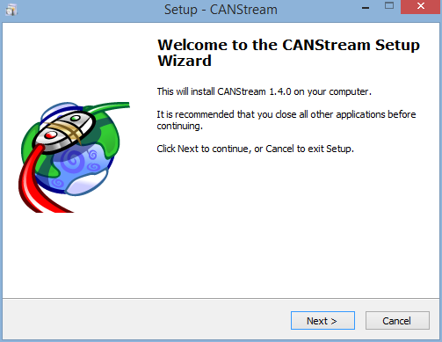

Click ‘Next' to start the installation.

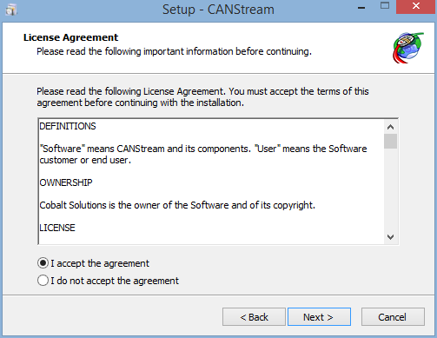

Click ‘I accept the agreement' and then click ‘Next'.

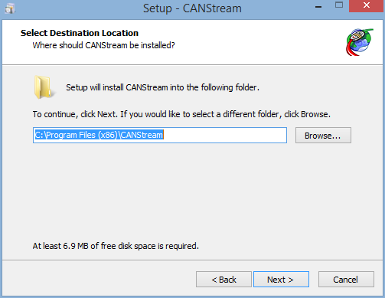

Check the installation folder, change it if you want by clicking the ‘Browse..' button and then click ‘Next'.

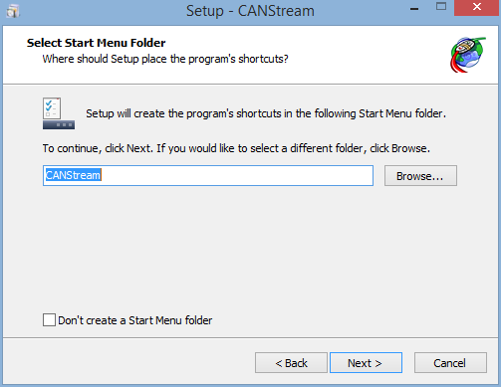

Check the name of the Start Menu folder that will be created and click ‘Next'. If you don't want create any 'Start Menu folder', just tick the box ‘Don't create a Start Menu folder' and then click ‘Next'.

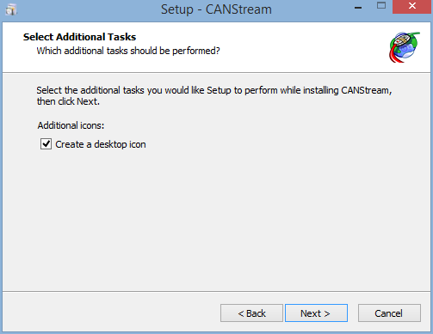

If you want create a desktop icon for CANStream, tick the box ‘Create a desktop icon' and then click ‘Next'.

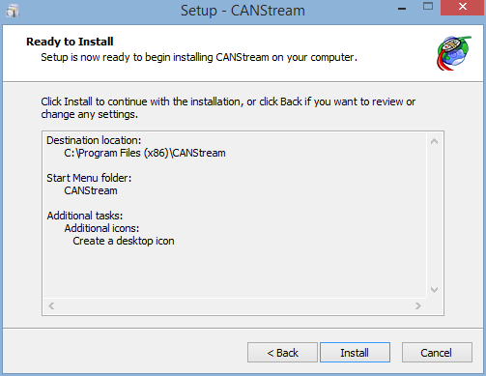

If you are happy with all settings summarized, click ‘Next' to start the actual installation of CANStream. Otherwise, click ‘Back' to change those settings.

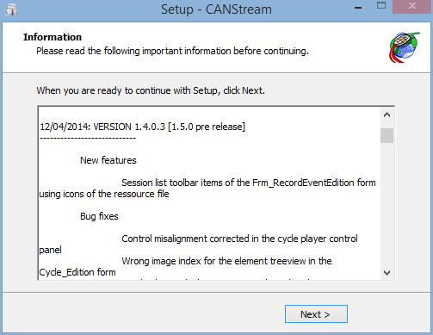

Check the release note for your information and click 'Next'.

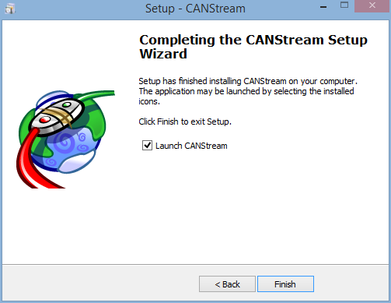

Here you are! CANStream has been installed. Just click ‘Finish' to launch CANStream. If you don't want launch CANStream now, simply uncheck the ‘Launch CANStream' box and click ‘Finish' to exit the installation wizard.

*Created with the Personal Edition of HelpNDoc:* [*Easily create Web Help sites*](http://www.helpndoc.com/feature-tour)

**PEAK USB CAN adapter driver**

In order to use the PEAK PCAN-USB adapter you need to install its driver.

Download the driver package on the Peak web site: <http://www.peak-system.com/fileadmin/media/files/usb.zip>

You should get a zip file (usb.zip) containing the driver installation wizard. Unzip this file and run lunch the file 'PeakOemDrv.exe'.

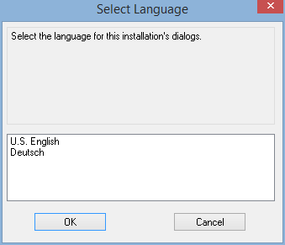

Select installation language and click 'OK'.

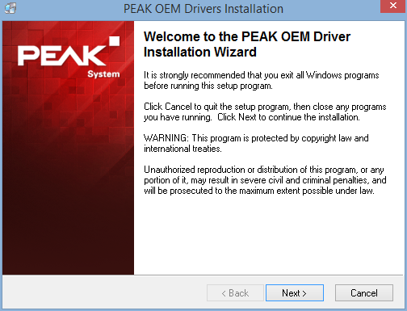

Click 'Next' to start the installation process.

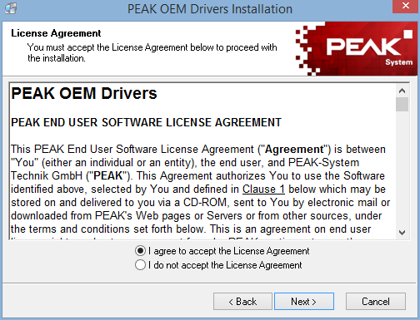

Read the license agreement and click 'I agree to accept the License Agreement' and then click 'Next'.

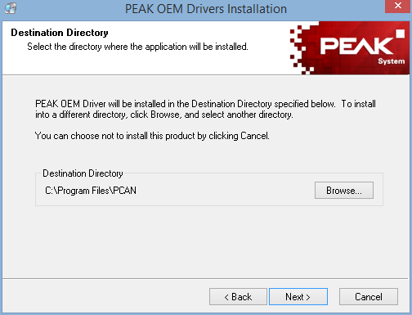

Check the installation folder and click 'Next'. Installation folder may be modified using the 'Browse' button.

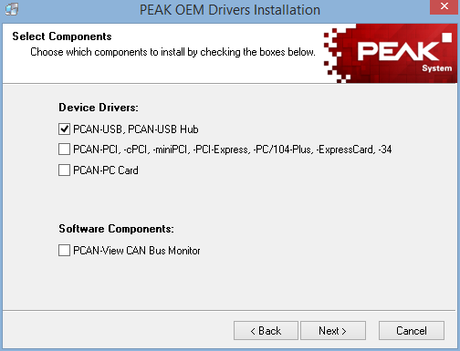

Since CANStream is only using PCAN-USB adapter the only driver requested is therefore 'PCAN-USB, PCAN-USB Hub'. Check this box and click 'Next'.

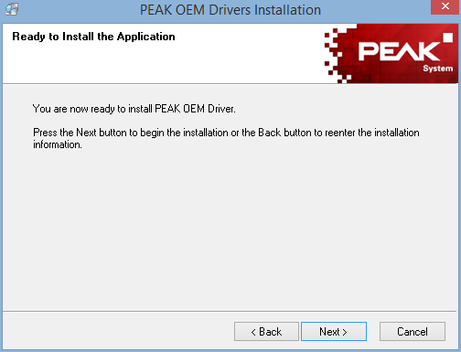

Click 'Next' to launch the actual driver installation.

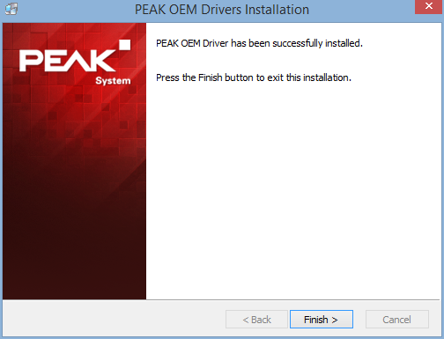

Once all files copied, click 'Finish' to quit the installation wizard.

*Created with the Personal Edition of HelpNDoc:* [*Generate EPub eBooks with ease*](http://www.helpndoc.com/create-epub-ebooks)

**Main interface**

At startup CANStream comes as the picture bellow.

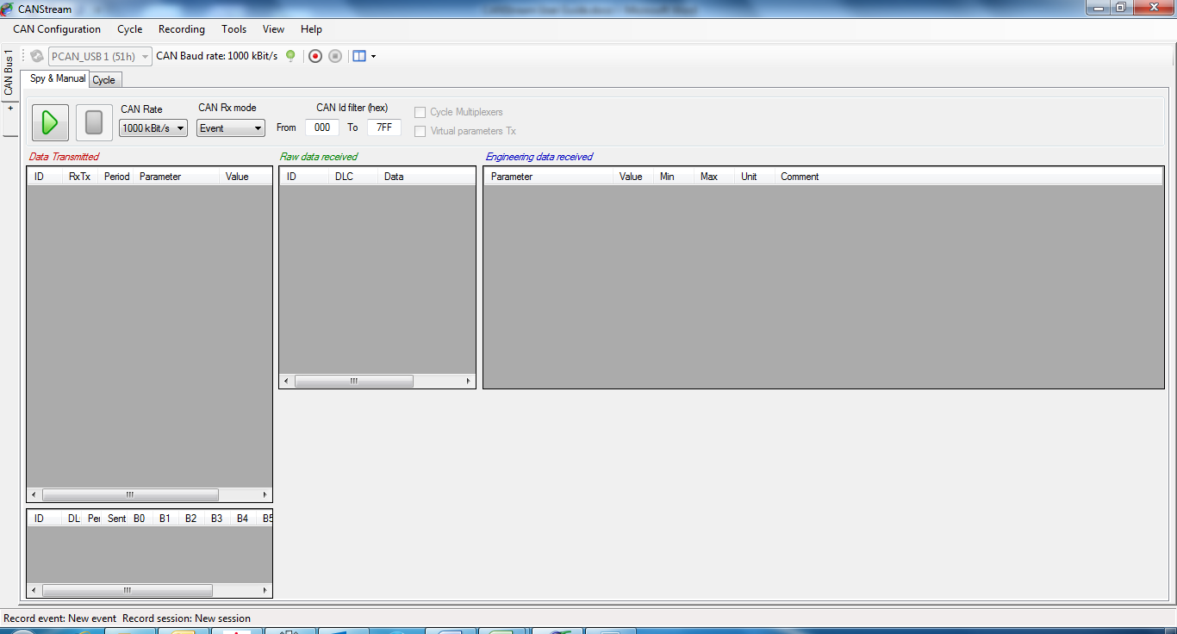

The main CANStream interface is composed of different elements

* + CAN Controller panels using the most of the space
  + The menu strip, on the top, regrouping all commands and tools accesses
  + A status bar on the bottom showing different information such like the current record event and session, the current CAN configuration name and error flags

*Created with the Personal Edition of HelpNDoc:* [*Easily create Web Help sites*](http://www.helpndoc.com/feature-tour)

**CAN Controller panel**

The CAN controller panel is where the CANStream magic happens!

There is one panel for each Peak PCAN-USB adapter you want to use. By default only one panel is opened, simply click the ‘+' tab to open a new panel and use an additional PCAN-USB adapter.

The CAN controller panel is composed of a tool bar and a multi-tab panel.

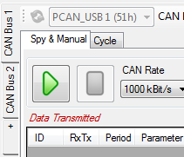

CANStream can handle up to eight PCAN-USB adapters, so it is possible to open a maximum of eight panels.

To close a panel and release its PCAN-USB adapter, stop the current panel operation (Manual control or Cycle player). Then right-click on the panel you want to close, and click the ‘Close CAN Bus' command.

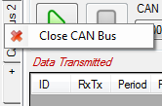

*Created with the Personal Edition of HelpNDoc:* [*Create iPhone web-based documentation*](http://www.helpndoc.com/feature-tour/iphone-website-generation)

**CAN controller modes**

A CAN controller has two operation modes, ‘Manual & Spy’ and ‘Cycle’. Each mode has its own tab in the panel.



*Created with the Personal Edition of HelpNDoc:* [*Full-featured Help generator*](http://www.helpndoc.com/feature-tour)

Spy & Manual mode

The ‘Spy & Manual’ mode is intended to be used to spy the content of frames (or messages) circulating on the bus.

Using this mode, it also possible to send messages containing values set by the user.

Both reception and transmission handle ‘Engineering’ and ‘Raw’ formats of data. ‘Engineering’ means that user can read and write actual physical values of CAN signals while the ‘Raw’ format means raw byte values of the CAN messages.

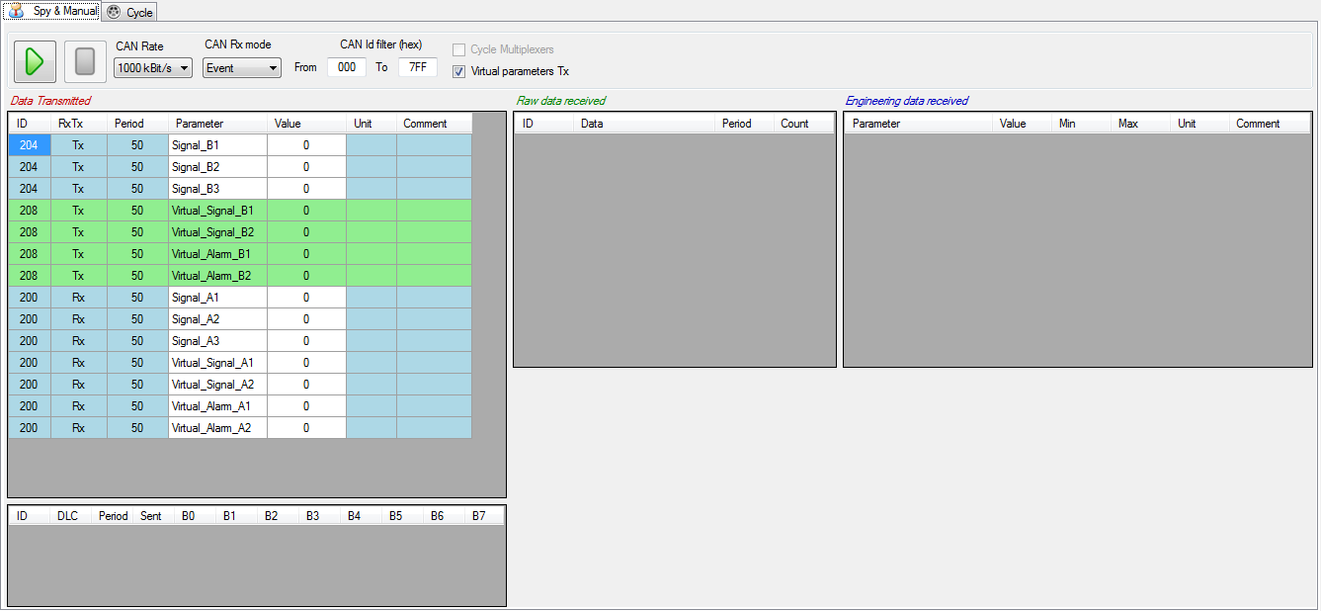

*Created with the Personal Edition of HelpNDoc:* [*Create HTML Help, DOC, PDF and print manuals from 1 single source*](http://www.helpndoc.com/help-authoring-tool)

Cycle mode

In ‘Cycle’ mode CANStream is sending a pre-defined sequence of message. This mode allows simulation of real usage conditions in which values have a very high dynamic that couldn’t be replicated by a human.

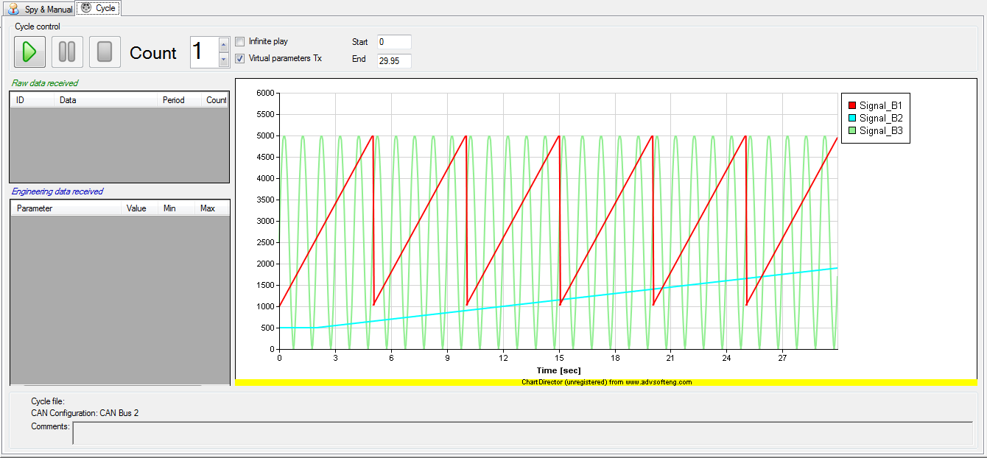

*Created with the Personal Edition of HelpNDoc:* [*Full-featured EPub generator*](http://www.helpndoc.com/create-epub-ebooks)

**CAN controller panel tool bar**

The CAN controller panel tool bar contains common commands for both ‘Spy & Manual’ and ‘Cycle’ modes



At the CANStream start up or on new controller opening, if a PCAN-USB adapter is connected and free (not used by another application) CANStream takes the control of this adapter and tool bar is as shown above.

By default the CAN Baud rate is set to 1000 kBit/s, however Baud rate can be changed in the CAN Configuration editor.

The ‘Stop connection’ button  permits to stop the connection and to release the PCAN-USB adapter in order to make it available for another controller panel or another application. Click the ‘Start connection’ button  to restart the connection using the same PCAN-USB adapter.

When the connection stops, ‘Refresh PCAN USB Devices list’ command  and the PCAN USB device list are enabled.



Click the ‘Refresh PCAN USB Devices list’ button  to refresh the ‘PCAN USB Devices list’. Click in the list to select the PCAN-USB device that you want use.



The ‘Start stream recording’ button  starts the data recorder. When it is clicked, the ‘Stop stream recording’ button  becomes enabled allowing the stop of data recording.

Command ‘View’  contains several sub-commands to customize the appearance of the ‘Spy & Manual’ panel. See the ‘Manual control layout’ section for more details.

*Created with the Personal Edition of HelpNDoc:* [*Produce electronic books easily*](http://www.helpndoc.com/create-epub-ebooks)

**Menu strip**

The menu strip gives access to all CANStream functions and tools.



*Created with the Personal Edition of HelpNDoc:* [*Full-featured EBook editor*](http://www.helpndoc.com/create-epub-ebooks)

**CAN Configuration**

This menu contains all function related to the CAN configuration of the current controller.

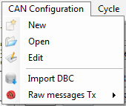

 New: Create a new CAN configuration.

 Open: Open a CAN configuration file.

 Edit: Edit the current CAN Configuration.

 Import DBC: Import a DBC file and use it as current CAN configuration.

 Raw messages Tx: Management of transmitted raw messages list.

*Created with the Personal Edition of HelpNDoc:* [*Free EPub and documentation generator*](http://www.helpndoc.com)

**Cycle**

This menu contains all functions related to the cycle player.

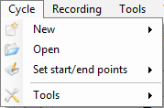

 New: Create a new cycle. Check the ‘Cycle creation’ section for more details.

 Open: Load a cycle into the cycle player of the current CAN controller.

 Set start/end points: Access to cycle starting and ending points control functions. Check the ‘Cycle playing’ section for more details.

 Tools: Access to cycle creation tools. Check the ‘Cycle creation’ section for more details.

*Created with the Personal Edition of HelpNDoc:* [*Easy EBook and documentation generator*](http://www.helpndoc.com)

**Recording**

This menu contains all functions related to the data recorder.

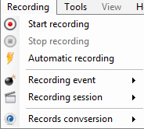

 Start recording: Start the data recorder.

 Stop recording: Stop the data recorder.

 Automatic recording: Enable or disable the automatic recording. Check the ‘Data recording’ section for more details.

 Recording event: Access to recording event control functions. Check the ‘Recording event’ for more details.

 Recording session: Access to recording session control functions. Check the ‘Recording session’ for more details.

 Recording conversion: Access to recording conversion control function. Check 'Recording conversion' for more details.

*Created with the Personal Edition of HelpNDoc:* [*Single source CHM, PDF, DOC and HTML Help creation*](http://www.helpndoc.com/help-authoring-tool)

**Tools**

This menu contains all CANStream tools access

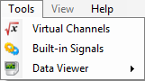

 Virtual Channels: Open the virtual channels editor.

 Built-in Signals: Open the built-in signals editor.

 Data Viewer: Open the data viewer.

*Created with the Personal Edition of HelpNDoc:* [*Free EPub and documentation generator*](http://www.helpndoc.com)

**View**

This menu contains layout configuration functions for the manual mode of the current CAN controller.

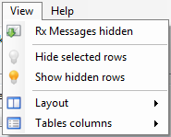

 Rx Messages hidden: Hide Rx messages in the transmission panel

 Hide selected rows: Hide the selected rows of the active grid

 Show selected rows: Show hidden rows of the active grid

 Layout: Access to the control layout configuration functions.

 Tables columns: Access to the grid columns configuration functions.

*Created with the Personal Edition of HelpNDoc:* [*Write eBooks for the Kindle*](http://www.helpndoc.com/feature-tour/create-ebooks-for-amazon-kindle)

**Help**

This menu contains access to the help file and the ‘About’ form

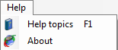

 Help topics: Open the CANStream user guide. This function is also accessible by pressing the ‘F1’ key.

 About: Open the CANStream ‘About’ form containing different information including the release name and version and license request command.

*Created with the Personal Edition of HelpNDoc:* [*Easily create EPub books*](http://www.helpndoc.com/feature-tour)

**Status bar**

The status bar of CANStream is located at the bottom of the main window. This bar contains different information.



The name of the CAN configuration file currently in use



Names of current data recording event and session.



In case of CAN error, name and description of the error detected will also appear in the status bar.



*Created with the Personal Edition of HelpNDoc:* [*Create HTML Help, DOC, PDF and print manuals from 1 single source*](http://www.helpndoc.com/help-authoring-tool)

**About form**

The CANStream ‘About’ form is accessible through the command 'Help\About'  of the main menu strip.



It contains different information including the release name and version.

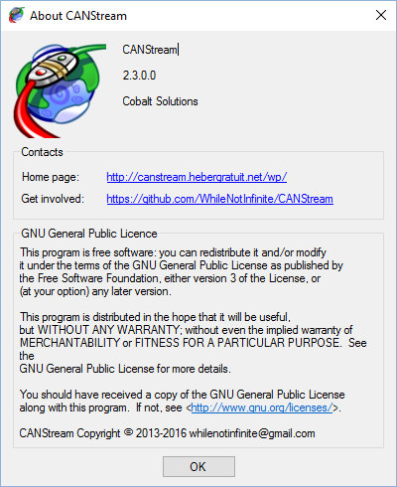

*Created with the Personal Edition of HelpNDoc:* [*Free EPub and documentation generator*](http://www.helpndoc.com)

**Keyboard shortcuts**

See bellow the list of keyboard shortcuts and their corresponding commands.

|  |  |  |
| --- | --- | --- |
| ***Key*** | ***Command*** | ***Description*** |
| ***Ctrl + C*** |  | ***Copy*** |
| ***Ctrl + X*** |  | ***Cut*** |
| ***Ctrl + V*** |  | ***Paste*** |
| ***Ctrl +Shift + V*** |  | ***Special paste*** |
| F1 | Help\Help topics | Show CANStream documentation |
| F2 | View\Layout\Cycle player\Data | Show\Hide cycle player data panel |
| F3 | View\Layout\Cycle player\Graph | Show\Hide cycle player graph panel |
| F4 | View\Layout\Spy and Manual\Data Tx\Engineering messages | Show\Hide manual engineering data Tx panel |
| F5 | View\Layout\Spy and Manual\Data Tx\Raw messages | Show\Hide manual raw data Tx panel |
| F6 | View\Layout\Spy and Manual\Data Rx\Data | Show\Hide manual data Rx panel |
| F7 | View\Layout\Spy and Manual\Data Rx\Graph | Show\Hide manual data Rx graph\History panel |
| F8 | View\Layout\Reset | Reset the current CAN controller layout |
| F9 | Recording\Start recording | Start CAN frames recording |
| F10 | Recording\Stop recording | Stop CAN frames recording |
| F11 | Recording\Record conversion\Select records to convert | Open up the trace files list window for conversion selection |
|  |  |  |

*Created with the Personal Edition of HelpNDoc:* [*Easily create EPub books*](http://www.helpndoc.com/feature-tour)

**CAN Frames configuration**

You can use CANStream to send and receive CAN messages in raw format (hexadecimal byte values) but if you want use all features of CANStream and get the maximum out of it (and I'm sure you do), the first thing you have to do is to create a CAN configuration file.

A CAN configuration file contains the description of all messages (frames) circulating on the CAN bus and all properties of all parameters (nodes) for each message. Such configuration doesn't need to be exhaustive, you can setup only messages and parameters which are of your interest and simply ignore those you don't want work with.

CANStream actually handles two kinds of CAN configuration file: single bus configuration and multiple buses configuration.

A single bus configuration simply contains descriptions and properties of CAN messages and parameters for a single CAN bus. This the configuration you have to use if you are using only one Peak PCAN-USB adapter.

A multiple buses configuration does the same but it can handle up to height CAN buses at the same time. This is the kind of configuration which is intended to be used when you are using simultaneously two, three or more (up to eight) Peak PCAN-USB adapters.

*Created with the Personal Edition of HelpNDoc:* [*Easily create iPhone documentation*](http://www.helpndoc.com/feature-tour/iphone-website-generation)

**CAN Configuration form**

To create a CAN configuration, click on the ‘CAN Configuration' menu of the menu strip and then click on ‘New'.

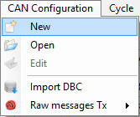

The CAN configuration editor should appear as bellow.

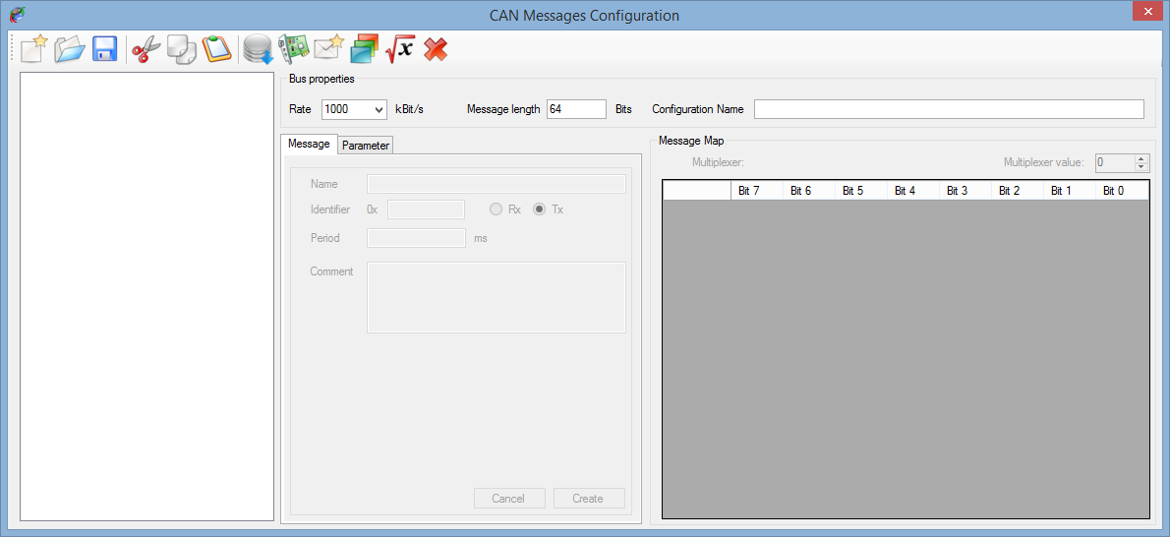

The CAN configuration editor contains several things:

* + A tool bar containing all CAN configuration edition functions access
  + A tree view in which the CAN configuration is shown as a tree
  + A multitab panel where messages and parameters properties are set
  + The bus properties panel showing general properties of a CAN bus
  + A grid showing the mapping of the active CAN message

All edition functions of a CAN configuration are available in the tool bar.

 New: Create a new CAN configuration.

 Open: Open an existing CAN configuration for edition.

 Save: Save the current CAN configuration into a file.

 Cut: Cut an element of the CAN configuration and place it on the clipboard.

 Copy: Copy an element of the CAN configuration to the clipboard.

 Past: Past an element of the CAN configuration from the clipboard.

 DBC Import: Import a DBC file in the current CAN configuration.

 New CAN controller: Add a CAN controller to the current CAN configuration.

 New CAN message: Add a CAN message to the CAN configuration.

 New CAN parameter: Add a CAN parameter to the current CAN message.

 New virtual CAN parameter: Add a virtual CAN parameter to the current CAN message.

 Delete: Delete an element of the CAN configuration.

*Created with the Personal Edition of HelpNDoc:* [*Easily create iPhone documentation*](http://www.helpndoc.com/feature-tour/iphone-website-generation)

**Single bus configuration**

A single bus configuration is a CAN configuration made for only one CAN controller used through a single Peak PCAN-USB device.

*Created with the Personal Edition of HelpNDoc:* [*Free help authoring environment*](http://www.helpndoc.com/help-authoring-tool)

**Bus properties**

First, set the CAN bus properties in the ‘BUS properties' panel. Most important properties here are bus rate and message length. By default those properties are set to 1000 kBit/s for the rate and 64 bits (8 bytes) for the message length. Optionally, you can give a name to your configuration.



*Created with the Personal Edition of HelpNDoc:* [*Full-featured Kindle eBooks generator*](http://www.helpndoc.com/feature-tour/create-ebooks-for-amazon-kindle)

**CAN message properties**

Click the ‘New message'  button of the tool bar to create a new CAN message.

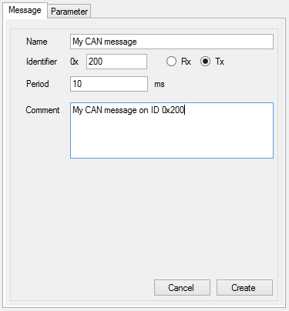

Most important CAN message properties are its identifier (ID) which must be an hexadecimal value. The message direction, ‘Rx' whether the message is received by CANStream or ‘Tx' whether it is sent by CANStream. Period in millisecond to indicate the frequency of the message reception or transmission.

You may also give a name and add a comment to your message but those are not mandatory.

Then click the ‘Create' button to add your new message into the current configuration.

*Created with the Personal Edition of HelpNDoc:* [*Full-featured Help generator*](http://www.helpndoc.com/feature-tour)

**CAN signal properties**

Once your message created, add some parameters (signals) to it by clicking the ‘New parameter' button .

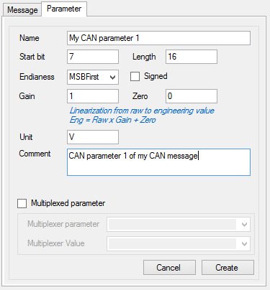

A CAN parameter has several important properties that need to be set with attention.

* + Start bit: The index of the bit in the frame where the parameter starts. Whether parameter endianess is MSB or LSB (see below for details) start bit will be different.
  + Length: The number of bits use by the parameter in the frame.
  + Endianess: How the parameter engineering (or physical) value is encoded inside its bits. There two different endianesses, MSB first (Most significant byte first) also known as Motorola format and LSB first (Least significant byte first) also known as Intel format.

There are tons of documentation available on the web describing in great details the difference between those two formats. Basically, for a given value, let's say 50 000, its encoded value will be 0xC350 in MSB format, while it will be 0x50C3 in LSB format.

* + Signedness: Indicating whether parameter sign (positive or negative) is considered for the parameter value encoding.
  + Gain and Zero: Those are values used to scale the parameter value from the raw to the engineering format
  + Name, unit and comment: Those properties are not essential but it may ease parameters identification and value exploitation.
  + Multiplexed parameter: Use those settings if you want multiplex your message. See the ‘Multiplexed parameter' section for more details.

Once all properties set, click the ‘Create' button to add the parameter to the current message.

*Created with the Personal Edition of HelpNDoc:* [*Produce Kindle eBooks easily*](http://www.helpndoc.com/feature-tour/create-ebooks-for-amazon-kindle)

**CAN Configuration tree view**

The CAN configuration tree view, on the left of the CAN configuration editor, shows all messages and all parameters of each message in a tree form.

Each message is represented by a tree node and all its parameters are a child node (or a branch) of this message node.

Click on a message or a parameter node to display its properties. Those properties can also be modified. Select the element that you want to modify, make all changes you need and then click on the ‘Modify' button.

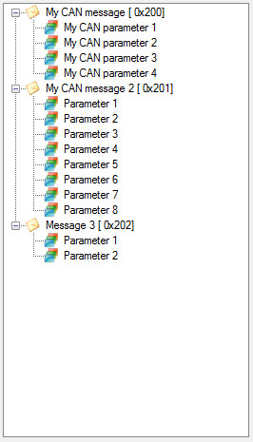

Using ‘Cut' , ‘Copy'  and ‘Past'  commands of the tool bar, you can duplicate or move messages and parameters inside the configuration.

The ‘Delete selection'  button allows to delete a message or a parameter.

*Created with the Personal Edition of HelpNDoc:* [*iPhone web sites made easy*](http://www.helpndoc.com/feature-tour/iphone-website-generation)

**Multiplexed parameter**

Once you have at least two parameters in a message, one of those parameters, the multiplexer, can be used to multiplex other parameters of the message.

As we saw in the ‘CAN signal properties' section, each parameter uses a range of bits inside the message frame. In a multiplexed message, the same bit range of the frame, or a part of it, can be shared between multiple parameters. In other words, a single message can have different parameters arrangements, current arrangement being defined by the current value of the multiplexer.

The multiplexer must be unique within a message while there could be bunches of multiplexed and fixed parameters.

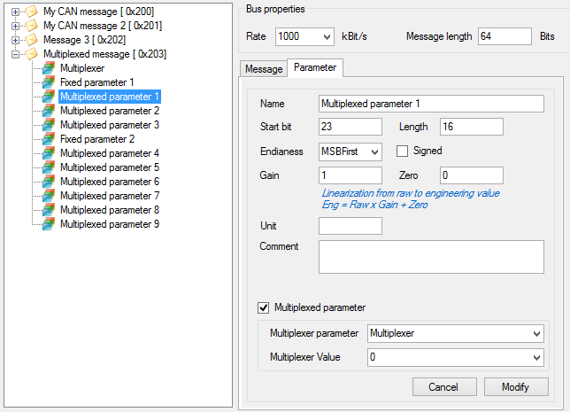

On the example above, parameters ‘*Multiplexed parameter X*' are sharing the same range of bits within the message ‘*Multiplexed message*', multiplexer of this message being the ‘Multiplexer' parameter.

To create multiplexed parameters inside a message, in first create a fixed parameter (a parameter which is not multiplexed and which will be present in all arrangements of the message). Then create a second parameter. In the properties of your second parameter, tick the ‘Multiplexed parameter' box. Lists ‘Multiplexer parameter' and ‘Multiplexer value' are now active.

Select the multiplexer parameter in the ‘Multiplexer parameter' list and then select which of its value is making your parameter active in the ‘Multiplexer value' list.

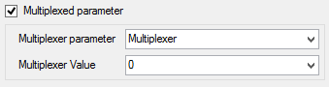

*Created with the Personal Edition of HelpNDoc:* [*Produce electronic books easily*](http://www.helpndoc.com/create-epub-ebooks)

**Message map**

The message map is a grid that shows, in graphical way, parameters bit mapping of a given CAN message.

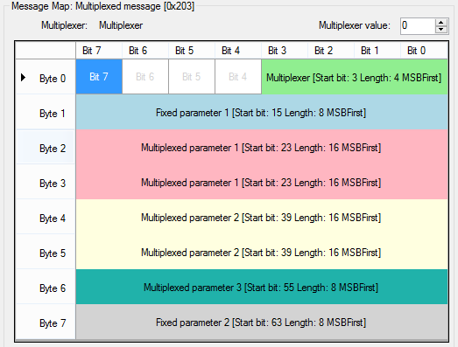

Each row of the grid represent a single byte of the message while each column is the bit number for each byte.

Inside this grid, parameters are represented by colored area. Most important properties of a parameter are written inside its area.

Click on a parameter to display or edit all its properties.

For multiplexed messages, change the multiplexer value to see the message map for any multiplexer value.

*Created with the Personal Edition of HelpNDoc:* [*Full-featured EBook editor*](http://www.helpndoc.com/create-epub-ebooks)

**Virtual CAN signal**

Basically, a virtual CAN signal is a virtual channel embedded into a CAN message.

A standard CAN signal can be used either in manual TX or RX mode in a cycle. For transmission (TX) it uses a static value defined by the user. In reception (RX) it simply gets the value received.

Value of a virtual CAN signal is neither defined by the user or received! The value is computed real time using other parameter values. See the 'Virtual channel' section for more details.

Click the 'New virtual parameter' button  to create a virtual CAN signal.

The virtual channels selection window should appear.

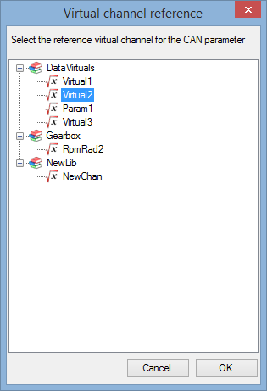

Pick up the virtual channel that you want to add in your message and click 'OK'.

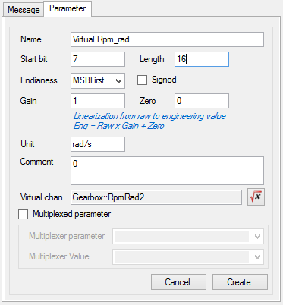

Configure your virtual signal the same way you would do for a standard parameter and then click the 'Create' button.

Note that compared to standard parameter, for virtual CAN signal the section 'Virtual chan' appeared. This section shows the virtual channel used as source of the virtual signal.

The source is indicated using the following format: 'XXX::YYY' where 'XXX' is the name of the library hosting

your virtual channel and 'YYY' is the name of the virtual channel.



Click on the  button to change the virtual source.

In order to be easily identified in the CAN configuration tree view, virtual CAN signal are marked with the virtual channel icon .

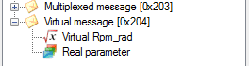

*Created with the Personal Edition of HelpNDoc:* [*Free EPub producer*](http://www.helpndoc.com/create-epub-ebooks)

**Vector CAN data base (dbc) import**

A Vector CAN data base file (extension *.dbc) is, at the end of day, a Vector CAN configuration. By the way, Vector is the editor of the famous tool CANalyser, one the most used (if not the most) tool in the CAN engineering world.

For more detail about CANalyser and DBC file, please visit <http://vector.com/vi_canalyzer_en.html>.

As per CANStream a DBC file contains CAN message and parameters description.

To save the pain of creating a CANStream CAN configuration file from scratch if you have already a DBC, CANStream can import it and convert it to its own format.

Do to so, click the 'Import DBC' button .

Select the DBC file to import and click 'Open'.

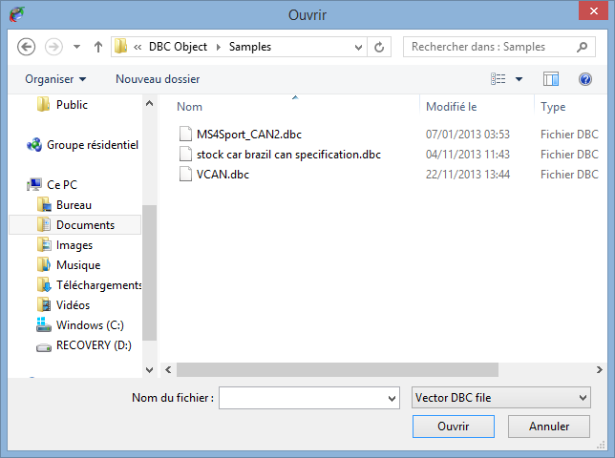

All messages contained in the DBC as well as all their parameters are going to be added to the current CAN configuration.

Note that the 'DBC import' function doesn't reset the current CAN configuration, it simply add messages coming from the DBC.

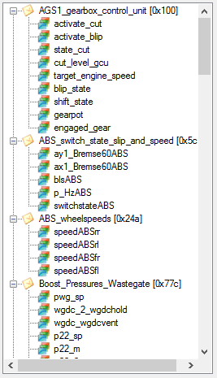

*Created with the Personal Edition of HelpNDoc:* [*Easy EBook and documentation generator*](http://www.helpndoc.com)

**Multiple buses configuration**

As we saw in the previous section, a CAN configuration contains description of CAN messages and parameter for a single CAN bus.

In the CANStream world, a CAN bus is considered as a Peak PCAN-USB adapter. One CAN bus = one PCAN-USB.

Since CANStream can handle up to eight PCAN-USB adapters, it can run simultaneously up to eight CAN configurations. Those multiple configurations (or buses) can be grouped in a single file in order to have the user configuring its buses once and using and reusing them with a simple command.

To create a multiples buses CAN configuration, click on the ‘CAN Configuration' menu of the menu strip and then click on ‘New'.



The CAN configuration editor should appear as bellow.



Click the 'New CAN bus controller' button  to create a new CAN Bus.

Then, add messages and parameters using the same method you would use for a single bus configuration.

You don't need to create such configuration from scratch. You can open  an existing single bus configuration or import a DBC file  first and then create all buses on the top of it. On the 'New CAN bus controller' button  click, CANStream will automatically create a fist CAN bus for existing messages and then create a second CAN bus in which you can add messages and parameters.

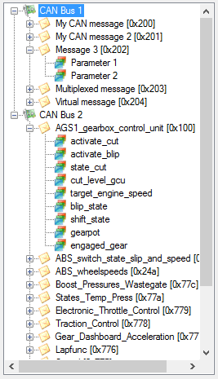

In multiple CAN buses mode, each bus is represented in the configuration tree view by the bus controller icon . Then CAN messages of a bus become child nodes (or branches) of the CAN bus.

Multiple Buses CAN configuration file has a specific extension (*.mcb). Use standard 'Save CAN configuration' button  to save your multiple buses configuration, CANStream will automatically switch to the '*.mcb' extension.

When you are using the 'Open CAN configuration' command  , the file opening dialog has two file extension filters: '*.xcc' for single bus configuration and '*.mcb' for multiple buses configuration. Just switch to the '*.mcb' extension to open a multiple buses configuration and load it into the CAN configuration edition form.

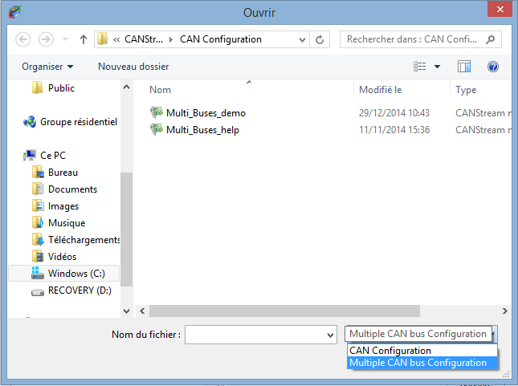

*Created with the Personal Edition of HelpNDoc:* [*Free EPub and documentation generator*](http://www.helpndoc.com)

**CAN Bus information**

While working with multiple buses CAN configuration, a third tab 'Bus controller' appears in the edition form in addition of 'Message' and 'Parameter' tabs.

Click on a CAN bus node  of the CAN configuration tree view to edit its properties.

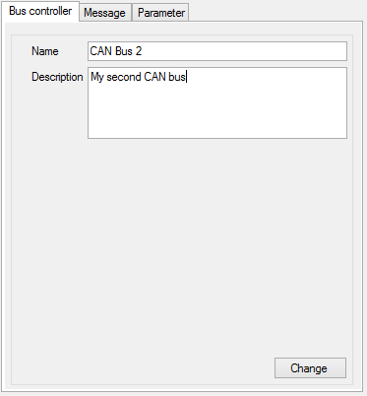

In addition of standard CAN bus properties, in that tab, you can add few information about the current bus.

* + Name: To give a sensible name to your bus.
  + Description: You can write a short description of the bus in order to ease usage of multiple buses configuration.

Then, click the 'Change' button to apply your changes.

*Created with the Personal Edition of HelpNDoc:* [*Free Kindle producer*](http://www.helpndoc.com/feature-tour/create-ebooks-for-amazon-kindle)

**Configuration import & export**

While creating a multiple buses CAN configuration, using the 'CAN Configuration\Import' command , CANStream offers the possibility to use an existing single bus CAN configuration (*.xcc) for the current CAN bus.

Simply right click on the CAN bus node  of the tree view that you want to set, select the 'CAN Configuration' item  and then the 'Import' command . A file opening dialog will pop up in which you can choose the CAN configuration file to import.

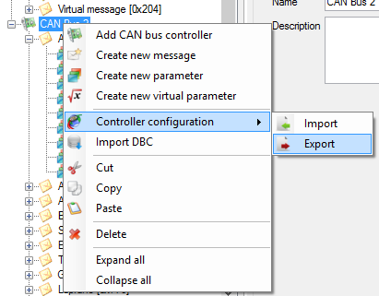

On the other way around, the 'Export' command  permits to export the CAN configuration of a particular bus in order to reuse it as a single CAN bus configuration.

*Created with the Personal Edition of HelpNDoc:* [*Easily create Help documents*](http://www.helpndoc.com/feature-tour)

**Spy & Manual mode**

The ‘Spy & Manual' mode is intended to be used to spy the content of frames (or messages) circulating on the bus.

Using this mode, it also possible to send messages containing values set by the user.

Both reception and transmission handle ‘Engineering' and ‘Raw' formats of data. ‘Engineering' means that user can read and write actual physical values of CAN signals while the ‘Raw' format means raw byte values of the CAN messages.

The ‘Spy & Manual' mode is controlled through the tool bar of the ‘Spy & Manual' panel.

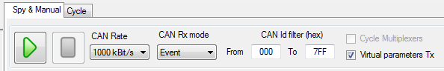

This tool bar contains the following elements.

 Start button: Start data transmission and reception.

 Stop button: Stop data transmission and reception.

 CAN rate selection: Allows definition of the CAN communication speed.

 Rx mode selection: Allows selection of the message reception mode (event, manual, periodic).

 Rx IDs filter: Allows the definition of the range of CAN message IDs that have to be considered in the reception panel.

 Virtual parameters transmission enabled flag: Enable and disable the transmission of virtual CAN signals.

 Multiplexer auto-cycling flag: If the CAN configuration in use contains some multiplexed message, CANStream will automatically cycle the multiplexer value for data transmission.

*Created with the Personal Edition of HelpNDoc:* [*Full-featured Help generator*](http://www.helpndoc.com/feature-tour)

**Data Reception**

The ‘Start' button  of the tool bar will be enabled only if an operational PCAN-USB device has been selected.

Click that button to start the data reception. While the manual mode is operating, ‘Start' button  is disabled. Click the ‘Stop' button  to stop the manual mode operation and consequently the data reception.

Those commands control both transmission and reception parts of the ‘Spy & Manual' mode.

*Created with the Personal Edition of HelpNDoc:* [*Easily create HTML Help documents*](http://www.helpndoc.com/feature-tour)

**Raw format data Reception**

Received frames raw values (before decoding) are shown into the ‘Raw data received’ grid.

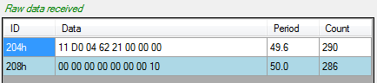

*Created with the Personal Edition of HelpNDoc:* [*Produce electronic books easily*](http://www.helpndoc.com/create-epub-ebooks)

**Engineering format data Reception**

In order to decode data received over the CAN bus, a CAN configuration file has to be loaded. Then when CAN frames are received they are decoded and signals are shown in the ‘Engineering data received' grid.

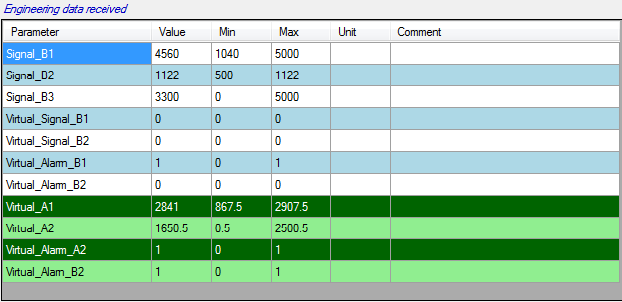

*Created with the Personal Edition of HelpNDoc:* [*Easily create CHM Help documents*](http://www.helpndoc.com/feature-tour)

**Virtual data Reception**

If one or more virtual channels libraries are loaded and data received are containing signal used in those virtual channels, virtual channels are automatically computed and their values are shown into the grid with green background color.



*Created with the Personal Edition of HelpNDoc:* [*iPhone web sites made easy*](http://www.helpndoc.com/feature-tour/iphone-website-generation)

**Received data graphic**

When CAN frames received contains data that can be decoded using the loaded CAN configuration, values of CAN signals received can be traced in real time into a graphic.

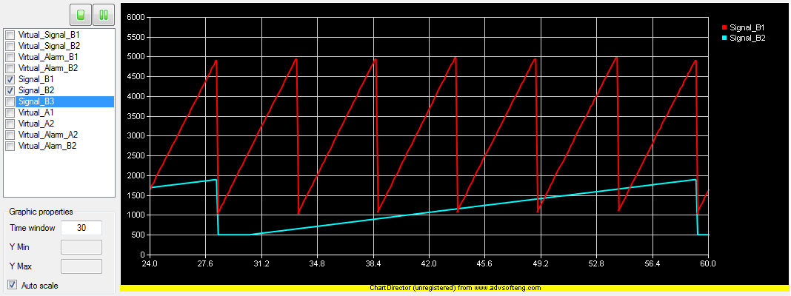

The graphic shows CAN parameters values as a function of the time. By default, the graphic is empty, simply select data to trace by checking channels in the channels list.

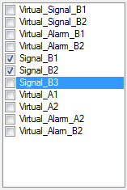

Using the small tool bar on the top of the channel list, it is possible to stop or freeze the graphic.



Button  stops the real time graphic plotting. Once clicked this button becomes ‘Start plot’ button  Those two commands actually reset the graphic window so all data plotted will be lost after a ‘Stop/Start’ commands.

Button  freezes the real time graphic plotting. Once clicked this button becomes ‘Resume’ button  Unlike the ‘Stop’ button, ‘Freeze’ command doesn’t reset the graphic. On graphic resuming, graph will appear as if it never stopped before.

Graphic time window and Y axis scale can be changed through the ‘Graphic properties’ panel.

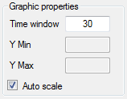

Field ‘Time window’ define the time span between the beginning and the end of graphic.

If check box ‘Auto scale’ is ticked, all values of all plotted signal are shown in the graphic. Uncheck that box to define the scale of the Y axis. After having typed a value into the ‘Y min’ or ‘Y max’ fields; press ‘Enter’ to update the graphic.

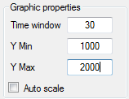

*Created with the Personal Edition of HelpNDoc:* [*Easily create Web Help sites*](http://www.helpndoc.com/feature-tour)

**Data Transmission**

The ‘Start' button  of the tool bar will be enabled only if an operational PCAN-USB device has been selected.

Click that button to start the data transmission. While the manual mode is operating, ‘Start' button  is disabled. Click the ‘Stop' button  to stop the manual mode operation and consequently the data transmission.

Those commands control both transmission and reception parts of the ‘Spy & Manual' mode.

Transmission panel of ‘Spy & Manual' control is divided in two parts: ‘Engineering' on the top and ‘Raw' data transmission at the bottom.

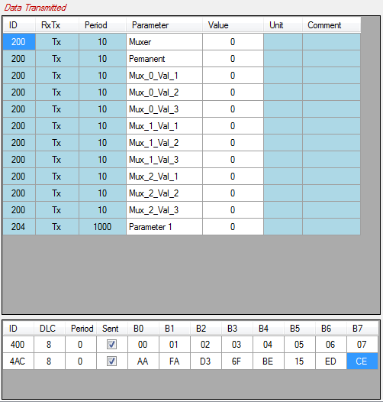

*Created with the Personal Edition of HelpNDoc:* [*Easily create Web Help sites*](http://www.helpndoc.com/feature-tour)

**Raw format data Transmission**

To send ‘Raw' CAN messages over the bus, you first need to define those messages. Click the ‘CAN Configuration\ Raw messages Tx' menu to get the raw messages management functions.

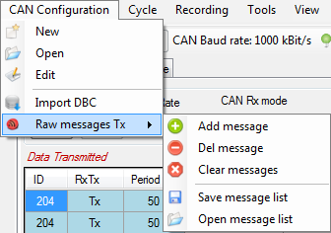

Alternatively, right click in the raw message grid to open the creation menu.

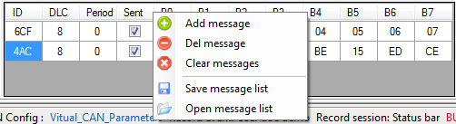

This contextual menu contains a bunch of commands to manage the raw message list.

 Add message: Add a message in the list.

 Del message: Remove a message from the list.

 Clear messages: Remove all messages of the list.

 Save: Save the message list in a file.

 Open: Open a message list file.

Once messages have been loaded or created it is possible to set their properties in the different cells of the grid.

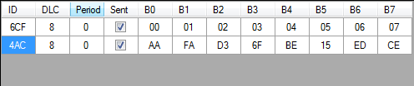

* + ID: Message identifier.
  + DLC: Message byte length.
  + Period: Message transmission period in millisecond.
  + Sent: Define whether or not the message is sent.
  + B0… B7: Message bytes value.

If the property ‘Period' is set to zero, message is not sent over.

*Created with the Personal Edition of HelpNDoc:* [*Single source CHM, PDF, DOC and HTML Help creation*](http://www.helpndoc.com/help-authoring-tool)

**Engineering format data Transmission**

In order to send engineering data over the CAN bus a CAN configuration file has to be loaded. Once loaded, this CAN configuration is displayed in the ‘Engineering data transmission' grid.

Simply change the content of the ‘Value' cell to send a new value.

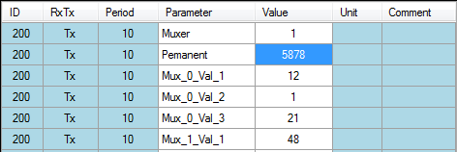

*Created with the Personal Edition of HelpNDoc:* [*Single source CHM, PDF, DOC and HTML Help creation*](http://www.helpndoc.com/help-authoring-tool)

**Virtual data Transmission**

Virtual CAN signal appear with a green color into the grid.

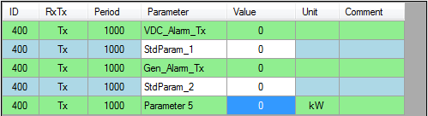

Since the value of a virtual CAN signal is calculated, its value cannot be set by the user.

Virtual CAN signal transmission can be turned on and off at any time, checking or unchecking the box .

*Created with the Personal Edition of HelpNDoc:* [*Easily create iPhone documentation*](http://www.helpndoc.com/feature-tour/iphone-website-generation)

**Cycle mode**

The ‘Cycle’ mode of CANStream sends a pre-defined sequence of message. This mode allows simulation of real usage conditions in which values have a very high dynamic that couldn’t be replicated by a human.

The ‘Cycle’ mode is controlled through the tool bar of the ‘Cycle’ panel.

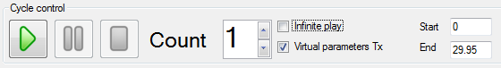

This tool bar contains the following elements.

 Start button: Starts cycle play.

 Pause button: Makes a pause in the cycle.

 Stop button: Stop cycle play.

 Cycle loops: Number of cycle repetition.

 Infinite repetition: If that box is checked, cycle is in definitively repeated until the ‘Stop’ button is clicked.

 Virtual CAN signal sent: If that box is checked, virtual CAN signal values are sent along cycle data.

 Cycle starting point: Defines the cycle play starting time for partial cycle playing.

 Cycle ending point: Defines the cycle play ending time for partial cycle playing.

*Created with the Personal Edition of HelpNDoc:* [*Easy CHM and documentation editor*](http://www.helpndoc.com)

**Cycle playing**

Open a cycle using the ‘Cycle\Open’ command of the menu strip.

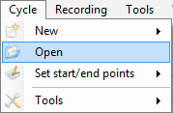

Once loaded, cycle data are showed into the cycle graphic.

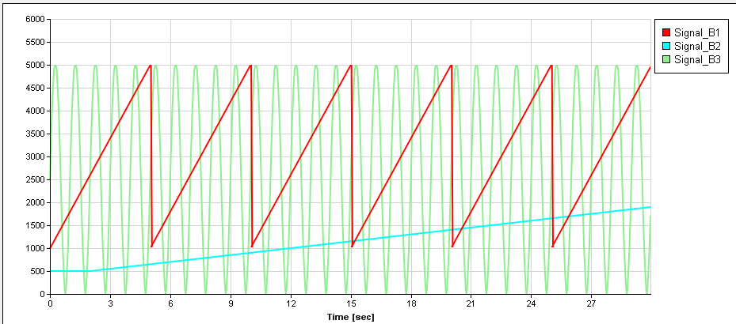

Prior to start the cycle; set the number of cycle repetitions in the ‘Count’ field. Then, click the ‘Play’ button  to start the cycle.

The cycle can be stopped at any time using the ‘stop’ button  or just held at the current position clicking the ‘Pause’  button.

During the cycle playing, a cursor appears in the graphic showing the current position within the cycle.

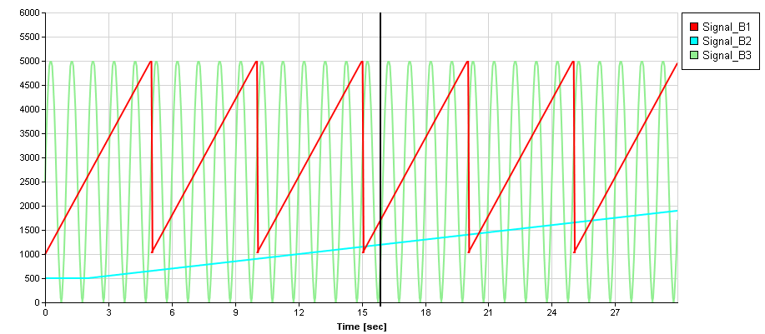

In addition of this cursor, some more information shows up in the cycle control panel while the cycle is played.

Current repetition number (starting at one)



Cycle progression bars.



Those progress bars show the progression of the cycle.

* + Current cycle: Progression of the current cycle
  + Total: Progression of the whole sequence considering the number of repetitions. For instance, if repetition is set to two, the ‘Total’ bar will be filled up two times slower than the ‘Current cycle’ bar.

By default, all cycle data are plotted into the graphic. To hide one or more signal, right click in the graphic and uncheck signals that you don’t want to see.

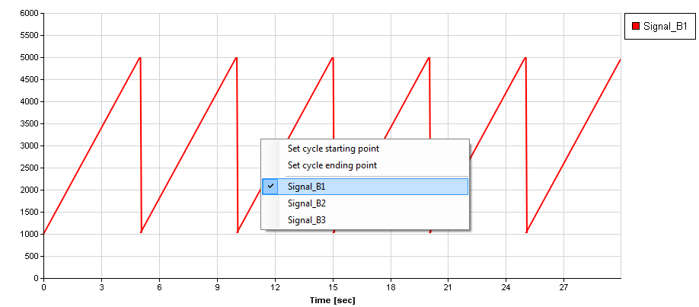

*Created with the Personal Edition of HelpNDoc:* [*Easily create PDF Help documents*](http://www.helpndoc.com/feature-tour)

**Cycle Reception data panel**

During cycle playing, data received are shown and decoded in the ‘Received data’ panel. As per the manual mode, this panel is split in two parts: raw data and engineering data.

In the panel ‘Raw data received’ received CAN frames and values of their bytes are shown. While the ‘Engineering data received’ shows decoded signal values of received frames.

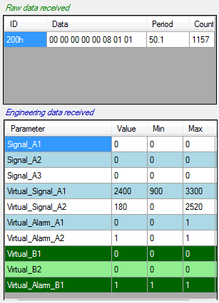

As per the manual mode, columns and rows of those two grids can be customized using their contextual menus or the ‘View’ menu of the main menu strip.

*Created with the Personal Edition of HelpNDoc:* [*Free CHM Help documentation generator*](http://www.helpndoc.com)

**Cycle starting and ending points setting**

By default, a cycle is played from the beginning to the last sample value. This is not mandatory since user can define the part of the cycle that will be played. Then cycle will no longer be played from the beginning to the end but from the starting and/or ending points defined by the user.

Even better, user doesn’t necessarily need to define both starting and ending points. If only the starting point is defined, then cycle will be played from this point to the end. Alternatively, if only the ending point is set, cycle will be played from the beginning to this ending point.

There are two methods to define cycle starting and ending points.

The numeric method: simply change the value of ‘Start’ and ‘End’ fields. Value of those fields must be time in second.



If values set are different than actual cycle beginning and ending points cursors appear in the graphic showing current cycle starting and ending points.

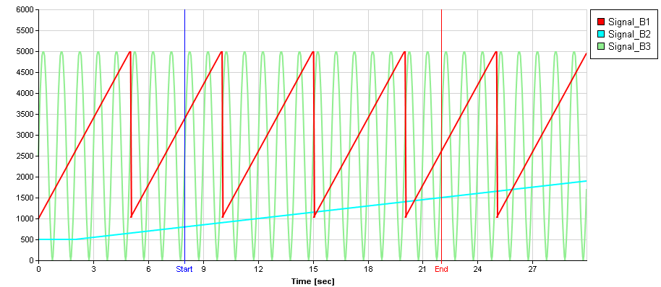

The second method consists in positioning those cursors directly into the graphic.

To do so, right click in the graphic and click ‘Set cycle starting point’ to set the starting point or ‘Set cycle ending point’ for the ending point.

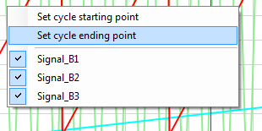

Then place the cursor at the position you want the cycle to start or end by clicking this position into the graphic.

Once that position defined, right click again into the graphic to get the contextual menu and click ‘Confirm cycle start/end points settings’ to confirm starting or ending position.

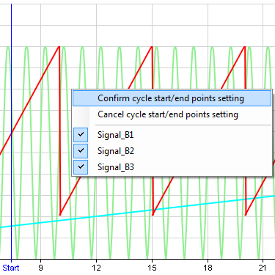

If you click ‘Cancel cycle start/end points settings’, the cursor goes back to the previous position defined if any. Otherwise it simply disappears and starting or ending are either the beginning or the end of the cycle.

*Created with the Personal Edition of HelpNDoc:* [*Easily create Help documents*](http://www.helpndoc.com/feature-tour)

**Cycle loop number setting**

A cycle can be played multiple times. To define the number of cycle repetitions, simply change the value ‘Count’ prior to launch the cycle.



Alternatively, a cycle can be played in definitively by checking the box ‘Infinite play’ . In that case, cycle will be played and repeated until the ‘Stop’ button  is clicked.

*Created with the Personal Edition of HelpNDoc:* [*Free help authoring tool*](http://www.helpndoc.com/help-authoring-tool)

**Virtual CAN signals in cycle**

As per manual mode, virtual channels can be computed based on values received on the CAN bus while a cycle is played. This can be particularly useful if virtual channels are alarms sent to a device to stop unit operation or ignore commands.

When a virtual channel is computed, it appears in the ‘Engineering data received’ with green background.

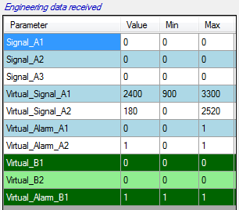

*Created with the Personal Edition of HelpNDoc:* [*Free EBook and documentation generator*](http://www.helpndoc.com)

**Cycle creation**

Prior to be loaded and played, a cycle has to be somehow created…

CANStream proposes three methods to create cycle files:

* + Easy cycle creation: With this method the cycle is created based on a data file. This mode has very few options, that’s why it is called ‘easy’.
  + Advanced cycle creation: Unlike the ‘easy’ mode, the ‘advanced’ mode has extended options in order to tweak the cycle.
  + Record replay: This is actually the easiest cycle creation mode! Cycle is built using a record which is converted into a cycle file.

*Created with the Personal Edition of HelpNDoc:* [*Free iPhone documentation generator*](http://www.helpndoc.com/feature-tour/iphone-website-generation)

**Easy cycle creation**

The ‘Easy cycle creation’ method creates a cycle based on a data file. This mode has very few options, that’s why it is called ‘easy’.

Click the ‘Cycle\New\Easy cycle creation’ menu of the main menu strip to access the ‘Easy cycle creation’ mode.

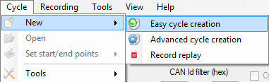

The ‘Easy cycle creation’ form shows up.

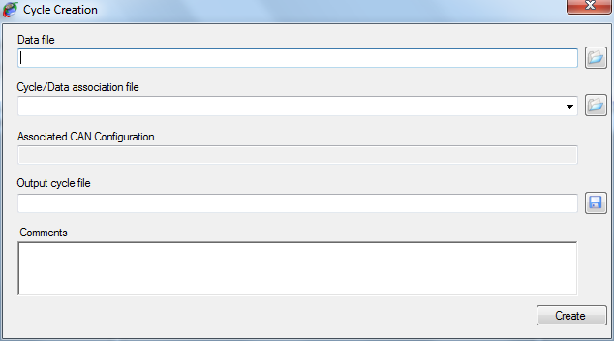

To create a cycle using this method, simply follow steps described below:

* + Select a cycle source data file by clicking the ‘Open’  button on the right of the ‘Data file’ field.

Several formats of data are supported for cycle creation. Change the extension by changing the extension filter of the open file dialog.

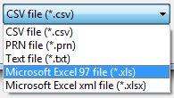

* + Select a ‘Cycle/Data association’ file by clicking the ‘Open’  button on the right of ‘Cycle/Data association file’ filed. If your association file is located in the ‘Cycle Data Association’ folder of the ‘CANStream’ folder of ‘My documents’, it will present in the list. So you can drop down the list and pick up the association file that you want to use.

Once the association file selected, the CAN configuration for which the association has been made for is displayed (for information) in the ‘Associated CAN configuration’ text box. This text box cannot be modified, so select another association file (or make a new one) if you don’t want use the CAN configuration showed.

* + Set the name and path of the output cycle file clicking the ‘Save’  button.
  + Optionally write a description of your cycle in the ‘Comments’ area.
  + Then click the ‘Create’ button  to launch the cycle creation.

Depending of the type of the source file (Excel or ASCII) and its size, it may take several minutes to create the cycle. This is particularly long with large Excel files since the Excel automation interface for .NET application is a kind of slow…

However, during the creation a progress bar appears indicating progression of the cycle creation process. At the end of the cycle creation, a message box pops up to let the user know that creation process has ended.

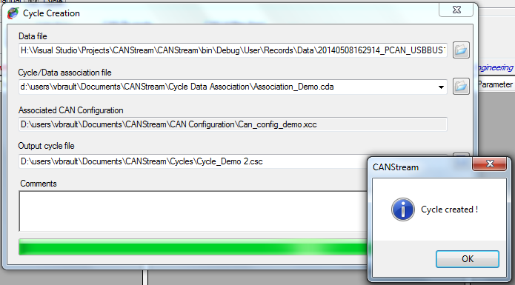

*Created with the Personal Edition of HelpNDoc:* [*Easy EBook and documentation generator*](http://www.helpndoc.com)

Cycle data association

A ‘Cycle data association’ file is a file containing association between CAN parameters and data source channels.

For example, let’s say that you have a CAN configuration containing a CAN parameter called ‘Speed’ and that you want create a cycle using this configuration. You have a source data file to create your cycle but in this data file, the ‘Speed’ channel is called ‘Velocity’.

A ‘Cycle data association’ file will fix that issue since it allow to associate CAN parameters with a data channel. So in our case we will simply states that the CAN parameter ‘Speed’ is using values of the data channel ‘Velocity’ as source of data.

To open the ‘Cycle data association’ edition form, click the ‘Cycle\Tools\New Cycle\Data association’ menu.

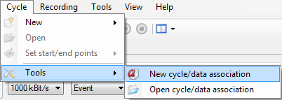

The ‘Cycle data association’ edition form appears.

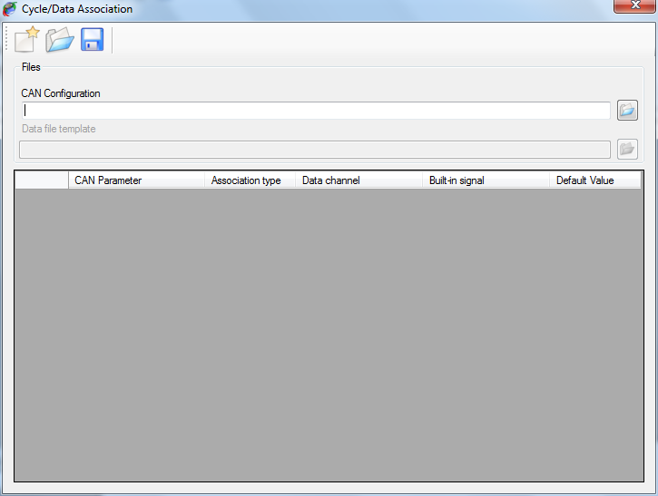

This form contains a tool bar on the top to access the ‘Cycle data association’ file management commands (new, open, save).

A control panel in which CAN configuration and data file are intended to be specified.

A grid, containing actual CAN parameter/data channel associations.

Click the ‘Open’  button on the right of the ‘CAN configuration’ field.

Then select the data file that you want to use as template to set associations by clicking the ‘Open’  button on the right of the ‘Data file template’ field.

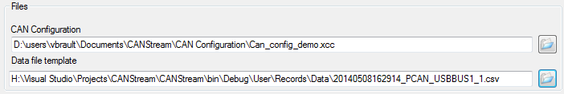

As mentioned by its label, that file is a template. So it doesn’t mean that association works only with this particular data file. It means association will work with any data file having the same structure as the template.

This is important here to underline that by ‘structure’ we consider both data channel name and data channel location. If channel ‘Velocity’ is placed on the third column of the data file, association will work with all data file having a channel ‘Velocity’ on the third column. If ‘Velocity’ moves to the fifth column for some reasons, association won’t any longer work and association file will have to be modified accordingly.

Another important point is that CANStream consider data of the first column as time vector. If time isn’t on the first column it may results to unpredictable cycle.

Once the CAN configuration loaded the association grid is filled, each row of the grid being a CAN parameter of the CAN configuration.

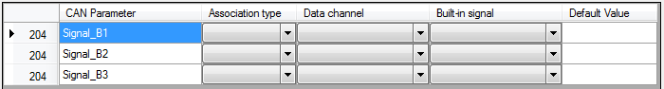

The association grid has six columns:

* + Message ID: Identifier of the message containing the CAN parameter (for information only).
  + CAN Parameter: Name of the CAN parameter in the CAN configuration.
  + Association type: Type of the association.
  + Data channel: Name of the data channel associated to the CAN parameter.
  + Built-in signal: Name of the built-in signal associated to the CAN parameter.
  + Default value: Fix value associated to the CAN parameter.

*Created with the Personal Edition of HelpNDoc:* [*Produce electronic books easily*](http://www.helpndoc.com/create-epub-ebooks)

Association type

Main purpose of an association file is to associate CAN parameters with data channel. Actually, a CAN parameter can be associated with something else than a data channel.

There are four types of association:

* + None: CAN parameter isn’t associated, its value will zero in the cycle
  + AcqData: CAN parameter is associated to a data channel. CAN parameter values in the cycle will be values of the data channel.
  + Built-in signal: CAN parameter is associated to a built-in signal. CAN parameter values in the cycle will be values of the built-in signal
  + Fixed value: CAN parameter is associated to a fix value. CAN parameter values in the cycle will be the value defined all the time.

Click on ‘Association type’ cell of a CAN parameter and pick up the association that you want to use.

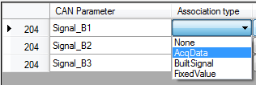

Once the association type defined, select the data channel or built-in signal in the corresponding cell.

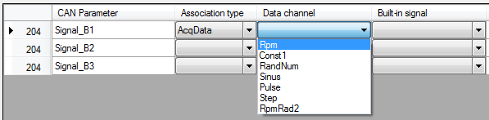

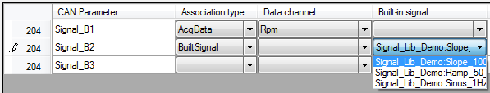

For a ‘Fixed value’ association simply type a value into the ‘Default value’ cell.

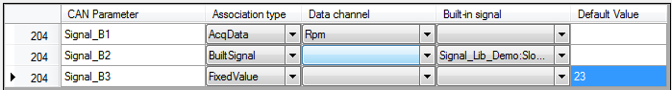

Several CAN parameters can be associated with the same data channel or built-in signal.

Once all associations are set click the ‘Save’  button of the tool bar to save the association file.

*Created with the Personal Edition of HelpNDoc:* [*Full-featured EBook editor*](http://www.helpndoc.com/create-epub-ebooks)

**Advanced cycle creation**

The ‘Advanced cycle creation’ method has extended options for cycle creation allowing tweaking the cycle in order to fit with particular needs.

With the ‘Advanced cycle creation’ method, cycle creation configuration can be saved into a cycle creation configuration file (*.x3c) in order to have configuration re-useable. Such file contains all information needed to create the cycle (CAN configuration, built-in signals, virtual channels) so it can be easily distributed to others without having to give a whole bunch of files.

The biggest advantage of using the ‘Advanced cycle creation’ is that it can use virtual channels as source of data for the cycle. Thus, since virtual channels can be computed using multiple built-in signals, variables and functions, it allows the generation of complex profiles for the cycle.

Click the ‘Cycle\New\Advanced cycle creation’ menu of the main menu strip to access the ‘Advanced cycle creation’ mode.

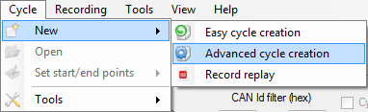

If there is no CAN configuration currently loaded, a message box pops up proposing to load one.

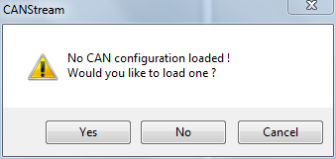

If you answer ‘Yes’ a ‘File open’ dialog will show up in which you can select the CAN configuration that has to be used to create the cycle.

If you answer ‘No’, the ‘Advanced cycle creation’ form will open but you still will have to open a CAN configuration file in order to create a cycle.

If you answer ‘Cancel’, it cancels the cycle creation and returns to the main form of CANStream.

Well, let’s say that we have answered ‘No’ to this question… Form appears as below.

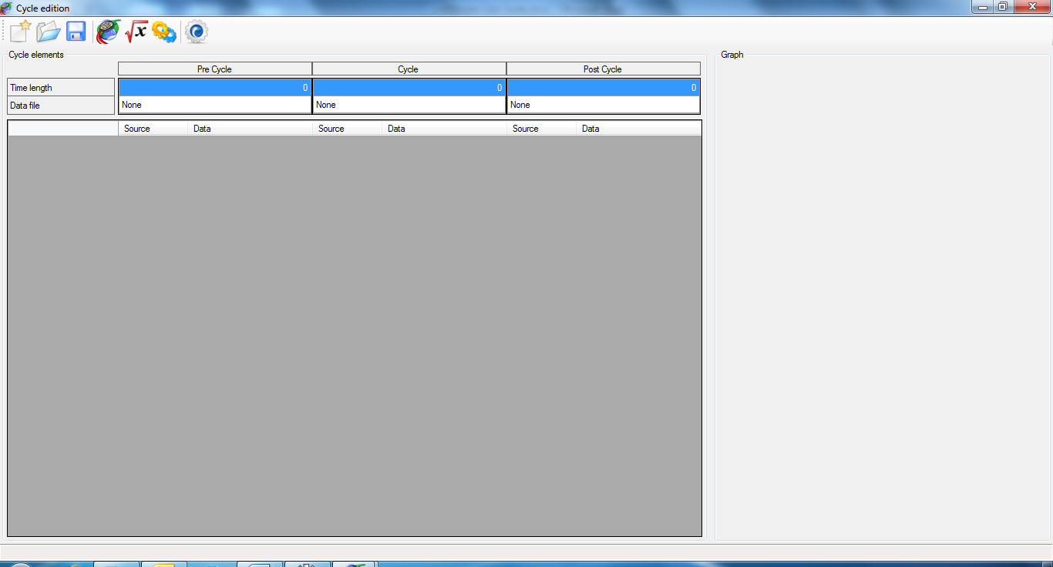

In the ‘Advanced cycle creation’ environment, a cycle is split in three parts: ‘Pre-cycle’, ‘In cycle’ and ‘Post-cycle’.

Those parts can be considered as sub-cycles, final whole cycle being the concatenation of the three parts. If we consider the ‘In cycle’ part as the actual cycle, the ‘Pre-cycle’ part is the sequence played before the cycle like an introduction. The ‘Post-cycle’ part is therefore the sequence played after the cycle like a conclusion.

‘Pre’ and ‘Post’ cycle concept is very useful when the system to test has to be gently started and stopped.

For instance, something looking like the profile bellow.

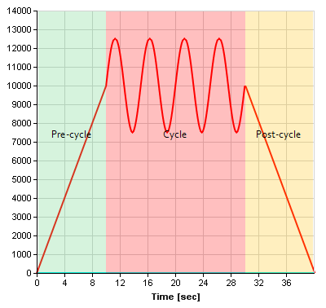

*Created with the Personal Edition of HelpNDoc:* [*Easily create EBooks*](http://www.helpndoc.com/feature-tour)

Advanced cycle creation tool bar

The tool bar at the top of the form contains some commands:

 New: Create a new cycle creation configuration file

 Open: Open a cycle creation configuration file

 Save: Save the current cycle creation configuration file

 Load CAN Configuration: Load a CAN configuration file

 Virtual channel: Reload the current virtual channels library collection (in case of virtual channel modification during the cycle edition).

 Built-in Signals: Reload the current built-in signals library collection (in case of built-in signals modification during the cycle edition).

 Build cycle: Starts the cycle creation process.

*Created with the Personal Edition of HelpNDoc:* [*Easily create Web Help sites*](http://www.helpndoc.com/feature-tour)

Cycle parts setting

The grid on the top regroups cycle parts properties.

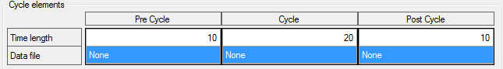

There is one column for each cycle part.

Row ‘Time length’ specifies the time length (in second) of each part, final cycle time length being the sum of cycle parts length. So in the example above, final cycle will be 40 seconds (10 + 20 + 10 = 40).

Row ‘Data file’ contains the file used as data source for each cycle part. All cycle parts can use the same or different files.

To set a data file for a cycle part, click in the ‘Data file’ cell of the part to make the ‘Open file’ button visible.

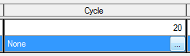

Click this button to open the open file dialog and select a file. Once the data file selected, its name is shown in the cell.

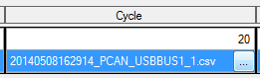

If the time length of the data file exceeds the time length of the cycle part, CANStream will propose you to change the cycle part length in order to match the length of the data file but this is not mandatory.

If the time length of a part exceeds the data file time length, data file will be replayed until the cycle part ends.

*Created with the Personal Edition of HelpNDoc:* [*Produce Kindle eBooks easily*](http://www.helpndoc.com/feature-tour/create-ebooks-for-amazon-kindle)

Cycle definition

If there was not CAN configuration loaded at the form start up, click the ‘Load CAN Configuration’ button  of the tool bar to load one.

Once loaded, all CAN parameters contained in CAN messages set with ‘Transmission’ (Tx) flag will be display in the grid.

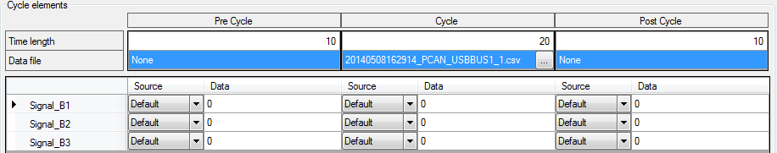

Each row of the grid represents a CAN parameter and has three groups of two columns.

Those three groups are respectively, ‘Pre-cycle’, ‘Cycle’ and ‘Post-cycle’ parts of the cycle.

The two columns of each group are configuration of the CAN parameter for a given cycle part.

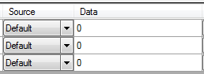

Column ‘Source’ defines the data source for the CAN parameter. Click the ‘Source’ cell to drop the source list down and pick up the desired source.

There are six possible sources:

* + None: CAN parameter value is set to zero.
  + Default: CAN parameter value is set with the default value which is zero.
  + Constant: CAN parameter value is set with the constant value set in the ‘Data’ cell.
  + BuiltSignal: CAN parameter value is set with value of the built-in signal defined in the ‘Data’ cell.
  + VirtualChannel: CAN parameter value is set with value of the virtual channel defined in the ‘Data’ cell.
  + AcqData: CAN parameter value is set with value of the acquisition data channel defined in the ‘Data’ cell.

If the ‘Source’ property is set to ‘BuiltSignal’ or ‘VirtualChannel’, click the ‘Data’ cell to get the list of items available.

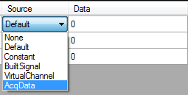

Available item list takes a form of a tree where libraries are roots of the tree and items (virtual channels or built-in signals are branches. Just double-click an item to select it as data source of the CAN parameter.

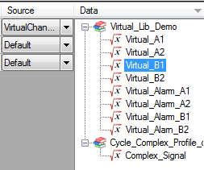

If the ‘Source’ property is set to ‘AcqData’, click the ‘Data’ cell to get the list of data channels available. Simply double-click a channel to select it as data source of the CAN parameter.

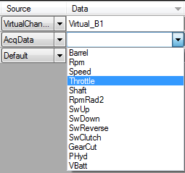

You don’t need here to select a source for each CAN parameter and for all cycle parts. If a cycle part length is null, it won’t generated so it can be ignored while selecting data sources of CAN parameters.

Once all CAN parameter of your interest are set, click the ‘Build cycle’ button  to launch the cycle creation.

At the first cycle building, a ‘file save’ dialog pops up. Set the name and path of the output cycle file. The cycle can be built several times but the ‘file save’ dialog will show up only once.

During cycle building, the ‘Abort’ button  will appear. Click this button at any time while CANStream is building the cycle to cancel the process.

At the end of the cycle creation process, a message box will pop up indicating that cycle has been successfully created.

In addition, a graphic preview of the cycle will be drawn on right side of the form.

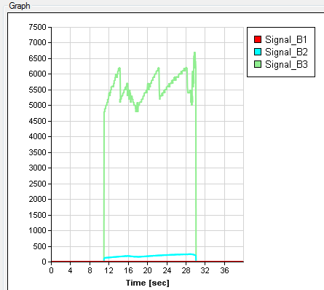

As per the cycle player graph, right click in the graph to select traces that you want to see in the graphic.

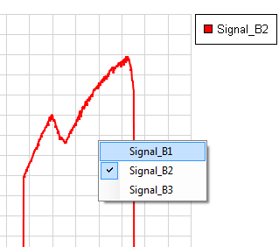

*Created with the Personal Edition of HelpNDoc:* [*Free Web Help generator*](http://www.helpndoc.com)

**Record replay**

The ‘Record replay’ cycle creation method simply transform one or more PCAN Trace files (*.trc) into a cycle file. This method is particularly useful to quickly replicate a behavior that has been previously recorded.

With this method you don’t need to associate anything, frames contained in the PCAN Trace file are simply reformatted to fit with the CANStream cycle file format.

Click the ‘Cycle\New\Record replay’ menu of the main menu strip to access the ‘Record replay creation’ mode.

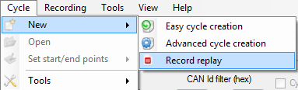

The ‘Record replay’ form shows up.

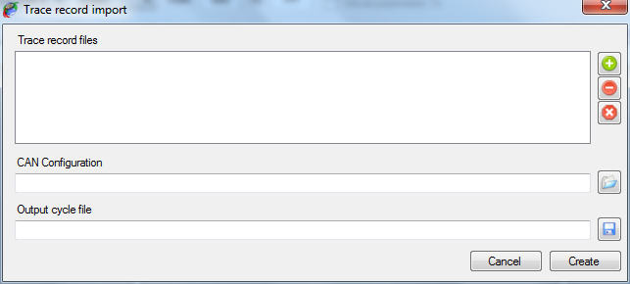

*Created with the Personal Edition of HelpNDoc:* [*Free help authoring environment*](http://www.helpndoc.com/help-authoring-tool)

Record replay configuration

To create a cycle using this method, simply follow steps described below:

* + Add one or more PCAN Trace file into the ‘Trace record file’. Basically all trace files are concatenated to each other in the order they appear in the list in order to make the final cycle.

Trace files list control commands are located on the left of the list. There are three commands:

 Add: Add a PCAN Trace file into the list.

 Del: Remove a PCAN Trace file from the list.

 Clear: Clear all PCAN Trace file from the list.

* + Select a CAN configuration file by clicking the ‘Open’ button  on the right of the ‘CAN Configuration’ field. This CAN configuration is only use to get the CAN bus speed (1000 kBit/s, 500 kBit/s) nothing else.
  + Define name and file path of the output cycle by clicking the ‘Save’ button  on the right of the ‘Output cycle file’ field.
  + Click the ‘Create’ button  to launch the cycle creation.

During the cycle creation process two progress bars appears.

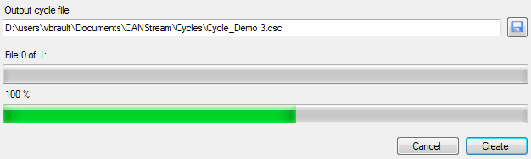

The first bar, on the top, indicates the process progression among PCAN Trace file to convert. The second bar, at the bottom, indicates the progression of the conversion for the current file.

At the end of the cycle creation, when all PCAN Trace file have been converted, a message box pops up indicating that process has ended.

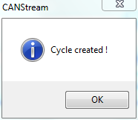

At any time in the process it is possible to cancel the cycle creation by clicking the ‘Cancel’ button .

*Created with the Personal Edition of HelpNDoc:* [*Produce Kindle eBooks easily*](http://www.helpndoc.com/feature-tour/create-ebooks-for-amazon-kindle)

**CAN controller appearance options**

The appearance of a CAN controller can be customized in order to best fit with user needs.

*Created with the Personal Edition of HelpNDoc:* [*Generate EPub eBooks with ease*](http://www.helpndoc.com/create-epub-ebooks)

**Control layout**

The ‘View’  command of the tool bar contains functions to customize the appearance of the current CAN controller.

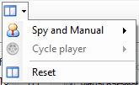

Whether the active panel is ‘Spy and Manual’  or ‘Cycle’  the corresponding commands group is enabled. ‘Reset’  button restores all default layout options for both ‘Spy and Manual’ and ‘Cycle’ panels.

*Created with the Personal Edition of HelpNDoc:* [*Produce electronic books easily*](http://www.helpndoc.com/create-epub-ebooks)

**Manual control layout**

Click ‘Spy and Manual’  to get layout commands of this mode.

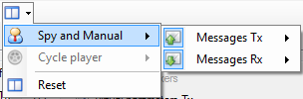

The menu is divided in two parts:

 Messages Tx: for the transmission part of the manual control.

 Messages Rx: for the reception part of the manual control.

The ‘Message Tx’  menu is divided in two parts:

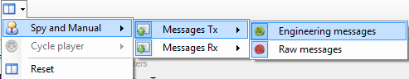

 Engineering messages: Showing or hiding the ‘Engineering’ section of the data transmission panel.

 Raw messages: Showing or hiding the ‘Raw’ data section of the data transmission panel.

The ‘Message Rx’  menu is also divided in two parts:

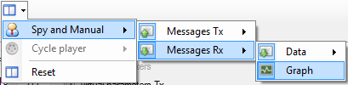

 Data: Showing or hiding the ‘Data’ section of the data reception panel.

 Graph: Showing or hiding the ‘Graphic trace’ section of the data reception panel.

Finally, ‘Data’  menu is split in two parts as well:

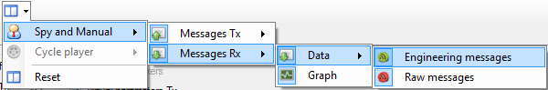

 Engineering messages: Showing or hiding the ‘Engineering’ section of the data reception panel.

 Raw messages: Showing or hiding the ‘Raw' data section of the data reception panel.

*Created with the Personal Edition of HelpNDoc:* [*Easily create Web Help sites*](http://www.helpndoc.com/feature-tour)

**Cycle control layout**

Click ‘Cycle player’  menu to get layout commands of this mode.

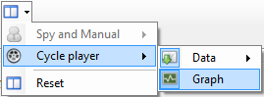

The ‘Cycle player menu is divided in two parts:

 Data: Showing or hiding the ‘Data’ section of the cycle panel.

 Graph: Showing or hiding the ‘Graphic trace’ section cycle.

Then, ‘Data’ sub-menu is split in two parts

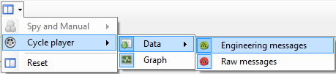

 Engineering messages: Showing or hiding the ‘Engineering’ section of the data reception panel.

 Raw messages: Showing or hiding the ‘Raw data section of the data reception panel.

*Created with the Personal Edition of HelpNDoc:* [*Free PDF documentation generator*](http://www.helpndoc.com)

**Grids contents control**

The contents of all grids (columns and rows) of a CAN controller can be individually customized.

To customize the content of a grid, right click on it to get its contextual menu.

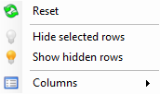

Grid customization commands are also available through the ‘View’ menu of the main menu strip.



*Created with the Personal Edition of HelpNDoc:* [*Produce electronic books easily*](http://www.helpndoc.com/create-epub-ebooks)

**Grid rows**

Each row of a grid can be hidden. Select rows that you want hide and click ‘Hide selected rows’ . Then click on ‘Show hidden rows’  to make hidden rows visible.

*Created with the Personal Edition of HelpNDoc:* [*Easily create HTML Help documents*](http://www.helpndoc.com/feature-tour)

**Grid columns**

The width of the different columns of a grid cannot be changed but it is possible to selected columns that have to be shown and columns that have to be hidden.

Menu ‘Columns’  of the contextual menu of a grid contains columns title for the grid owning the contextual menu. Simply check or uncheck column titles to make columns visible or invisible.

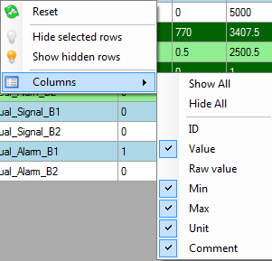

Commands ‘Show all’ and ‘Hide all’ show and hide all columns at once. Then every single column can be individually set checking or unchecking its title.

The ‘Table columns’  menu of the ‘View’ menu contains columns control commands of all grid of a CAN controller.

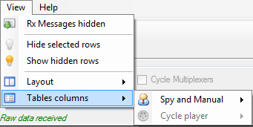

Whether the active panel is ‘Spy and Manual’  or ‘Cycle’  the corresponding commands group is enabled.

*Created with the Personal Edition of HelpNDoc:* [*Free iPhone documentation generator*](http://www.helpndoc.com/feature-tour/iphone-website-generation)

Manual control grid columns

Click ‘Spy and Manual’ to get the grid columns commands of this mode.

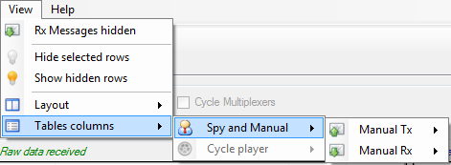

The menu is divided in two parts:

 Messages Tx: for the transmission part of the manual control.

 Messages Rx: for the reception part of the manual control.

The ‘Manual Tx’  contains columns control commands of the engineering data transmission grid.

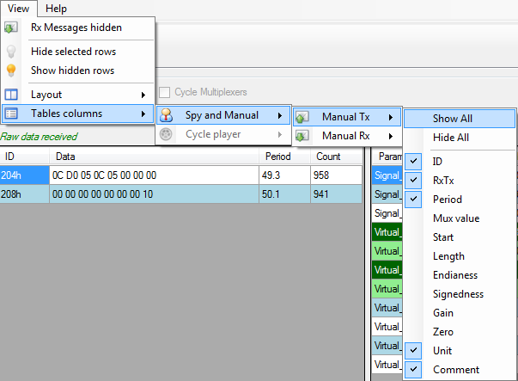

Columns of the raw data transmission grid cannot be customized since all columns are needed.

The ‘Manual Rx’  menu is divided in two parts:

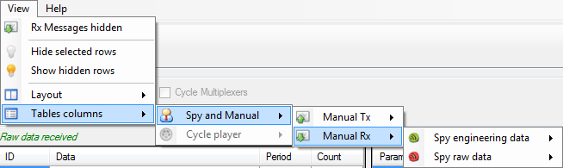

 Engineering messages: containing columns control commands of the engineering data reception grid.

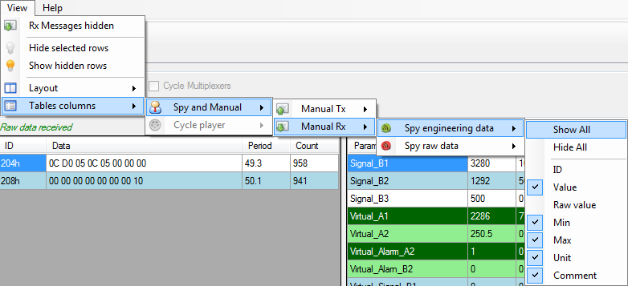

 Raw messages: containing columns control commands of the raw data reception grid.

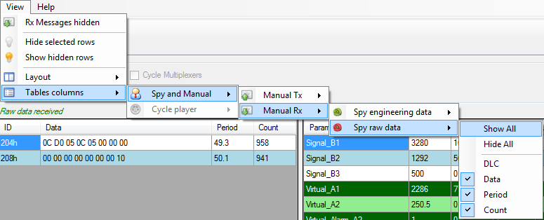

*Created with the Personal Edition of HelpNDoc:* [*Free CHM Help documentation generator*](http://www.helpndoc.com)

Cycle player grid columns

Click ‘Cycle player’  to get the grid columns commands of this mode.

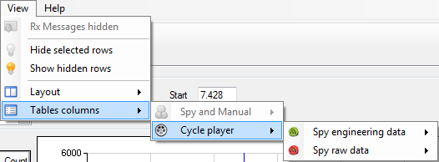

The ‘Cycle player’ menu is divided in two parts:

 Engineering messages: containing columns control commands of the engineering data reception grid for the cycle panel.

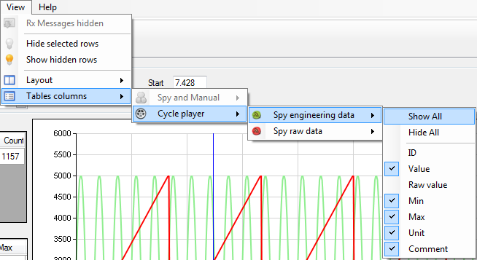

 Raw messages: containing columns control commands of the raw data reception grid for the cycle panel.

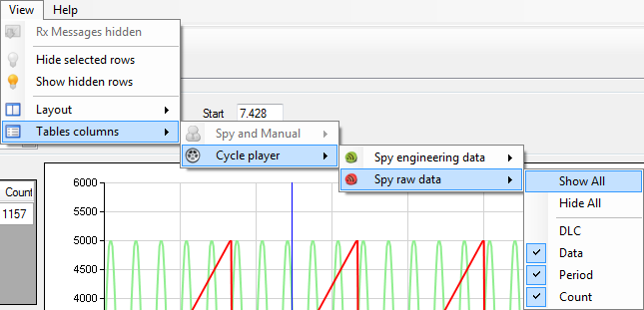

*Created with the Personal Edition of HelpNDoc:* [*Easily create Help documents*](http://www.helpndoc.com/feature-tour)

**Data logging**

While manual or cycle player modes are running it is possible to record all CAN frames circulating on the CAN bus. For the time that data logger is turned on, the content of all frames as well as their time stamps will be recorded and stored into a file.

Such logging files are actually very difficult to read for a human. Indeed, it is a very large file containing hexadecimal values. Fortunately CANStream offers the ability to decode those files and convert it to a readable format. On the top of that, CANStream can also show logging data in a graphic window to make easy and accurate the record analysis.

Data recording doesn’t require any special configuration; just turn it on and off when you need. However, logging file naming convention being a kind of meaningless, it may be very difficult to identify which particular logging file among twenty or thirty files (or even more) is corresponding to a particular test. To assist the user in this task, CANStream has also some functions to enhance logging files storage.

*Created with the Personal Edition of HelpNDoc:* [*Full-featured EPub generator*](http://www.helpndoc.com/create-epub-ebooks)

**Data logging start & stop**

Data logger can be turned on when a PCAN-USB device is connected and used by CANStream. When this is the case, the ‘Start stream logging’ button  of the tool bar becomes active.



Just click this button to start logging the data. When data logging starts, the ‘Start stream logging’ button is disabled and the ‘Stop steam logging’ button  is active. Simply click this button to stop the data logging.



You don’t necessarily need to start the ‘Spy & Manual’ or the ‘Cycle’ mode to record data. If CAN frames are circulating in the bus they will be recorded whether or not CANStream is operating.

Start and stop logging commands are also available in the ‘Recording’ menu of the main menu strip.



*Created with the Personal Edition of HelpNDoc:* [*Easily create EBooks*](http://www.helpndoc.com/feature-tour)

**Automatic recording**

If you don’t want manually start and stop the logger each time you are testing, you can turn on the ‘Automatic recording’ feature.

To enable this function, click the ‘Automatic recording’ item in the ‘Recording’ menu of the main menu strip.

When active, the ‘Automatic recording’ is automatically turning the logger on and off when you start and stop CANStream ‘Spy & Manual’ or ‘Cycle’ mode. Thus your entire work session can be recorded without the need to care about the logger itself.

While automatic recording is active the thunderbolt icon of its menu item is highlighted.



*Created with the Personal Edition of HelpNDoc:* [*Easily create PDF Help documents*](http://www.helpndoc.com/feature-tour)

**Data file formats**

Data logging function of CANStream is dealing with two different file extensions: ‘*.trc’  and ‘*.csv’ .

 ‘*.trc’ files are raw data file generated by the Peak PCAN-USB driver. Those files contain CAN frames in hexadecimal format and their timestamps.

 ‘*.csv’ files are decoded and converted logging file generated by CANStream. Those files are intended to be used by the user either in the data analysis window of CANStream or in an external application such as Microsoft Excel or equivalent.

*Created with the Personal Edition of HelpNDoc:* [*Produce electronic books easily*](http://www.helpndoc.com/create-epub-ebooks)

**Peak PCAN trace file**

Example of a Peak PCAN trace file (*.trc) 

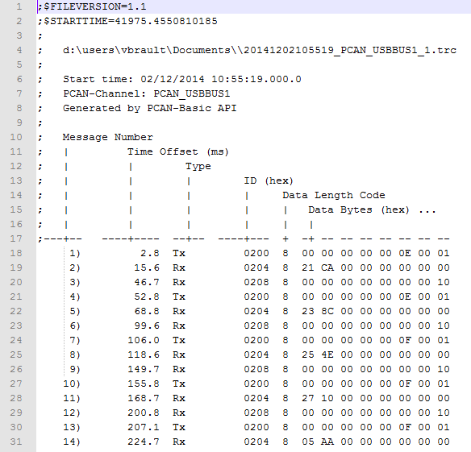

*Created with the Personal Edition of HelpNDoc:* [*Full-featured EBook editor*](http://www.helpndoc.com/create-epub-ebooks)

**Record data file**

Example of a CANStream record data file (*.csv) .

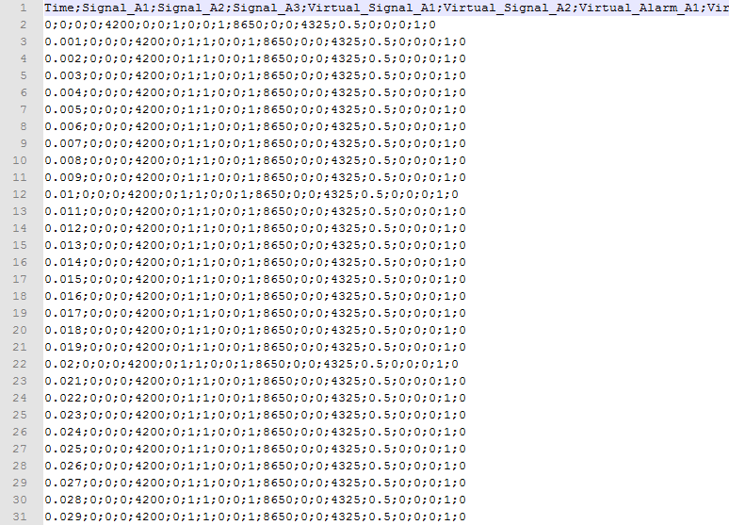

*Created with the Personal Edition of HelpNDoc:* [*Easy to use tool to create HTML Help files and Help web sites*](http://www.helpndoc.com/help-authoring-tool)

**Logging file conversion**

Logging files conversion from the Peak ‘PCAN trace’ format (*.trc)  to the CANStream ‘Record data file’ (*.csv)  is made using a CAN configuration file in order to identify CAN messages and get CAN signals values out of raw byte values of recorded frames.

Very basically, CANStream identifies CAN messages thanks to their identifiers and decodes frame byte values using CAN parameter properties set into the CAN configuration file.

There are two methods to convert data logging file; the manual conversion and the automatic conversion. With manual conversion, user has to manually launch the conversion process while in automatic mode, logging files are automatically converted as soon as the data logger stops and the logging file is closed.

*Created with the Personal Edition of HelpNDoc:* [*Single source CHM, PDF, DOC and HTML Help creation*](http://www.helpndoc.com/help-authoring-tool)

**Manual conversion**

The ‘Record conversion’  sub-menu of the ‘Recording’ menu of the main menu strip contains all data file conversion commands.

As far as the manual conversion, two options are available. It is possible to either convert all logging files at once or to manually select in a list files that have to be converted.

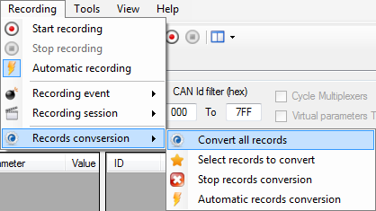

Click the ‘Convert all records’ menu to convert all data files by a single click.

To make your own selection of files to convert, click the ‘Select record to convert’  menu.

The file selection form shows up.

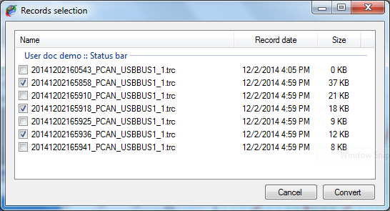

Check the box of all files that you want to convert and then click the ‘Convert’ button once you are ready to launch the conversion process.

*Created with the Personal Edition of HelpNDoc:* [*Free HTML Help documentation generator*](http://www.helpndoc.com)

**Automatic conversion**

As per the automatic recording, automatic conversion only needs to be activated.

Click the ‘Automatic record conversion’ item in the ‘Recording conversion’  menu of the main menu strip.

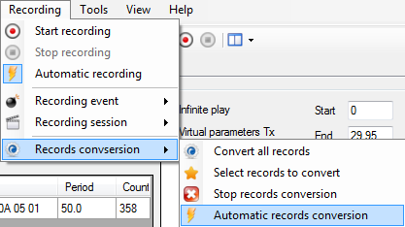

When active, the ‘Automatic conversion’ is automatically launching the file conversion process when the data logger stops and the logging file is closed. Coupled with the automatic recording, the automatic conversion allows you to have your entire work session recorded and converted without the need to care about neither the logger nor conversion.

While automatic conversion is active, the thunderbolt icon of the menu item is highlighted.



*Created with the Personal Edition of HelpNDoc:* [*Easy EBook and documentation generator*](http://www.helpndoc.com)

**Conversion process control**

A progress bar appears in the main form status bar during the conversion process.



This bar shows the progression of the complete conversion process. When the bar is full all logging files have been converted.

You can stop the conversion at any time during the process by click the ‘Stop conversion’ button  of the status bar.

*Created with the Personal Edition of HelpNDoc:* [*iPhone web sites made easy*](http://www.helpndoc.com/feature-tour/iphone-website-generation)

**Data file storage structure**

The data file storage structure is described in great details in the next section. However, basic structure is the following.

All data files (*.trc and *.csv) are stored in the ‘Records’ folder in ‘CANStream’ folder of the user ‘Documents’ directory (…\users\xxx\Documents\CANStream\Records)

The ‘Records’ folder contains three sub-folders: ‘Data’, ‘Raw’ and ‘Stack’.

* + Data folder: contains converted record data files (*.csv) .
  + Raw folder: contains PCAN Trace data files (*.trc)  that have been converted already.
  + Stack folder: contains PCAN Trace data files (*.trc)  that are waiting to be converted.

You may find also a couple of XML files in those three folders. Check the next section for more details about those XML files.

*Created with the Personal Edition of HelpNDoc:* [*Produce electronic books easily*](http://www.helpndoc.com/create-epub-ebooks)

**Recording event & Recording session**

Until you have only three, four or five data files it is fairly easy to remember and identify what those file are. Imagine now that you have fifty of those data files! It becomes a kind of tricky to figure out what file is the file corresponding to the test you are looking for, especially if you are looking for an old record.

To assist you with file archiving and make data files research a way easier, CANStream uses the ‘Event\Session’ structure for data storage.

With such structure, data files are not stored in a unique folder. A folder is created for each event and sub-folders are created for every session. Then data files are placed into their respective session folder.

Term ‘event’ should be considered as a major group. Let’s say ‘CANStream documentation’. Inside this event we have multiple ‘sessions’ each of them corresponding to a specific topic. Let’s say that we have three sessions ‘Manual mode’, ‘Cycle mode’ and ‘Virtual channel’.

Thanks to this structure, we know that all data of the ‘CANStream documentation’ folder are data that have been generated for the documentation. Then, session folders indicate for what exact part of the documentation, data files have been recorded.

On the top of that, for every session of every event, CANStream creates an XML file containing information about the session or event. An event/session XML file contains the name of the event or session, its date and description and optionally a bunch of user information. This list of user information can be anything the final user has found useful to identify and track data files. In our example (CANStream documentation) we can set the CANStream release name and the name of the CAN configuration that have been used. Number and content of user information is actually unlimited so you can have how many you want and write whatever you want.

Name of both current recording event and current session is shown in the main form status bar.



*Created with the Personal Edition of HelpNDoc:* [*Easy EPub and documentation editor*](http://www.helpndoc.com)

**Recording event creation & edition**

Record event control commands are available in the ‘Record event’ item  of the ‘Record’ menu of the main menu strip.

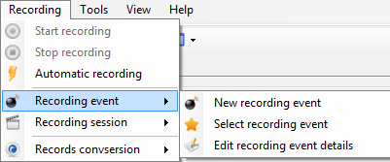

Click the ‘New recording event’ menu  to create a new recording event or click the ‘Edit recording event details’ menu  to edit the current recording event.

The recording event edition form shows up.

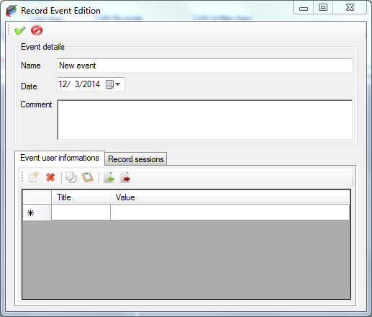

Tool bar on the top contains only two commands

 Apply: Create the record event or apply changes to the current record event

 Cancel: Cancel the record event creation or change made to the current record event

When creating a new record event, this event becomes the current record event. So all records performed afterward will stored under this new event.

Frame ‘Event details’ contains main information about the recording event.

* + Name: Name of the recording event
  + Date: Starting date of the recording event
  + Comment: Recording event description.

Panel at the bottom of the form has two tabs.

* + Event user information: Management of user information attached to the record event. Check the ‘User information’ section for more details
  + Record sessions: Management of the record sessions of the current event

The ‘Record sessions’ panel contains session control commands for the current record event. When creating a new record event, a session ‘New session’ is created by default.

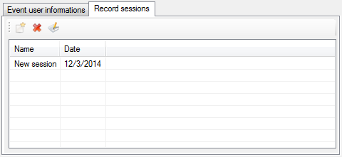

All sessions of the record event are listed in the record session list. Tool bar on the top of the list contains session control commands.

 New: Create a new session inside the current record event.

 Delete: Delete a session of the current record event.

 Edit: Edit details of the selected session. Check ‘Recording session creation & edition’ for more details.

When deleting a record session, session is only removed from the list. Data that may have been recorded under the session to delete are not deleted.

*Created with the Personal Edition of HelpNDoc:* [*iPhone web sites made easy*](http://www.helpndoc.com/feature-tour/iphone-website-generation)

**Recording event selection**

At any time, you can switch to a different recording event. If the recording event that you want switch to has already been created, it is possible to pick it up in a list.

Click the ‘Select recording event’ menu  to switch to another recording event.

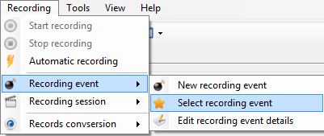

The available record events list pops up.

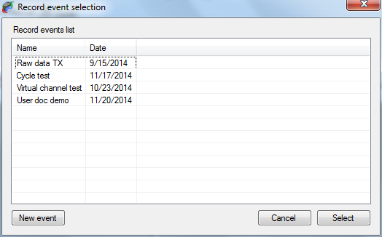

Just double click the record event you want to use or click the ‘Select’ button after having selected it into the list.

Alternatively, you can also create a new record event by clicking the ‘New event’ button.

*Created with the Personal Edition of HelpNDoc:* [*Single source CHM, PDF, DOC and HTML Help creation*](http://www.helpndoc.com/help-authoring-tool)

**Recording session creation & edition**

Record session control commands are available in the ‘Record session’  item of the ‘Record’ menu of the main menu strip.

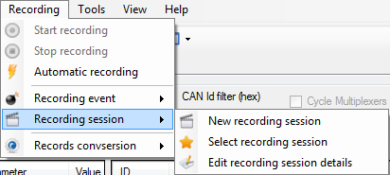

Click the ‘New recording session’ menu  to create a new recording session or click the ‘Edit recording session details’ menu  to edit the current recording event.

The recording session edition form shows up.

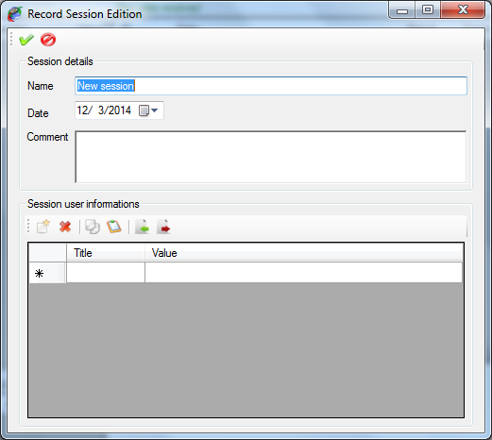

Tool bar on the top contains only two commands.

 Apply: Create the record session or apply changes to the current record session.

 Cancel: Cancel the record session creation or change made to the current record session.

When creating a new record session, this session becomes the current record session. So all records performed afterward will stored under this new session.

Frame ‘Session details’ contains main information about the recording session

* + Name: Name of the recording event.
  + Date: Starting date of the recording event.
  + Comment: Recording event description.

Panel ‘Session user information’ contains control commands for user information attached to the record session. Check the ‘User information’ section for more details.

*Created with the Personal Edition of HelpNDoc:* [*Free CHM Help documentation generator*](http://www.helpndoc.com)

**Recording session selection**

At any time, you can switch to a different recording session. It is possible to pick up in a list the recording session that you want switch to if this session has already been created.

Click the ‘Select recording session’ menu  to switch to another recording event.

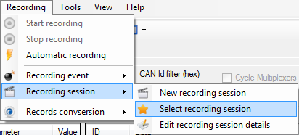

The available record session list pops up.

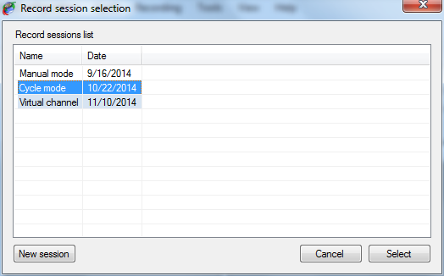

Just double click the record session you want to use or click the ‘Select’ button after having selected it into the list.

Alternatively, you can also create a new record session by clicking the ‘New session button.

*Created with the Personal Edition of HelpNDoc:* [*Easily create HTML Help documents*](http://www.helpndoc.com/feature-tour)

**User information**

User information for record event or record session is an optional collection of information defined by the user and which are attached to an event or to a session.

Number and content of this information is unlimited so you can have as many as you want of user information and they can contain whatever you want attached to an event or to a session. User information is not mandatory; it is possible to have event or session without any user information.

User information control panel is common for both recording event and recording session objects.

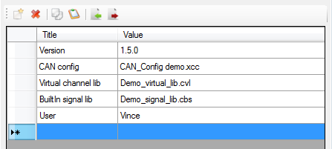

User information control panel is composed of a grid containing all user information, and a tool bar in which user info control commands are accessible.

User information is made of two fields:

* + Title: The title of the user information.
  + Value: Value of the user information.

To be considered as valid (and consequently to be stored) a user information must have a least a title. Value can remain empty but all grid rows having their ‘Title’ cell empty will be ignored.

To create a new ‘user information’, simply write its title in the empty row at the bottom of the list. Then write its value in the ‘Value’ cell.

The tool bar contains the following commands:

 Add: Create a new user information.

 Del: Remove a user information from the list.

 Copy: Copy a user information on the clipboard.

 Past: Past a user information from the clipboard.

 Import: Import a user information collection file.

 Export: Export the current collection of user information into a file.

In order to avoid the need of having to recreate all the time your collection of user information, it is possible to export a collection into a file and re-use this file whenever you need it. The same user information can be used either for a record event or a record session without any restriction.

*Created with the Personal Edition of HelpNDoc:* [*Produce Kindle eBooks easily*](http://www.helpndoc.com/feature-tour/create-ebooks-for-amazon-kindle)

**Data analysis**

In addition of logging and decoding data CANStream offers the possibility to analyze those data into a graphic window. The data viewer of CANStream allows loading multiple data files at once even if they are not part of the same record event or session. Data files are concatenated in order to create a data set that appear as a continuous record in the data viewer.

The menu ‘Tools’ of the main menu strip gives access to this data analysis window.

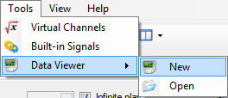

Item ‘Data Viewer’ of the ‘Tools’ menu contains two sub-menu: ‘New’  and ‘Open’ .

Click the ‘New’  menu to open an empty data analysis window and click the ‘Open’  menu to open an existing data analysis window.

*Created with the Personal Edition of HelpNDoc:* [*Free Kindle producer*](http://www.helpndoc.com/feature-tour/create-ebooks-for-amazon-kindle)

**Analysis window**

When creating a new analysis window, the window comes empty.

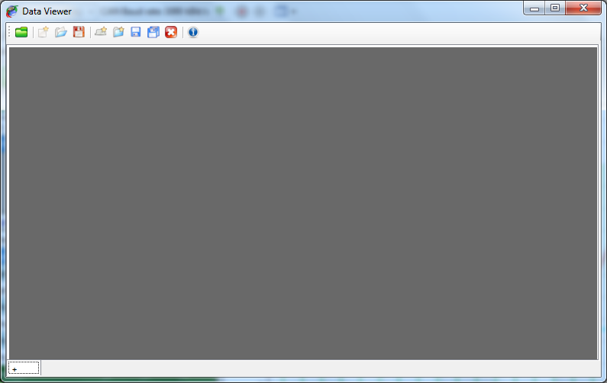

The data viewer window is composed of two elements.

* + The tool bar on the top, containing all data viewer control commands.
  + The multi-tab panel containing all pages of the data viewer.

Since the data viewer window can have multiple pages it can be considered as book. Each page of this book is a graphic window with a different graphic configuration.

Data to be displayed are loaded through the data browser. Check the ‘Data browser’ section for more details. However the set of data loaded is unique over the entire book. It means that all pages are actually showing the same set of data. It is consequently impossible to see the data file ‘A’ in the first page and the data file ‘B’ in the second page.

This behavior might sound as a weakness or a missing functionality, but actually this is not a weakness. Experienced users know that while working with multiple pages it is possible to get lost and not remember what exact data set is loaded on each page. So to make things easy all pages are showing the same data set.

*Created with the Personal Edition of HelpNDoc:* [*Free EBook and documentation generator*](http://www.helpndoc.com)

**Data viewer page creation**

Click the ‘+’ tab  at the bottom or click the ‘New data viewer page’ button  of the tool bar to create a new page in the data viewer.

The new data viewer page is created.

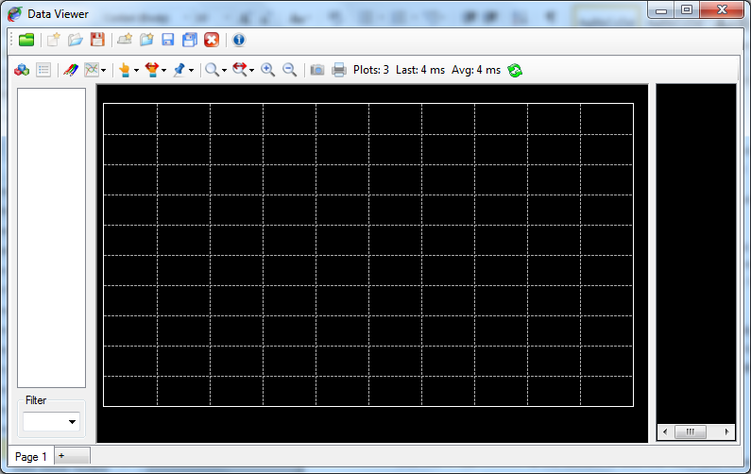

A data viewer book can contain as many pages as you wish. Each single page appears as a tab of the multi-tab panel.



Right click on a page tab to get the viewer page contextual menu.

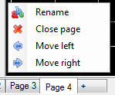

This contextual menu has four commands.

 Rename: Rename the active page of the data viewer.

 Close: Close the active page of the data viewer.

 Move left: Move the active page one step on the left.

 Move right: Move the active page one step on the right.

Click the ‘Rename’ menu  to rename a page. A text box pops up.



Write the new name for the page in this text box.



Then press the ‘Enter’ key.



Data viewer pages can be individually saved and loaded through commands available in the tool bar. The entire data viewer book can be saved as well.

An entire section of the documentation is dedicated to the usage and configuration of the graphic window. Please check this section for more details.

*Created with the Personal Edition of HelpNDoc:* [*Free EPub producer*](http://www.helpndoc.com/create-epub-ebooks)

**Data viewer Toolbar**

Tool bar of the ‘Data viewer’ window contains the following commands

 Data browser: Open the data browser window.

 New: Create new data viewer book.

 Open: Open a data viewer book.

 Save: Save the current data viewer book (all pages).

 New page: Create a new data viewer page.

 Open page: Open an existing data viewer page (only one).

 Save page: Save the current data viewer page.

 Save all pages: Save all pages of the data viewer book.

 Close page: Remove the current page from the data viewer book.

 Info: Shows event and session details of the loaded data set.

*Created with the Personal Edition of HelpNDoc:* [*Free EPub and documentation generator*](http://www.helpndoc.com)

**Data set information**

When data are displayed into the data viewer it is possible to see their record event and record session information. Click the ‘Show event/session information’ button  of the tool bar to get the information window.

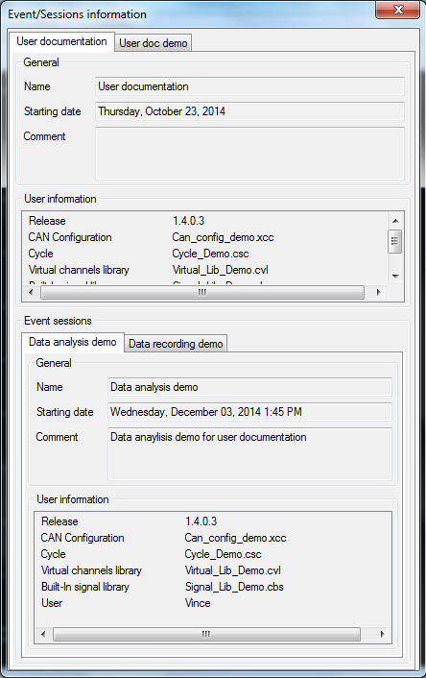

Event and session information cannot be changed from this window. They are only displayed for information purpose.

Information window contains only a multi-tab panel.

Each tab of the panel corresponds to one the record event of a data file of the current data set.



The ‘General’ section of the panel shows general information about the recording event.

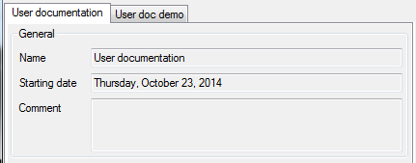

The ‘User information’ section shows all user information attached to the record event.

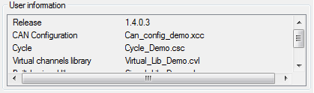

Section ‘Record sessions’ shows details of each record session being part of the current data set.

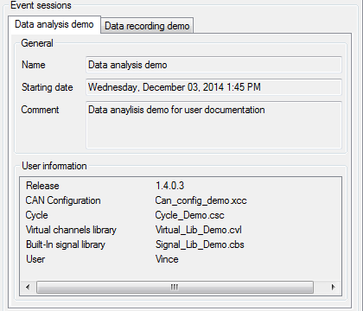

Each record session has its own tab in the ‘Event session’ section multi-tab panel.



As per record event, ‘General’ section of a record session tab shows general information about the record session.

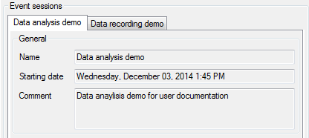

The ‘User information’ section shows all user information attached to the record session.

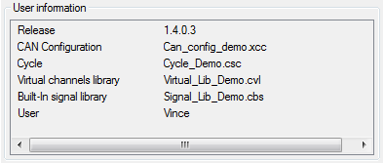

*Created with the Personal Edition of HelpNDoc:* [*Free CHM Help documentation generator*](http://www.helpndoc.com)

**Data browser**

The CANStream data browser in a data file explorer. Data that have to be displayed in the data viewer has to be loaded from this explorer.

Click the ‘Data browser’  button of the data viewer tool bar to open the data browser.

The data browser shows up.

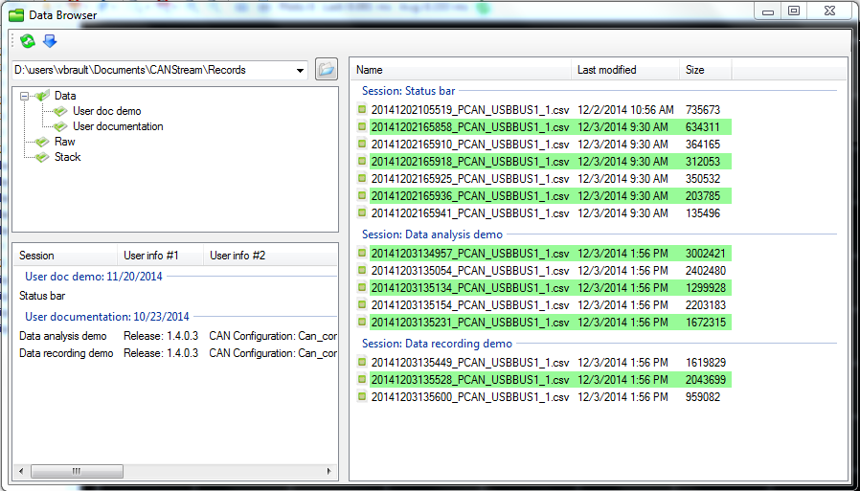

The data browser is made of four parts:

* + The tool bar: Toolbar contains only two commands, ‘Refresh’ and ‘Load’
  + The root folder tree: It shows the folder arborescence from current root folder
  + The event list: It shows all record events contained in the selected folder
  + The data file list: It shows all data files grouped by record session present in the selected folder and all its sub-folders.

*Created with the Personal Edition of HelpNDoc:* [*Full-featured Help generator*](http://www.helpndoc.com/feature-tour)

**Root folder tree**

The root folder tree shows the folder arborescence from the current root folder.

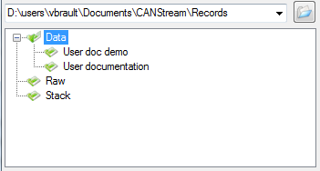

Click the ‘Open’  button to change the root folder. Root folder text box is actually a list that can be dropped in order to get the history of all root folder previously used and quickly switch among those root folders.

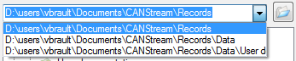

The last ten folders used as root folder are saved in this list.

Click a folder to explore its subfolders and all their child folders.

*Created with the Personal Edition of HelpNDoc:* [*Free EPub producer*](http://www.helpndoc.com/create-epub-ebooks)

**Events & sessions list**

The events and sessions list is located at the bottom of the root folder tree.

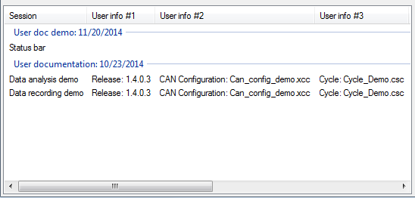

Each group of the list represents a record event.



Items of each group are a record session.

Select a session item in order to apply a filter to the logging data list and show only data file part of the selected record session.

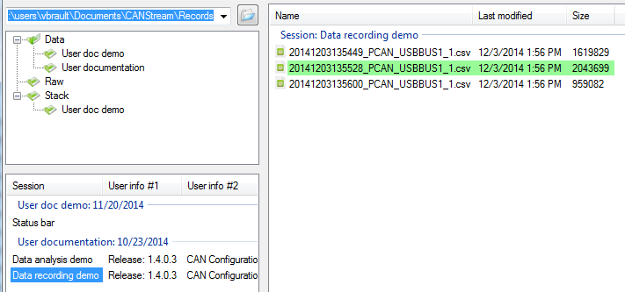

To get information about a particular record event of the list, right click one of its sessions.



Click the ‘Event details’  menu to get the information window.

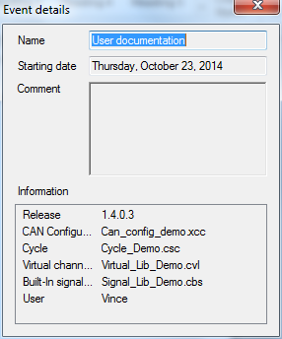

*Created with the Personal Edition of HelpNDoc:* [*Easily create EBooks*](http://www.helpndoc.com/feature-tour)

**Logging data list**

The logging data list contains actual data files that can be loaded into the data viewer window.

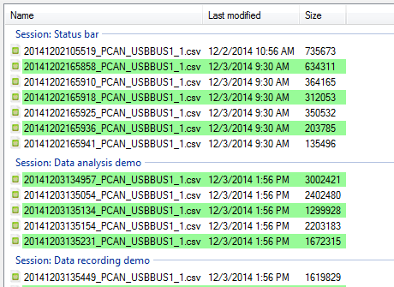

Each group of the list represents a record session.



Select all files that you want to load and press the ‘Enter’ key or click the ‘Load selected files’ button  of the tool bar.

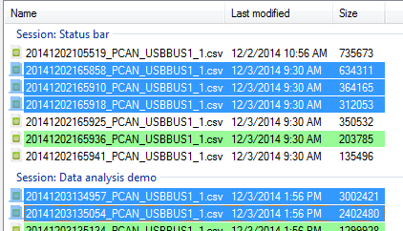

The data browser shows the two logging data formats. ‘*.csv’ files  for converted data file and ‘*.trc’ files  for raw PCAN-Trace data file.

‘*.csv’ files  only can be loaded in the data viewer. Files with such extension appear with a green background.

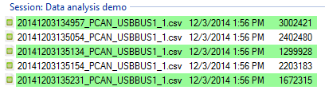

‘*.trc’ files  appear with a red background but they cannot be loaded directly into the data viewer. You need to convert those file (if it has not been done already) prior to see those data.

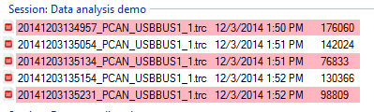

To get information about a particular record session of the list, right click one of its data files.

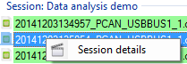

Click the ‘Session details’  menu to get the information window.

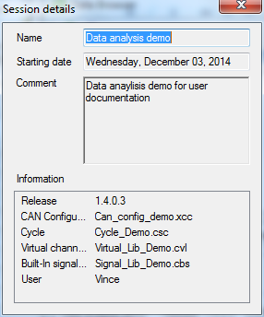

*Created with the Personal Edition of HelpNDoc:* [*Free Web Help generator*](http://www.helpndoc.com)

**Data browser tool bar**

The data browser tool bar contains only two commands.

.

 Refresh: Refresh the folder tree, event and session list as well as the data file list.

 Load: Load data files selected into the data viewer.

*Created with the Personal Edition of HelpNDoc:* [*Free help authoring tool*](http://www.helpndoc.com/help-authoring-tool)

**Graphic window**

The graphical data analysis window shows recorded data in a graphical form.

In addition of simply showing graphical data trace, the analysis window offers extensive tools such as zoom, cursors and statistics computation.

On the top of that, the graphical configuration of the analysis window is fully configurable run time. Through its intuitive configuration forms, it is possible for instance, to change the window back color or change the color of a data trace or even change its tracing mode just by simple clicks and without having to reload the data or reset the form.

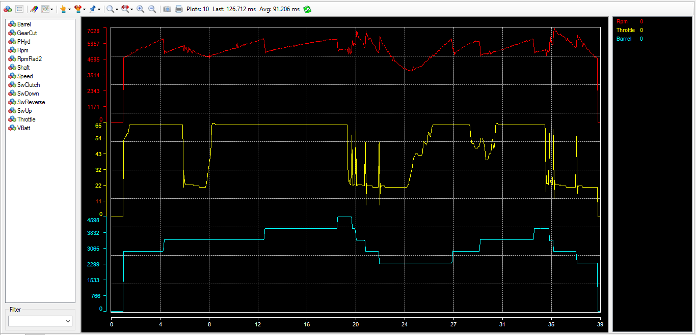

The analysis window has four main areas:

* + The graphic: where traces are drawn.
  + The channel list: On the left, where all channels available in the loaded data file are displayed.
  + The legend: On the right, where all channel plotted as well as their values, units and statistics are shown.
  + The tool bar: On the top, where all principal command of the graphic window are available.

*Created with the Personal Edition of HelpNDoc:* [*iPhone web sites made easy*](http://www.helpndoc.com/feature-tour/iphone-website-generation)

**Graphic window tool bar**

The analysis window tool bar is shown on the top of the graphic window form. It regroups main analysis window commands.

There are actually a lot more commands for the analysis windows spread into configuration forms and contextual menus.



 Channel list: Show or hide the channel list panel.

 Legend: Show or hide the graphic legend panel.

 Graphic configuration: Open the main graphic configuration form.

 Graphic layout: Change the current graphic layout (Parallel, Overlay, Custom).

 Cursor type: Change the current type of the main graph cursor.

 Cursor step: Change the current cursor step for key board arrows keys.

 Reference cursor: Reference cursor command (Set, Clear).

 Zoom mode: Change the current mode of zoom.

 Zoom factor: Change the current zoom factor of 'Zoom plus' and 'Zoom minus' functions.

 Zoom plus: Zoom plus command.

 Zoom minus: Zoom minus command.

 Snapshot: Graphic snapshot command.

 Print: Graphic print command.

*Created with the Personal Edition of HelpNDoc:* [*Write EPub books for the iPad*](http://www.helpndoc.com/create-epub-ebooks)

**Shortcut keys**

Here is a summary of all shortcuts keys of the analysis window.

|  |  |
| --- | --- |
| Key | Function |
| + | Zoom plus |
| - | Zoom minus |
| W | Zoom min (0% zoom) |
| N | Zoom max (100% zoom) |
| X | Zoom mode X |
| Y | Zoom mode Y |
| B | Zoom mode XY |
| V | Cursor vertical |
| H | Cursor horizontal |
| K | Cursor cross |
| Pg Up | Cursor step + |
| Pg Down | Cursor step - |
| R | Set reference cursor |
| ESC | Clear reference cursor |
| O | Graph layout overlay |
| P | Graph layout parallel |
| C | Graph layout custom |
| G | Graph properties edition |
| T | Show/Hide legend selected series |
| DEL | Remove legend selected series from the graph |

*Created with the Personal Edition of HelpNDoc:* [*Free PDF documentation generator*](http://www.helpndoc.com)

**Data file**

The data file format used by the analysis window is CSV (Column Separated Value)

Columns must be separated by a semi-comma character [ ; ].

Values decimal separator must be point [ . ] or comma [ , ].

First line of the file contains names of data channels.

First column must be abscisse value (X axis values).

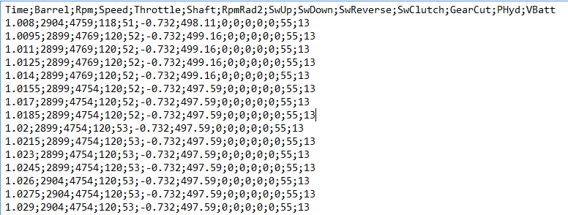

*Created with the Personal Edition of HelpNDoc:* [*Easy to use tool to create HTML Help files and Help web sites*](http://www.helpndoc.com/help-authoring-tool)

**Analysis functions**

This section regroup analysis features documentation of the graphic window.

*Created with the Personal Edition of HelpNDoc:* [*Free EPub and documentation generator*](http://www.helpndoc.com)

Main cursor

The main graphic cursor is a graphical help for analysis. It permits to point any coordinates within the graphic area.

Just click anywhere in the graphic area to make the cursor visible. Press the mouse right button and move the mouse to have the cursor following your movements. Release the mouse right button and the cursor gets fixed.

Default cursor type is 'Cross', which means that graphical cursor is taking a cross form.

There are actually seven cursor modes:

* + None: Graphical cursor is disabled.
  + Vertical line: Cursor is a vertical line following the mouse along the X axis.
  + Horizontal line: Cursor is a horizontal line following the mouse along the Y axis.
  + Cross: Cursor is cross made by a vertical and a horizontal line, lines crossing each other at the mouse location.
  + Graticule: Cursor is a small cross following the mouse inside the graphic area.
  + Square: Cursor is a small square surrounding the actual mouse location.
  + Circle: Cursor is a small circle surrounding the actual mouse location.

To change the cursor type, click on the 'Main graph cursor type' of the tool bar  and select the desired type. You can also use the 'Cursor' menu  of the graphic contextual menu (right click in the graphic area). 'Vertical line', 'Horizontal line' and 'Cross' are also available through keyboard shortcuts 'V', 'H' and 'K'.

While moving the graphic cursor, you can see in the legend that each trace value is updated with the actual value of the trace at the position of the cursor.



In addition of that, for 'Vertical', 'Horizontal' and 'Cross' cursor types, values of graphical coordinate are showed.

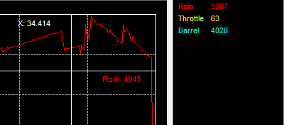

By coordinates, we mean X and Y axis values at the position of the cursor. For instance on the screen shot above, '34.414' is the value along the X axis and '4043' is the value along the Y axis which is named 'Rpm'. You may have more than one Y axis at the position of the cursor, in that case all axis values are showed.

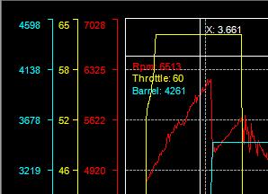

Using 'left', 'right', 'up' and 'down' arrow keys of the keyboard you can move the cursor to the direction you want. Obviously, 'up' and 'down' movements are disabled for the 'Vertical line' cursor type, while 'left' and 'right' are disabled for the 'Horizontal line' type.

By setting the 'Cursor step' you can define how big (or small) cursor movement will be for each arrow key press event.

To change the cursor step, click the 'Main cursor step' button  of the tool bar and select the step you want. This command is also available through the graphic contextual menu, under the 'Cursor \ Cursor step' menu. You may also use 'Page Up' and 'Page Down' keys to change the cursor step.

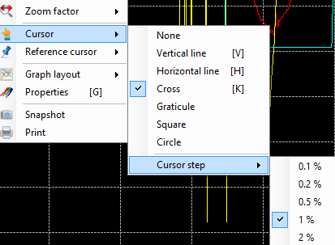

Cursor step values are percentage values... OK but percentage of what ? Good question !

Step values are percentage of the current X axis values span. For example, if 100 seconds of data are plotted and the cursor step is 1%, the cursor will move by step of 1 second.

For Y axis, since it could be several different values here, screen size is used as reference value. In other words, with a cursor step of 1%, cursor will move up and down by steps representing 1% of the screen size.

Graphical properties of the graphic cursor (color, size) can be adjusted through the graphic configuration form. Please check the 'Cursors properties' section for more details.

*Created with the Personal Edition of HelpNDoc:* [*Free Kindle producer*](http://www.helpndoc.com/feature-tour/create-ebooks-for-amazon-kindle)

Reference cursor

The reference cursor is an extension of the 'Main cursor' function. It permits to compare values of all traces between two particular points in the graphic.

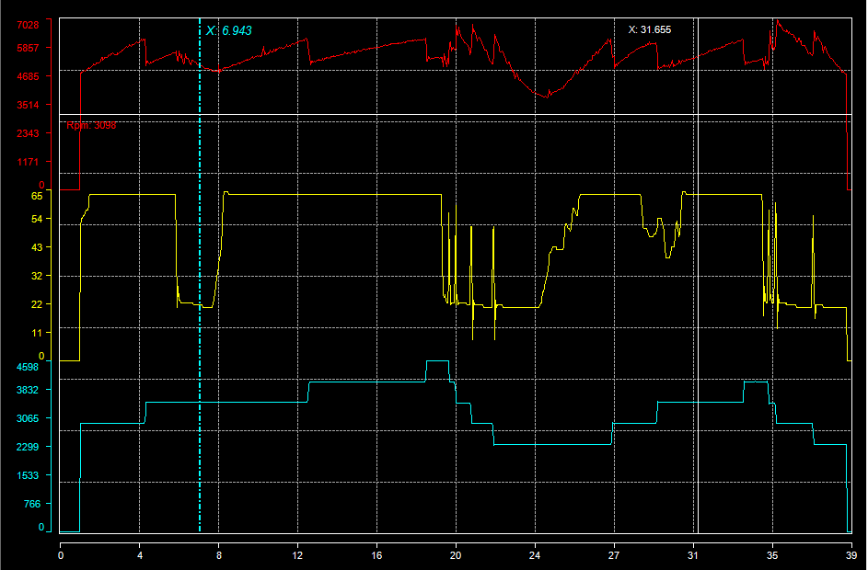

Click on the 'Reference cursor  \ Set' menu of tool bar to set the reference cursor position. This function is also accessible in the 'Reference Cursor\Set' command of the graphic window contextual menu, or by pressing the 'R' key of the keyboard.

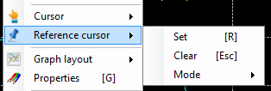

Place the reference at the position of your choice and then click the 'Reference cursor  \ Lock' command of the tool bar or the 'Reference Cursor\Lock' command of the graphic window contextual menu, or by press the 'Enter' to lock the reference cursor position and get the main cursor back on.

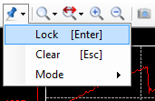

Main cursor being back, it can be place anywhere in the graph in order to compare the main cursor value and the reference cursor value.

Finally, once done with the comparison, click the 'Reference cursor  \ Clear' command of the tool bar or the 'Reference Cursor\Clear' command of the graphic window contextual menu, or by press the 'Escape' to clear the reference cursor.

The biggest benefit of the reference cursor is that it shows both reference and main cursor values in the legend, leading to have a direct cursors value comparison.

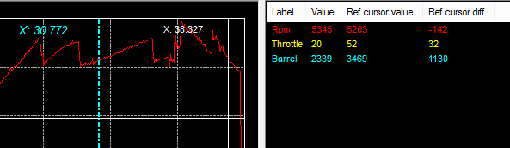

When the reference cursor is active, four statistics are added to the legend:

* + Reference cursor value: The actual value of the trace at the reference cursor position.
  + Reference cursor value difference: The difference in value between the main and the reference cursor.
  + Reference cursor value difference percentage: The difference in percentage of the reference value between the main and the reference cursors values.
  + Reference cursor gradient: Value the gradient between the main and the reference cursor values. Gradient being defined as the difference in value over cursors X axis values difference.

There are three kinds of reference cursor:

* + None: Reference cursor is disabled.
  + Vertical: Reference cursor is a vertical line. This mode is intended to be used with any main cursor type except the 'Horizontal line' main cursor type.
  + Horizontal: Reference cursor is a horizontal line. This mode is intended to be used with any main cursor type except the 'Vertical line' main cursor type.

Use the 'Reference cursor  \ Mode' command of the tool bar or the 'Reference Cursor\Mode' command of the graphic window contextual menu to change the current reference cursor type.

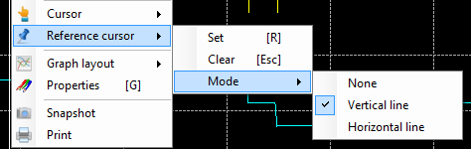

As per the main cursor, the reference cursor aspect can be customized in the graphic configuration form. Please check the 'Cursors properties' section for more details.

*Created with the Personal Edition of HelpNDoc:* [*Free help authoring tool*](http://www.helpndoc.com/help-authoring-tool)

Zoom

As per its name definition, zoom is a function permitting to zoom a particular graphic area and see traces of this area with greater details.

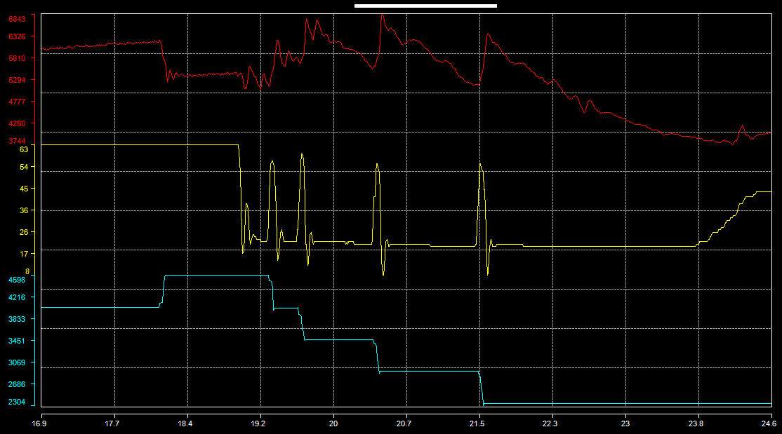

To zoom a particular area of the graphic, place the mouse cursor at the beginning, or at the end, of the area you want zoom in. Press the right mouse button and then drag the zoom box up the end of the zoom area. When the zoom area is defined click the 'Zoom' command of the contextual menu that pops up on the right mouse button release.

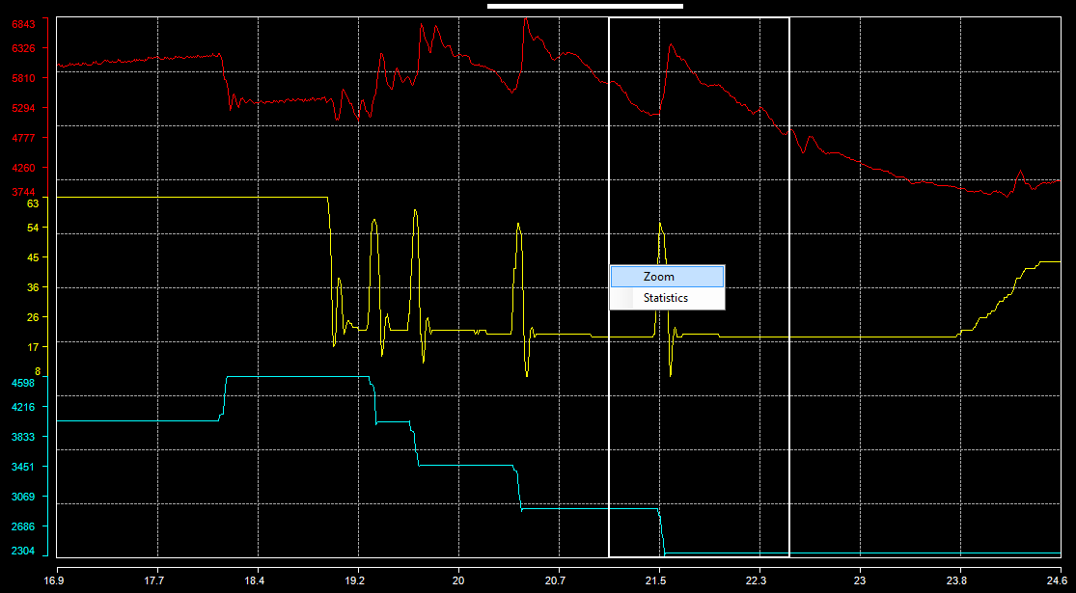

Four different zoom modes are available:

* + Disabled: Zoom function is disabled.
  + Zoom X: Zoom is performed along the X axis only, Y axis being unchanged.
  + Zoom Y: Zoom is performed along the Y axis only, X axis being unchanged.
  + Zoom XY: Zoom is performed along both X and Y axis.

To switch to a different zoom mode, click the 'Zoom Mode'  command of the tool bar or the 'Zoom mode'  command of the graphic window contextual menu.

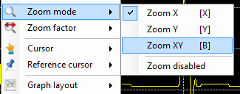

An alternative solution is to use zoom mode shortcut keys 'X', 'Y', 'B' for 'Zoom X', 'Zoom Y' and 'Zoom XY'.

Another way to zoom a graphic in and out is to use 'Zoom +'  and 'Zoom -'  functions. Both of those functions are available either in the tool bar or in the graphic window contextual menu. They are also accessible by pressing '+' and '-' keys of the keyboard for 'Zoom +' and 'Zoom -'.

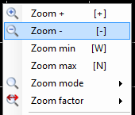

With this kind of zoom, the zoom area is defined by a factor applied around the main graphic cursor position. If the main graphic cursor is not set, the center of the screen is used as reference position.

The zoom factor can defined either through the 'Zoom factor'  button of the tool bar or through the 'Zoom factor'  item of the graphic window contextual menu.

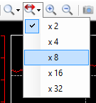

The zoom factor value represents the magnitude of zoom as a function of X axis values span (for zoom X and zoom XY) and the screen height (for zoom Y and zoom XY).

For example, if 80 seconds of data are plotted and the zoom factor is set to 'x 8', in the case of the 'Zoom X' mode, the X axis values span resulting of the zoom will be eight time smaller than the original span. So 80 / 8 = 10 sec.

In the case of a zoom out, the X axis values span will be eight time bigger than the original one. So 10 x 8 = 80 sec.

The third and last method to zoom in and out is to use 'Zoom min' and 'Zoom max' functions. Those functions are not available in the tool bar (for clarity) but they are in the graphic window contextual menu and through the shortcut keys 'W' and 'N' for 'Zoom min' and 'Zoom max'.

The 'Zoom min' will revert to a zoom magnitude of 1, so the whole data will be shown as if there wasn't any zoom. While 'Zoom max' will do the exact opposite and apply the biggest zoom factor (x 32).

While the zoom function is operating, X and Y zoom bars are shown.

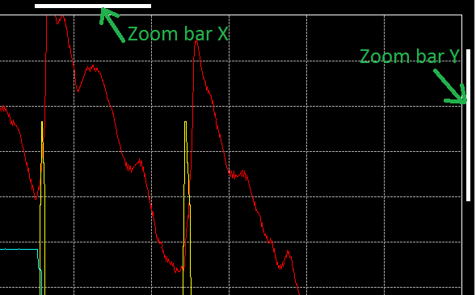

Obviously, the 'Zoom bar X' is shown only if the X axis is zoomed, so it won't be shown in 'Zoom Y' mode and the 'Zoom bar Y' is shown only if the Y axis is zoomed, so it won't be shown in 'Zoom X' mode.

Those zoom bars indicate two things:

* + The magnitude of the zoom: bar width (for the zoom bar X) and bar height (for the zoom bar Y) are function of the zoom magnitude.

If the zoom factor is set to 'x 8', zoom bar X width will be eight time smaller than the whole graphic area width. The same logic is used for the zoom bar Y, with a zoom factor of 8, zoom bar Y height will be eight time smaller than the whole graphic area height.

* + The position of zoomed area: bar left position (for zoom bar X) and bar top position (for the zoom bar Y) are function of the zoomed area position

if the whole data length is 60 seconds and the zoom area starts at the second 30, zoom bar X left position will right on the middle of the graphic area. The same logic applies as well for the zoom bar Y.

Zoom bar X and Y have also second purpose, they can be moved by user in order to move the zooming area.

Place the mouse cursor over one zoom bar and the cursor will transform either in 'east-west arrows' cursor for the zoom bar X or in 'north-south arrows' cursors for the zoom bar Y. Press the mouse right button and drag the zoom bar at the position you want to change the zooming area.

*Created with the Personal Edition of HelpNDoc:* [*Easily create Help documents*](http://www.helpndoc.com/feature-tour)

Statistics

Another useful feature of the analysis window is statistics computation.

As per the zoom function, right click is graphic area and drag the zoom box up to end of area in which you want compute statistics. Release the mouse right button and click the 'Statistics' command of the contextual menu that has popped up. Prior to do that, make sure the zoom mode is not 'Zoom disabled', otherwise the zoom box will not appear.

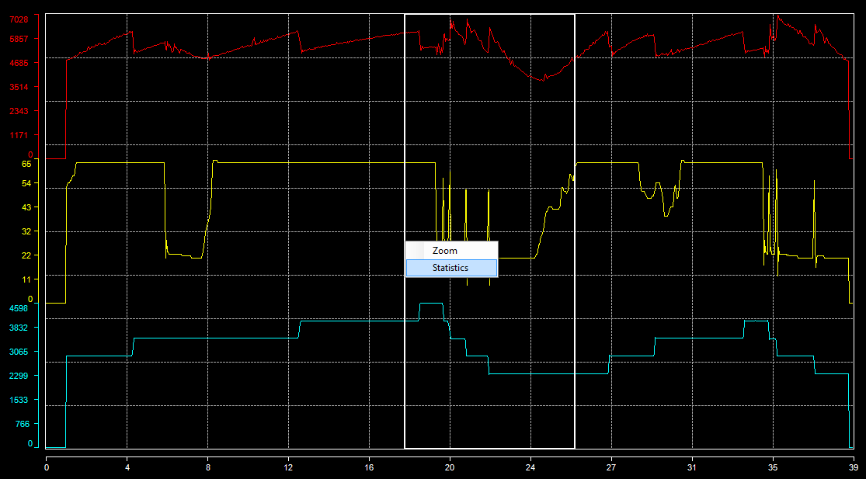

The statistics window appears.

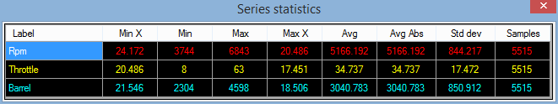

In this statistics windows we can find different statistics about plotted data

* + Min X: X axis value at the minimum trace value.
  + Min: Minimum value of the trace inside the zoom box.
  + Max: Maximum value of the trace inside the zoom box.
  + Max X: X axis value at the maximum trace value.
  + Avg: Average of all trace values inside the zoom box.
  + Avg abs: Average of all trace absolute values inside the zoom box.
  + Std dev: Standard deviation of all trace values inside the zoom box.
  + Samples: Trace samples count used for statistics computation.

Those statistics can even be copied into the Windows clipboard in order to be pasted into an external application such as Microsoft Excel.

Select all cells of the statistics grid that are of your interest and press Ctrl+C on your keyboard. All selected cells values are now in the Windows clipboard and are ready to be used in any application accessing the clipboard.

*Created with the Personal Edition of HelpNDoc:* [*Full-featured Documentation generator*](http://www.helpndoc.com)

Legend

As briefly explained in the 'Main cursor' and 'Reference cursor' sections, legend shows plotted trace values at the position of the main cursor.



If you make a right-click on the legend, the legend contextual menu will pop up and shows all available legend options.

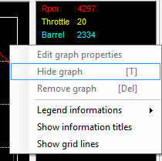

The 'Legend information' menu propose you to define what information you want to see in the legend.

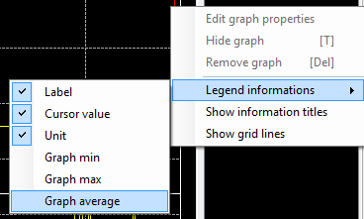

There are six information that you can make visible or invisible. Just check infos that you want to see, unchecked info will be invisible.

* + Label: Titles of the graphic traces set into the graphic configuration form.
  + Cursor value: Traces values at the position of the main cursor.
  + Unit: Trace units set set into the graphic configuration form.
  + Graph min: Traces minimum value visible in the graphic area.
  + Graph max: Traces maximum value visible in the graphic area.
  + Graph average: Traces average value of all sample visible in the graphic area.

In case of the reference cursor function usage, there are an extra bunch of infos that you can make visible.

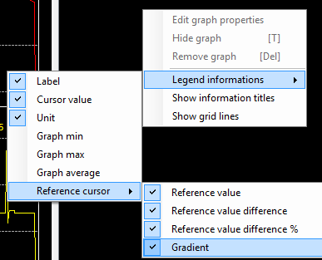

* + Reference cursor value: The actual value of the trace at the reference cursor position.
  + Reference cursor value difference: The difference in value between the main and the reference cursor.
  + Reference cursor value difference percentage: The difference in percentage of the reference value between the main and the reference cursors values.
  + Reference cursor gradient: Value the gradient between the main and the reference cursor values. Gradient being defined as the difference in value over cursors X axis values difference.

Menus 'Show legend information titles' and 'Show grid lines' permit to show and hide the legend header and legend grid lines.

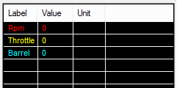

A right-click on a legend item will enabled trace related function of the legend.

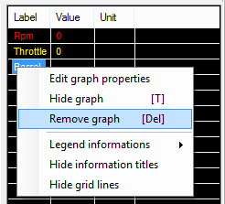

Menu 'Edit graph properties' will open the selected trace 'Detailed serie properties' windows in order to fine tune graphical properties of a particular trace.

'Hide graph' command will hide the selected trace in the graphic area. Alternatively, once a trace hidden, this menu becomes 'Show graph' in order to re-enable a hidden trace. This command is also available by pressing the 'T' key of the keyboard.

'Remove graph' will definitively remove a trace from the graphic area. Be careful, this operation is not revertible ! Once a trace removed it is gone for ever and you will have to add it into the graph again.

The legend panel can be hidden at any time by clicking the 'Show/Hide legend' button  of the tool bar. Once hidden click again the 'Show/Hide legend' button  to re-open the legend panel.

Some more legend properties can be adjusted through the graphic configuration form. Please check the 'General properties' section for more details.

*Created with the Personal Edition of HelpNDoc:* [*Create iPhone web-based documentation*](http://www.helpndoc.com/feature-tour/iphone-website-generation)

Snapshot

Snapshot function makes a picture of your graphic that can be reused in a presentation, or an email or anything else.

Snapshot outputs a bitmap picture file (*.bmp), this picture including legend but excluding the channel list.

To make a snapshot of your graphic, simply click the 'Make a snapshot image of the graphic' , set the name and path of the output picture in the file saving dialog and click 'Save'.

Example of a graphic snapshot.

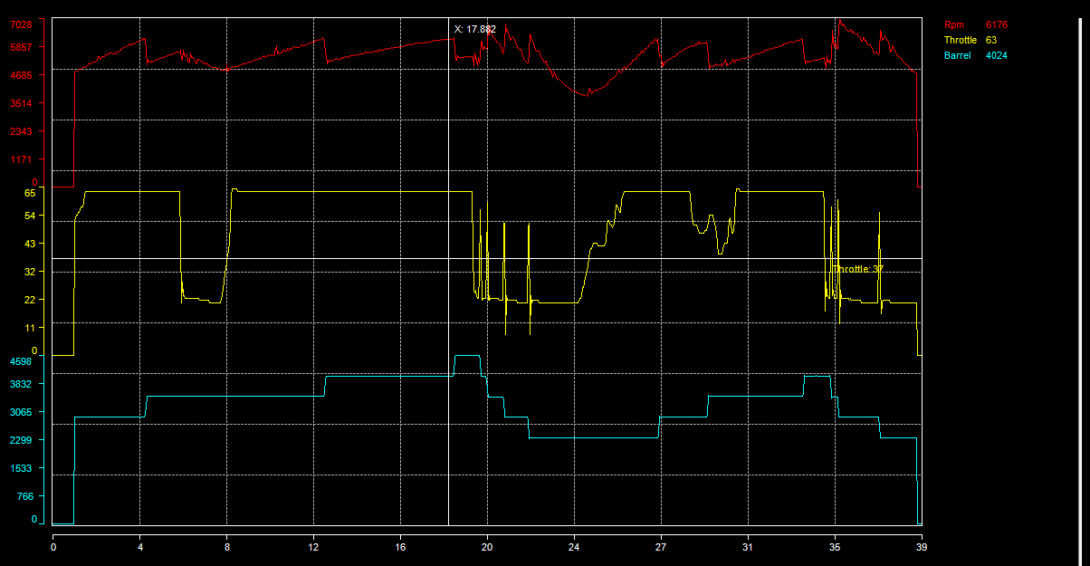

*Created with the Personal Edition of HelpNDoc:* [*Easy EPub and documentation editor*](http://www.helpndoc.com)

Print

The 'Print' function permits to print your graphic out.

Click the 'Print graphic'  button to open the print preview window.

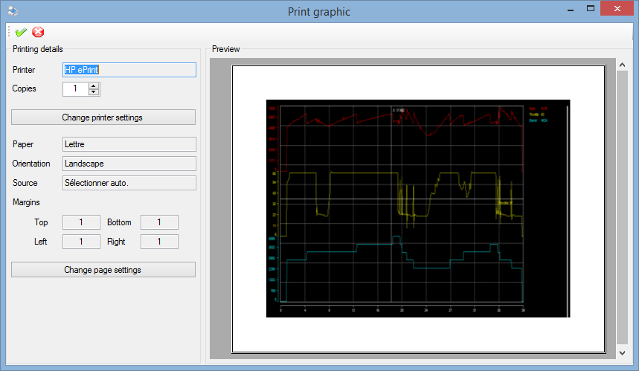

The right side panel of print preview form contains printing details such as printer name, number of copies, paper format and orientation.

The left side panel shows an actual preview of the document as it will be once printed out.

Set the number of copies to print in the field 'Copies'. To change the printer and its properties, click the 'Change printer settings' button.

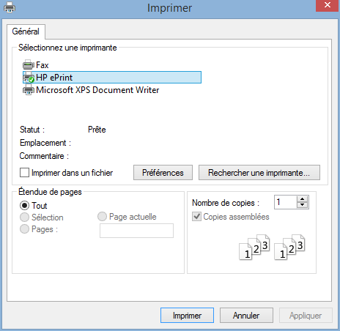

Click the 'Change page settings' button to change paper orientation or adjust margins.

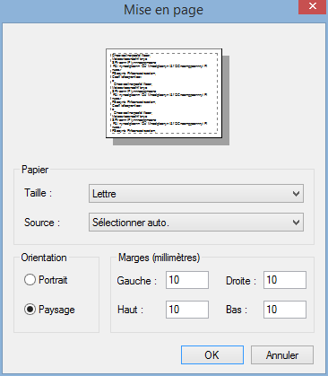

Once done with all settings, click the 'Print'  button to print the page.

The 'Cancel'  button, simply close the form. It doesn't cancel the printing request if such request has been sent to a printer.

*Created with the Personal Edition of HelpNDoc:* [*Create iPhone web-based documentation*](http://www.helpndoc.com/feature-tour/iphone-website-generation)

**Graphic window settings**

This section regroup graphical properties configuration documentation of the graphic window.

*Created with the Personal Edition of HelpNDoc:* [*Easily create PDF Help documents*](http://www.helpndoc.com/feature-tour)

Channel list

The channel list shows the list of data channels contained in the data file loaded.

Channel list is located in the left side panel of the analysis window. It is visible by default but it can be hidden by clicking on the 'Show/Hide channel list'  button of the tool bar. Once hidden, click again on this button to get the channel list back.

Double click on a channel to add it in the graphic. This can also be done by a 'drag & drop' of a channel (or a bunch of channels) from the channel list to the graphic area.

Alternatively, select channels that you want to add in the graphic and press 'Enter'.

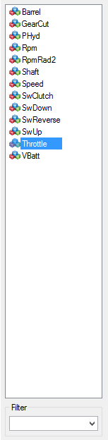

At the bottom of the channel list there is the 'Filter' area. This area permits to filter channel names shown in the list. Just type a name or a part of a name that you are looking for and press enter. If the character sting that you typed in is contained into one or more channels, only those channels will be shown in the list.

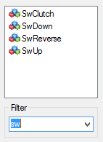

Filter is text box is actually a list that stores the last ten filters used. Just select that filter to reuse it.

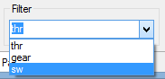

Clear the filter text box to reset the filter and get back the whole channel list.

*Created with the Personal Edition of HelpNDoc:* [*Easy to use tool to create HTML Help files and Help web sites*](http://www.helpndoc.com/help-authoring-tool)

Graphic layout

Term 'graphic layout' means the way graphic series (or traces) are set into the graphic.

There are three possible layouts:

* + Overlay: All series are overlaying each other on the full graphic area height.
  + Parallel: Series are evenly arranged onto the graphic area.

If there are four series to plot, each serie will be plotted over 25% of the whole graphic area height. If there are five series, each serie will use 20% of the graphic height, 10% for ten series, so forth and so on...

* + Custom: Series top and bottom position are defined by the user.

Series are not necessarily evenly set, a serie can fully or partially overlap one or more series.

Click the 'Graphic layout mode'  button of the tool bar to change the current layout. This command is also available through the 'Graph layout'  item of the graphic contextual menu.

Layout mode can also be changed using 'O', 'P' and 'C' shortcut keys for 'Overlay', 'Parallel' and 'Custom' modes.

Graphic in 'Overlay' layout mode:

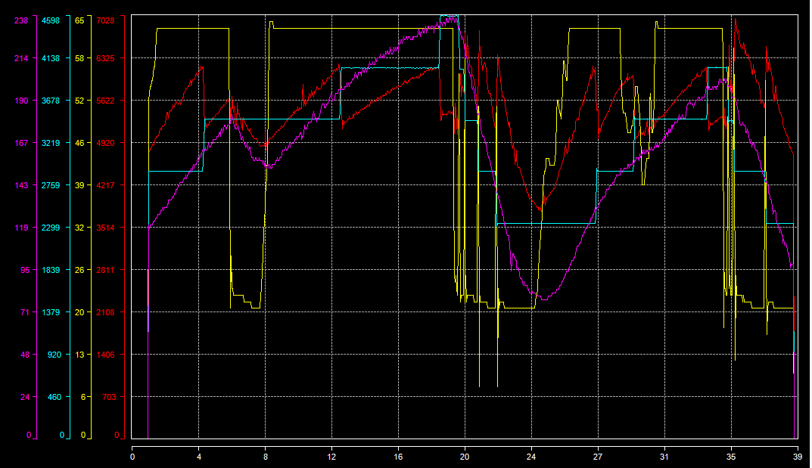

Graphic in 'Parallel' layout mode:

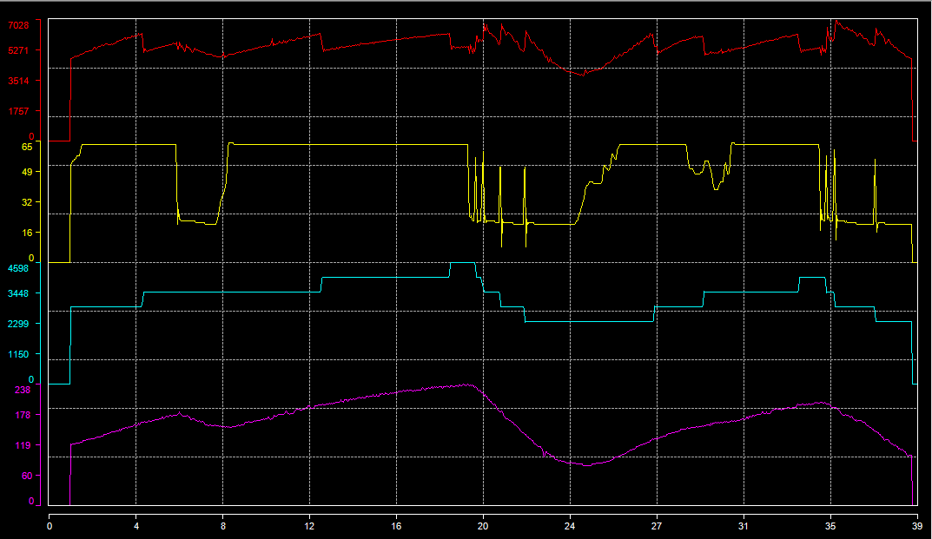

Graphic in 'Custom' layout mode:

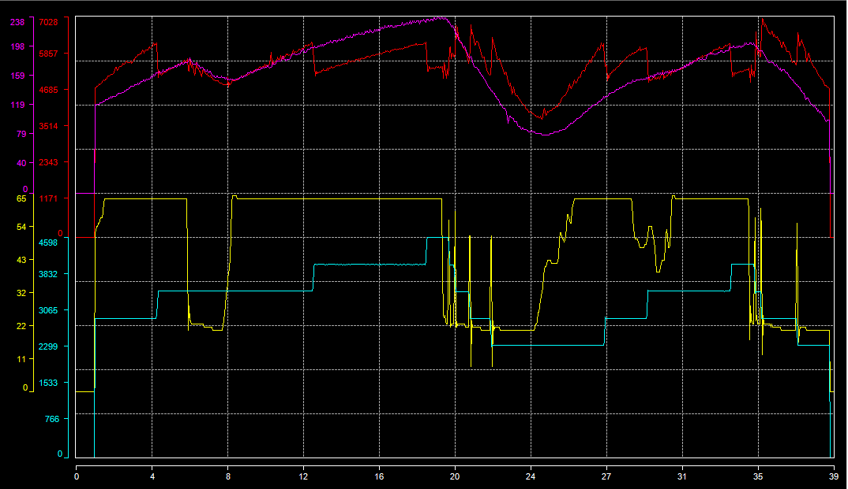

*Created with the Personal Edition of HelpNDoc:* [*Easy CHM and documentation editor*](http://www.helpndoc.com)

Graphic configuration

The graphic configuration window permits to edit all properties related to the the graphic window.

Click the 'Edit graph properties'  button of the tool bar to open the graphic configuration window. This command is also available through the 'Properties'  item of the graphic contextual menu. Alternatively, press the 'G' key of the keyboard to open the configuration window.

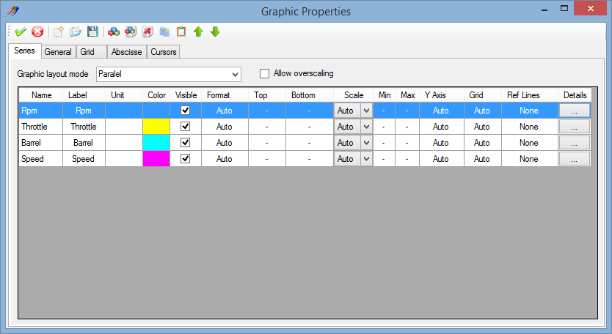

The graphic configuration window is composed by a tool bar and a multi-tabs window.

Each tab of the multi-tab is dedicated to a particular configuration section. There five different sections:

* + Series: Generic properties of the graph series (or trace).
  + General: General properties of the graphic window.
  + Grid: Graphic window grids properties.
  + Abscisse: Properties related to the graphic abscisse (X axis).
  + Cursors: Graphic properties of main and reference cursors.

Tool bar contains most common configuration commands.

 Apply: Apply graphic configuration changes.

 Cancel: Cancel graphic configuration changes.

 New: Create a new graphic configuration file.

 Open: Open a graphic configuration file (*xgw).

 Save: Save the graphic configuration file (*.xgw).

Check the 'Generic series properties' section for details of the rest of tool bar commands

*Created with the Personal Edition of HelpNDoc:* [*Single source CHM, PDF, DOC and HTML Help creation*](http://www.helpndoc.com/help-authoring-tool)

Generic series properties

The 'Series' tab of the graphic configuration window contains generic properties of graphic series (or trace)

List graphic layout mode permits to change the current layout mode of the graphic.

All graphic series (or traces) are shown is the series grid.



First cell apart, all cells value can be modified in order to set a particular property of a graphic serie.

* + Name: Name of data channel as shown in the channel list used as data source of the serie.
  + Label: Title of the serie in the graphic legend.
  + Unit: Serie value unit shown is the graphic legend.
  + Color: Trace color of the serie in the graphic and in the legend.
  + Visible: Serie visible flag. Check the box to make the serie visible, uncheck it to hide the serie.
  + Format: Double click on this cell to open the serie value format dialog.
  + Top: Serie top position in the graphic area. This setting is only available with the 'Custom' layout mode.
  + Bottom: Serie bottom position in the graphic area. This setting is only available with the 'Custom' layout mode.
  + Scale: Serie scaling mode, either 'Auto' or 'Manual'. See 'General serie properties' section for more details.
  + Y Axis: Double click on this cell to open the serie Y axis properties setting dialog.
  + Grid: Double click on this cell to open the serie custom grid properties setting dialog.
  + Ref lines: Double click on this cell to open the serie reference lines properties setting dialog.
  + Details: Click on this cell to open the whole detailed serie properties dialog.

Some commands of tool bar are specific to the 'Series' tab.

 Channel list: Open the channel list to add graphic series.

 Create serie: Create new graphic serie.

 Delete serie: Delete a graphic serie.

 Copy: Copy a graph serie.

 Past: Past a graph serie.

 Move up: Move a serie up in the grid.

 Move down: Move a serie down in the grid.

Check box 'Allow overscaling' enable over scaling for all graphic series.

Over scaling is applied on series only for the 'Manual' serie scaling mode. If the scale span set by the user is smaller than the actual serie values span, the 'Overscaling' flag will defined whether or not, out of scale sample should be drawn on the graphic.

Non over scaled graphic:

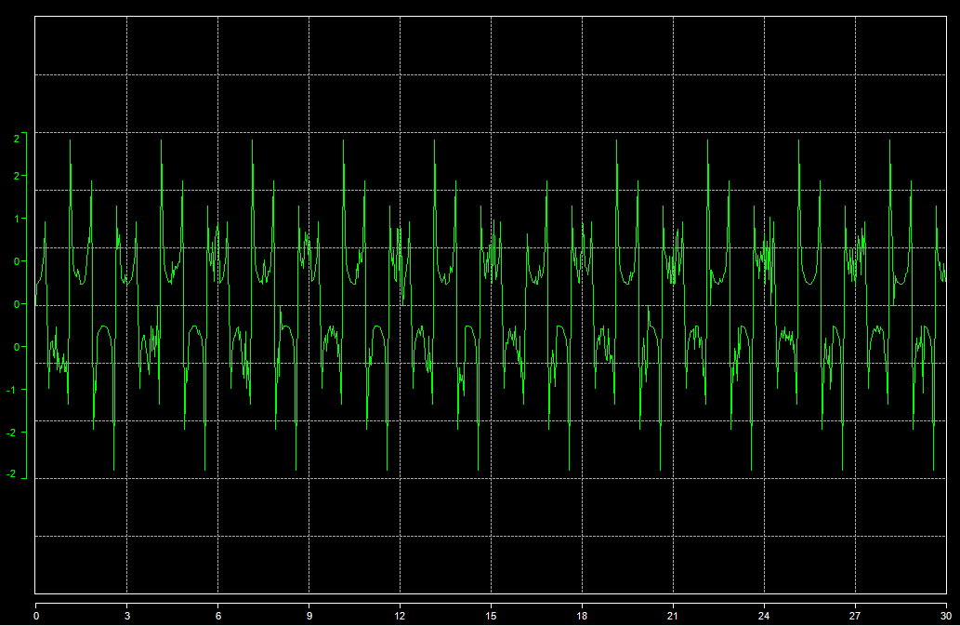

Over scaled graphic:

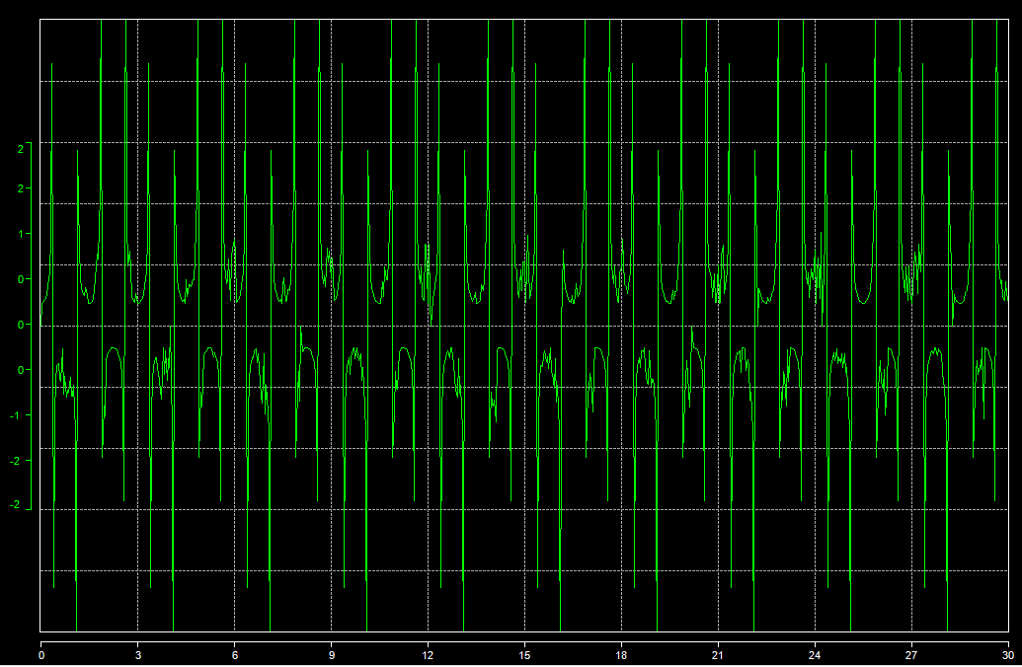

*Created with the Personal Edition of HelpNDoc:* [*Full-featured EPub generator*](http://www.helpndoc.com/create-epub-ebooks)

General properties

The 'General' tab contains general graph window properties.

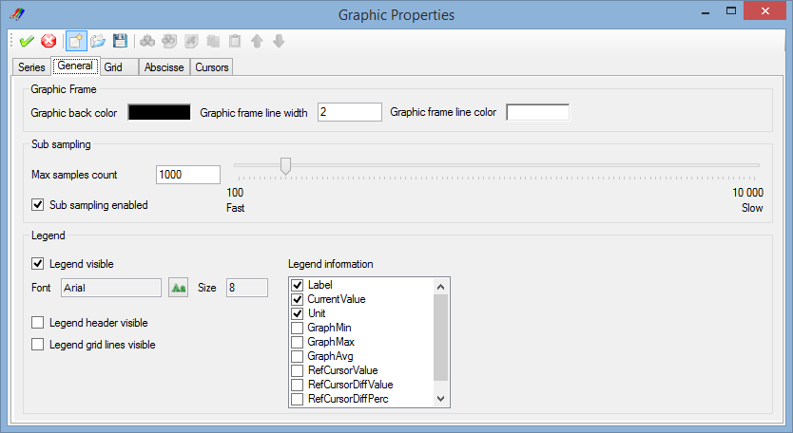

### Graphic frame

This panel contains properties of the graphic frame

* + Window back color: Double click on the colored square to open the color selection dialog and define the graph window back color.
  + Graphic frame line width: Set the desired width of the graphic frame lines.
  + Graphic frame line color: Double click on the colored square to open the color selection dialog and define the graphic frame lines color.

### Sub sampling

Sub sampling property defines the maximum number of samples that will drawn in the graphic for each serie.

In order to accelerate graphic drawing, number of samples drawn can be limited to a certain value that keeps drawing time within a reasonable limit without altering the graphic accuracy. Bigger is the drawn samples count longer will be the graphic drawing.

Tick the 'Sub sampling enabled' box to enable the sub sampling and move the sub sampling cursor or type a value into the 'Max samples count' text box to define the sub sampling level.

Sub sampling set to 100 (100 samples drawn).

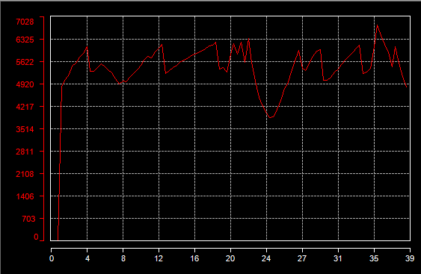

Sub sampling disabled (26 000 samples drawn).

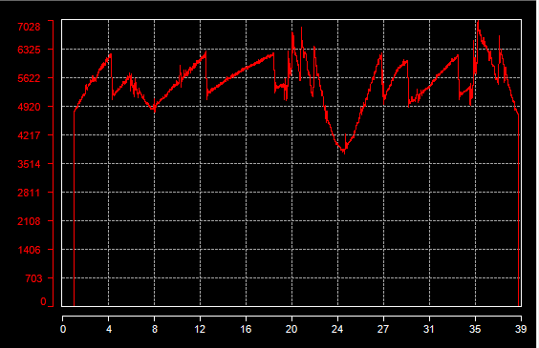

### Legend

In addition of legend properties that can be directly set in the graphic window (infos and header/grid lines visible), it is here possible to change the font used for legend items.

Click the 'Font'  button to open the font selection dialog, select a font and set its size and attributes and click 'OK'.

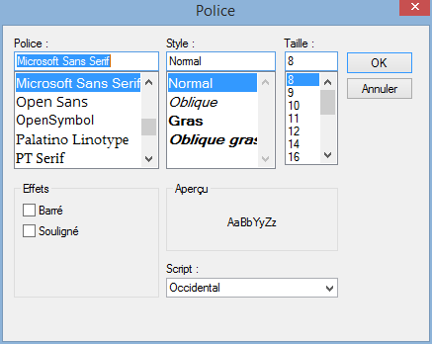

*Created with the Personal Edition of HelpNDoc:* [*Easily create CHM Help documents*](http://www.helpndoc.com/feature-tour)

Graphic grids properties

In order to enhance the analysis experience, vertical and horizontal grids are drawn in background of the graphic area.

There are two kinds of grid:

* + Main grid: Main grid (horizontal and vertical) chops the graphic area in ten parts.
  + Secondary grid: Secondary grid (horizontal and vertical) chops the graphic area in twenty parts.

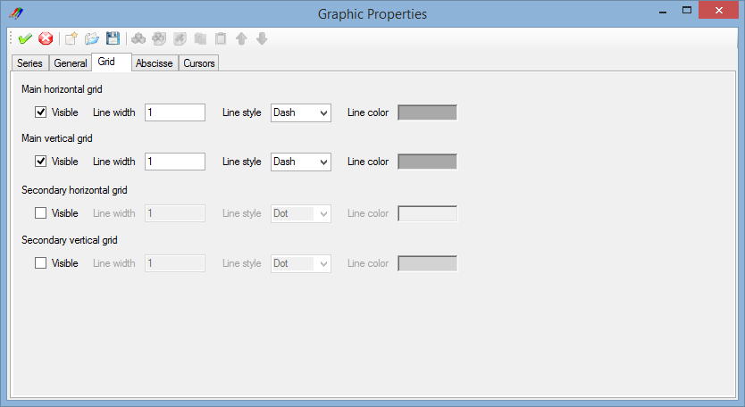

Each single grid (main/secondary, horizontal/vertical) can be individually set.

* + Visible: Check the 'Visible' box to make the grid visible.
  + Line width: Set the width of the grid line.
  + Line style: Set the line style of the grid line. Check 'Line styles' section for details.
  + Line color: Double click the colored area to open the color selection dialog and select the grid line color.

*Created with the Personal Edition of HelpNDoc:* [*Free EPub producer*](http://www.helpndoc.com/create-epub-ebooks)

Abscisse properties

The 'Abscisse' tab contains graph window abscisse (X axis) properties

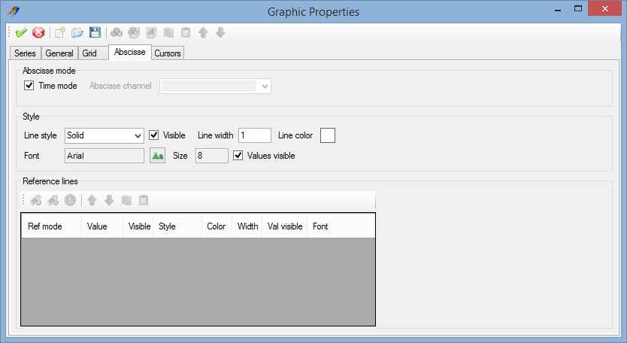

### Abscisse mode

By default graphic uses the first channel of the data file (the time basically) as values for the X axis. It is however possible to choose another data channel as data source for the X axis.

Uncheck the 'Time mode' box and pick a channel up in the 'Abscisse channel' list to use it as X axis data source.

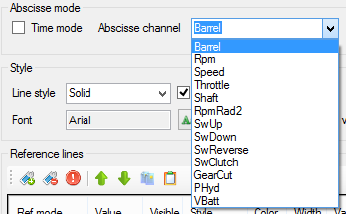

### Style

This panels regroup X axis aspect properties

* + Line style: Select the X axis line style. Check 'Line styles' section for details.
  + Visible: Check/uncheck this box the make the X axis visible or invisible.
  + Line width: Set the width of the X axis line.
  + Line color: Double click the colored square to open the color selection dialog and select the X axis line color.
  + Font: Click the 'Font' button to open the font selection dialog, select a font and set its size and attributes and click 'OK'.
  + Values visible: Check/uncheck this box the make the X axis values visible or invisible.

Example of a customized X axis.

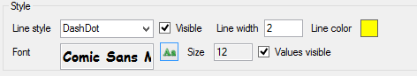



### Reference lines

Abscisse reference lines are available only if the abscisse time mode is disabled.

Manage X axis reference lines from this panel. Check 'Serie reference lines' section for more details.

Example of graphic using abscisse reference line.

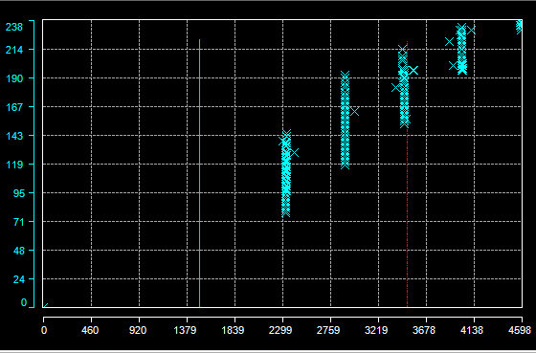

*Created with the Personal Edition of HelpNDoc:* [*Full-featured EBook editor*](http://www.helpndoc.com/create-epub-ebooks)

Cursors properties

The 'Cursors' tab contains graph cursors properties.

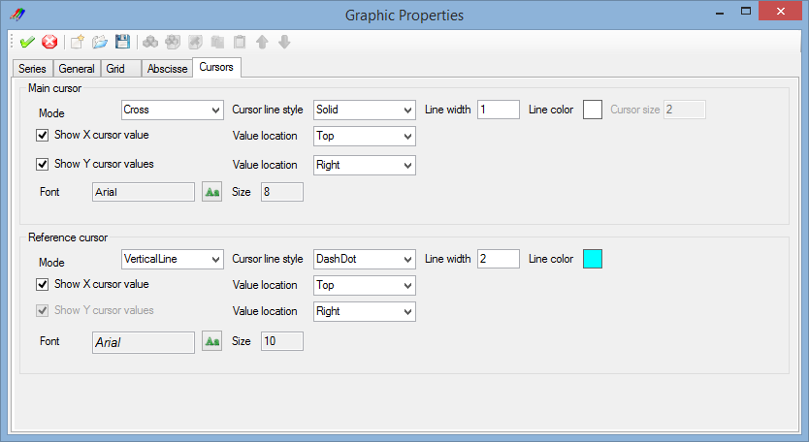

### Main cursor

In addition of main cursor properties that can be directly set in the graphic window, it is here possible to change the graphical aspect of the main cursor.

* + Mode: Select in this list the main cursor mode.
  + Line style: Select the cursor line style. Check 'Line styles' section for details.
  + Line width: Set the width of the cursor line.
  + Line color: Double click the colored square to open the color selection dialog and select the cursor line color.
  + Show X value: Check/uncheck this box the make the cursor X value visible or invisible.
  + Show Y values: Check/uncheck this box the make the cursor Y values visible or invisible.
  + X cursor value location: Set the location (left, right or center) of the cursor X value.
  + Y cursor values location: Set the location (top, bottom or center) of the cursor X values.
  + Font: Click the 'Font' button to open the font selection dialog, select a font and set its size and attributes and click 'OK'.

### Reference cursor

In addition of reference cursor properties that can be directly set in the graphic window, it is here possible to change the graphical aspect of the reference cursor.

* + Mode: Select in this list the main cursor mode.
  + Line style: Select the cursor line style. Check 'Line styles' section for details.
  + Line width: Set the width of the cursor line.
  + Line color: Double click the colored square to open the color selection dialog and select the cursor line color.
  + Cursor size: Only available for 'Graticule', 'Square' and 'Circle' modes, set the size of the cursor.
  + Show X value: Check/uncheck this box the make the cursor X value visible or invisible.
  + Show Y values: Check/uncheck this box the make the cursor Y values visible or invisible.
  + X cursor value location: Set the location (left, right or center) of the cursor X value.
  + Y cursor values location: Set the location (top, bottom or center) of the cursor X values.
  + Font: Click the 'Font' button to open the font selection dialog, select a font and set its size and attributes and click 'OK'.

*Created with the Personal Edition of HelpNDoc:* [*Full-featured Documentation generator*](http://www.helpndoc.com)

Graphic serie detailed configuration window

The graphic serie detailed configuration window permits to edit all properties related to a graphic serie.

To open this form, double click on a serie in the legend, or open the 'Graphic window configuration' form and click the 'Details' button of a serie in the 'Series' configuration tab.

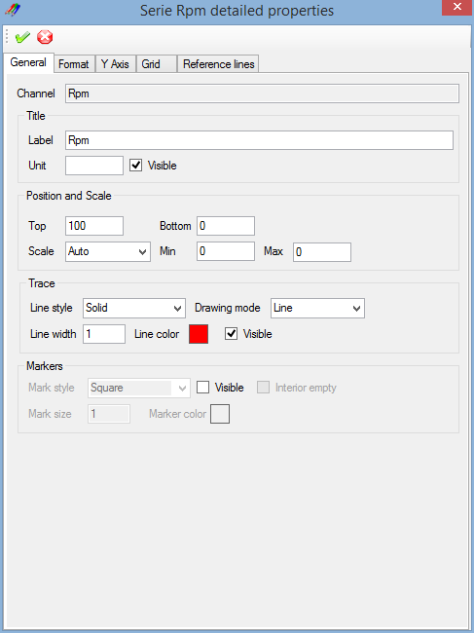

The graphic configuration window is composed by a tool bar and a multi-tabs window.

Each tab of the multi-tab is dedicated to a particular configuration section. There five different sections:

* + General: General properties of the graphic serie.
  + Format: Serie value format properties.
  + Y Axis: Serie Y axis properties.
  + Grid : Serie custom grid properties.
  + Reference lines: Serie reference lines properties.

Tool bar contains most common configuration commands.

 Apply: Apply graphic configuration changes.

 Cancel: Cancel graphic configuration changes.

*Created with the Personal Edition of HelpNDoc:* [*Free iPhone documentation generator*](http://www.helpndoc.com/feature-tour/iphone-website-generation)

Serie general properties

As per the 'Generic series properties' panel of the 'Graphic window configuration' form, this regroups main serie properties, but not only.

Graphical trace aspect can be fully customized from this panel.



### Channel

Content of this text box cannot be modified, it only shows the data channel source of the serie.

### Title

This panel contains legend properties of the serie.

* + Label: Title of the serie shown in the legend. Label can be different than the name of the data channel.
  + Unit: Serie value unit.
  + Visible: Master visibility switch, whatever 'Trace' and 'Marker' visibility states are if that box is not checked, serie will not be drawn in the graphic.

### Position and scale

Set the serie position and scale properties.

* + Top: Serie's top position in the graphic area.
  + Bottom: Serie's bottom position in the graphic area.
  + Scale mode: Scaling mode of the serie, either 'Auto' or 'Custom'.
  + Min: Custom scale minimum value.
  + Max: Custom scale maximum value.

It is important to note that 'Top' and 'Bottom' properties are applied only if the graphic layout is set to 'Custom'.

Regarding scaling mode, in 'Auto' mode, actual serie's minimum and maximum values are used to set the scale.

### Trace

Set the serie trace aspect.

* + Line style: Select the trace line style. Check 'Line styles' section for details.
  + Drawing mode: Serie's trace drawing mode, either 'Line' or 'Step'.
  + Line width: Set the width of the trace line.
  + Line color: Double click the colored square to open the color selection dialog and select the trace line color.
  + Visible: Trace visibility flag. Check that box to make the trace visible.

As far as the drawing mode, 'Line' means that two graphic samples will be joined by a simple line and 'Step' means that two sample will be joined with two lines in a shape of a step.

It is important to note, that assuming the the master visible switch of the title panel is set. If both 'Visible' checks of 'Trace' and 'Markers' are set, serie will be shown with trace and markers. If none of those are set, serie will not be drawn whatever value has the master visible switch.

### Markers

Set the serie trace aspect.

Markers are special shapes placed on each graphical sample marking the real position of a sample in the graph.

There are 5 possible shapes for makers:

 Square

 Round

 Diamond

 Cross

 Triangle

Markers have the following properties

* + Mark style: Select the marker style. ('Square', 'Round', 'Diamond', 'Cross' or 'Triangle').
  + Visible: Markers visibility flag. Check that box to make markers visible.
  + Interior empty: Set markers emptiness. If this box is not checked, markers will be filled with the maker color.
  + Mark size: Set the size of the marker.
  + Marker color: Double click the colored square to open the color selection dialog and select the mark color.

It is important to note, that assuming the the master visible switch of the title panel is set. If both 'Visible' checks of 'Trace' and 'Markers' are set, serie will be shown with trace and markers. If none of those are set, serie will not be drawn whatever value has the master visible switch.

Example of graphic set with trace and markers

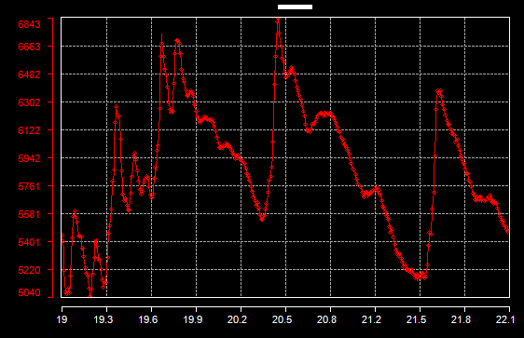

*Created with the Personal Edition of HelpNDoc:* [*Free iPhone documentation generator*](http://www.helpndoc.com/feature-tour/iphone-website-generation)

Serie format

The 'Format' tab contains serie value format properties

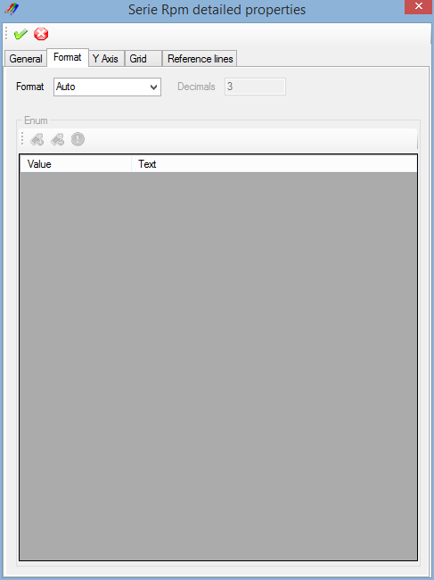

The serie's format describes how physical values of the serie are formated.

For example, if a the value of a serie is 21.47895526 in the data file, using the format property this value can be shown in the graphic as 21.5 or 21.48.

Five formats are available:

* + Auto: Value is shown as a decimal value and number of decimal digits is a function of the span of plotted samples.
  + Decimal: Value is shown as a decimal value and number of decimal digits is set by the user.
  + Hexadecimal: Value is shown as an hexadecimal value, decimal part of the value being skipped.
  + Binary: Value is shown as a binary value, decimal part of the value being skipped.
  + Enum: A text is set for every possible value and this text is shown in the legend.

### Enum format

To configure an enumeration for a serie, first select 'Enum' in the 'Format' list. Once 'Enum' selected, the enumeration configuration grid becomes active.

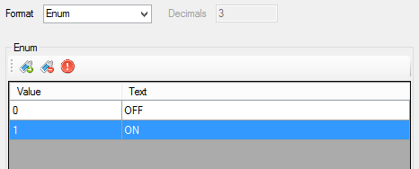

The 'Enum' panel is composed by a tool bar, containing enumeration control commands, and a grid containing every possible values of the serie and their corresponding text.

 Add enum: Add a value into the enumeration. Set a value into the 'Value' cell and the corresponding text into the 'Text' cell.

 Delete enum: Delete a value from the enumeration.

 Clear enums: Remove all values of the enumeration.

Example of graphic using enum format.

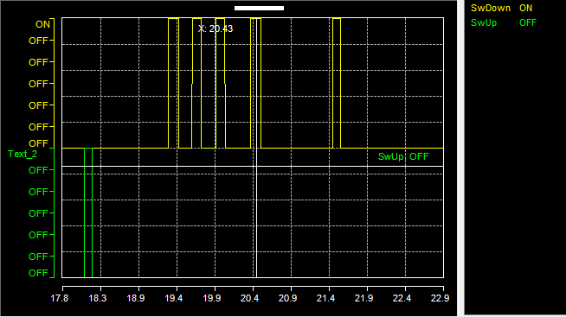

*Created with the Personal Edition of HelpNDoc:* [*Easily create Web Help sites*](http://www.helpndoc.com/feature-tour)

Serie Y Axis

The 'Y Axis' tab contains serie Y axis properties.

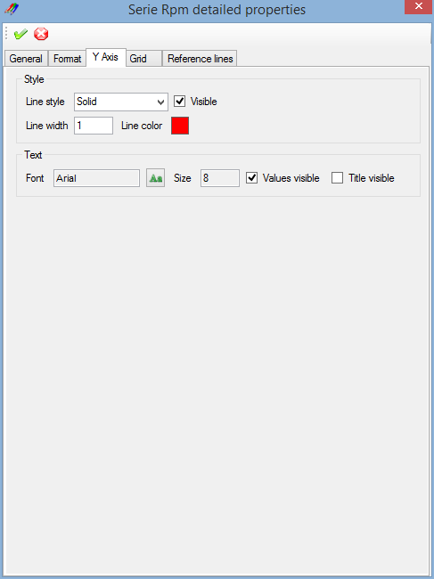

### Style

* + Line style: Select the Y axis line style. Check 'Line styles' section for details.
  + Visible: Y axis visibility flag. Check that box to make the Y axis visible.
  + Line width: Set the width of the Y axis line.
  + Line color: Double click the colored square to open the color selection dialog and select the Y axis line color.

### Text

* + Font: Click the 'Font'  button to open the font selection dialog, select a font and set its size and attributes and click 'OK'.
  + Value visible: Y axis values visibility flag. Check that box to make the Y axis values visible.
  + Title visible: Y axis title visibility flag. Check that box to make the Y axis title visible.

Example of a graphic with a customized Y axis.

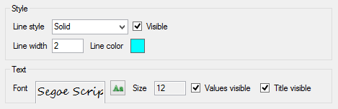

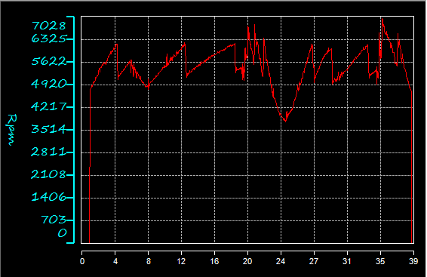

*Created with the Personal Edition of HelpNDoc:* [*Produce Kindle eBooks easily*](http://www.helpndoc.com/feature-tour/create-ebooks-for-amazon-kindle)

Serie custom grid

In addition of standard graphic grids, a graphic serie may have its own custom grid. Custom grid can be used as a complement of serie reference lines.

The 'Grid' tab of the 'Graphic serie detailed properties' window permits to set up this custom grid.

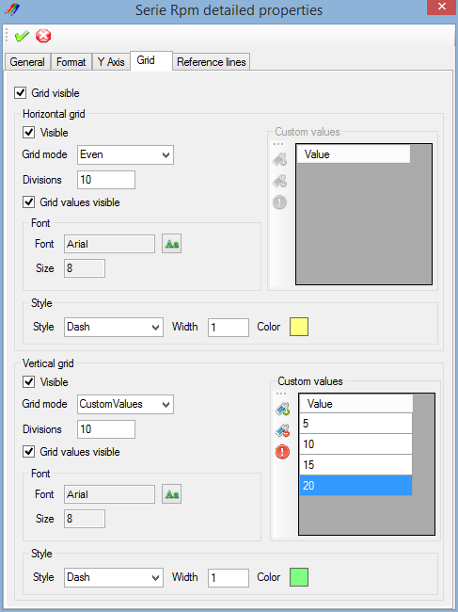

The 'Grid' tab is split in two sections: 'Horizontal grid' and 'Vertical grid'. Both sections containing properties for horizontal grid lines and vertical grid lines.

### Visible

The 'Grid visible' check box at the top of the tab  is the master grid visibility switch.

The serie's custom grid will be drawn only if this box is checked. This allows the user to decide whether or not the custom grid should be drawn by a simple command whatever the grid lines settings are.

### Grid lines properties

Both 'Horizontal grid' and 'Vertical grid' panels contain the same properties for grid lines.

* + Visible: Grid lines visibility flag. Check that box to make horizontal or vertical grid lines visible
  + Grid values visible: Grid lines values visibility flag. Check that box to make horizontal or vertical grid lines values visible

#### Grid mode

A serie custom grid may be drawn in different fashions:

* + None: No grid lines (equivalent to uncheck the 'Grid visible' box).
  + Even: Grid lines will be evenly set along graphic area of the serie.
  + MinMaxAvg: Three grid lines will be drawn at minimum, maximum and average values of the serie.
  + MinMaxZero: Three grid lines will be drawn at minimum, maximum and zero values of the serie.
  + CustomValues: Grid lines will be set at values defined by the user.

For the 'Even' mode, number of grid divisions is defined by the 'Divisions' field. It is the actual number of divisions made by the grid, number of grid lines being the number of division +1.

#### Custom values

The 'Custom values' panel is used when grid mode is set to 'CustomValues'. This panel is composed by a grid containing the user values list and a tool bar regrouping list control commands.

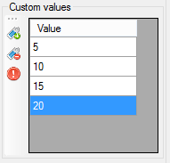

 Add value: Add a value into the list. Set a value into the 'Value' cell.

 Delete value: Delete a value of the list

 Clear values: Remove all values of the list

#### Font

The 'Font' panel defines font properties for grid lines values if the box 'Grid values visible' has been checked.

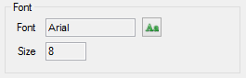

Click the 'Font'  button to open the font selection dialog, select a font and set its size and attributes and click 'OK'.

#### Style

The 'Style' panel defines graphical properties of grid lines.



* + Style: Select grid lines style. Check 'Line styles' section for details.
  + Width: Set the width of grid lines.
  + Color: Double click the colored square to open the color selection dialog and select grid lines color.

Example of a graphic using a serie custom grid:

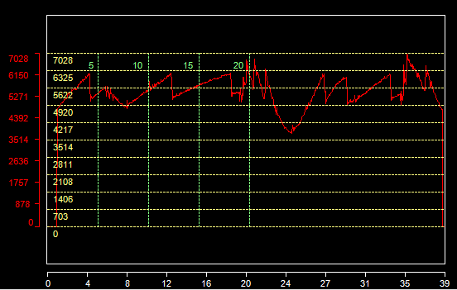

*Created with the Personal Edition of HelpNDoc:* [*Easily create HTML Help documents*](http://www.helpndoc.com/feature-tour)

Serie reference lines

A reference line is a line drawn at a particular value of a graphic serie. A single serie can have multiple reference lines and reference lines can be used as a complement of the serie custom grid.

Reference lines are usually horizontal except in the case of abscisse reference line where they are vertical.

The 'Reference lines' tab of the 'Graphic serie detailed properties' window permits to set up those reference lines.

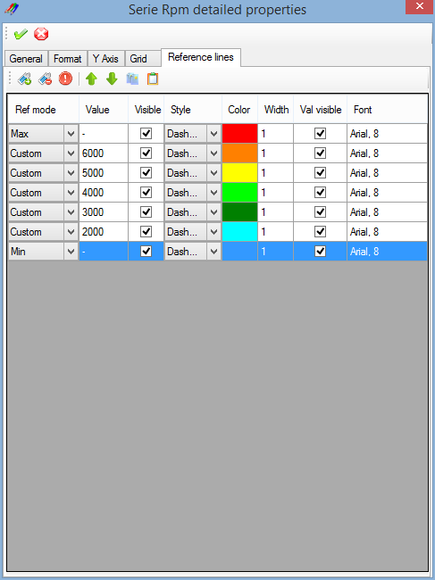

The 'Reference lines' tab is composed by a tool bar, containing reference lines control commands, and by grid showing properties of reference lines created by the user.

### Tool bar

Add: Create a new reference line.

 Delete: Delete reference lines selected.

 Clear: Delete all reference lines.

 Move up: Move a reference line up in the list.

 Move down: Move a reference line down in the list.

 Copy: Copy a reference line.

 Past: Past a reference line in the list.

### Reference lines grid

The reference lines grid has different columns for the different properties of a reference line.



* + Ref mode: Reference mode of the reference line.
  + Value: Value of the reference line in 'Custom' mode.
  + Visible: Reference line visibility flag. Check that box to make the reference line visible.
  + Style: Select reference line style. Check 'Line styles' section for details.
  + Color: Double click the colored cell to open the color selection dialog and select reference line color.
  + Width: Set the width of the reference line.
  + Val visible: Reference line value visibility flag. Check that box to make the reference line value visible.
  + Font: Double click the 'Font' cell to open the font selection dialog, select a font and set its size and attributes and click 'OK'.

#### Reference mode

Value of a reference line may be defined by different methods.

* + None: No reference line (equivalent to uncheck the 'Visible' box).
  + Zero: Reference line is drawn at the zero value of the graphic serie.
  + Min: Reference line is drawn at the minimum value of the graphic serie.
  + Max: Reference line is drawn at the maximum value of the graphic serie.
  + Average: Reference line is drawn at the zero average of the graphic serie.
  + Custom: Reference line is drawn at the value defined by the user in the 'Value' cell.

Example of a graphic using reference lines:

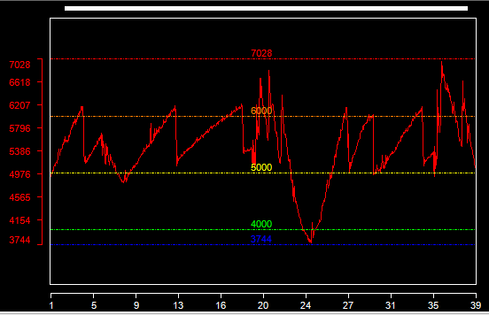

*Created with the Personal Edition of HelpNDoc:* [*Free EPub producer*](http://www.helpndoc.com/create-epub-ebooks)

Line styles

Five line styles are available

 Solid

 Dash dot

 Dash dot dot

 Dash

 Dot

*Created with the Personal Edition of HelpNDoc:* [*Create iPhone web-based documentation*](http://www.helpndoc.com/feature-tour/iphone-website-generation)

**Virtual Channels**

Unlike a real CAN signal, a virtual channel is not contained within any CAN message, it is virtual! Value of such channel is therefore not static but dynamically calculated using a mathematical expression

and values of one, two or more real CAN signals.

For example, let's consider CAN signals 'Signal_1', 'Signal_2' and a virtual channel 'Virtual' using 'Signal_1 + Signal_2' as expression.

On reception of signals 'Signal_1' and 'Signal_2', CANStream will evaluate expression of our virtual channel, then parameter 'Virtual' will take the sum of 'Signal_1' and 'Signal_2' as value.

Virtual channel expressions being evaluated each time a new value is received for 'Signal_1' or 'Signal_2', value of our virtual channel 'Virtual' is, at any time, equal to the sum of 'Signal_1' and 'Signal_2'.

Virtual channels calculation can be made using any CANStream object: CAN signal, built-in signal, logging data channel or another virtual channel as well.

Virtual channels can also become real since they can be sent in CAN message as a 'Virtual CAN parameter'.

*Created with the Personal Edition of HelpNDoc:* [*Free CHM Help documentation generator*](http://www.helpndoc.com)

**Virtual channel edition**

Virtual channels are stored in library. Several virtual channels libraries can be loaded at the same time. If a virtual channels library is loaded once, CAN stream will reload it at each start up so you don't have to reload all your libraries all the time.

Simply remove a library from the active libraries list to not load it at start up.

Click the 'Tools\Virtual channels'  command of the menu strip to open the virtual channel editor.

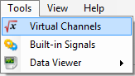

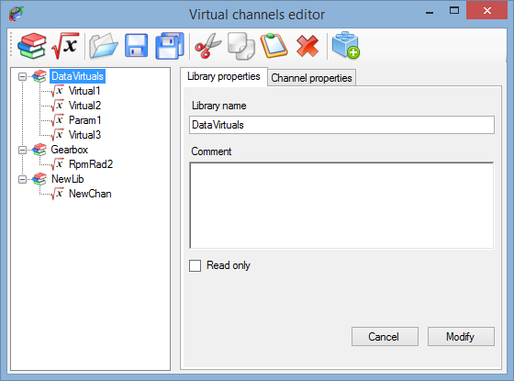

The virtual channels editor is composed by:

* + A tool bar, on the top, containing libraries and virtual channels control commands
  + A tree view, on the left, showing all active libraries and virtual channels part of those libraries
  + A multi-tab window, on the right, showing properties of either a library or a virtual channel

### Tool bar

 New library: Create a new virtual channels library.

 New virtual channel: Create a new virtual channel.

 Open library: Load an exiting virtual channels library.

 Save library: Save the active virtual channels library.

 Save all libraries: Save all active virtual channels libraries.

 Cut: Cut the selected item (library or channel).

 Copy: Copy the selected item (library or channel).

 Past: Past a cut/copied item (library or channel).

 Delete: Delete selected item (library or channel).

 Load object file: Load a virtual channel objects file.

### Tree view

The tree view shows all active libraries, each library is represented by a node  in the tree. Virtual channels of a library are child nodes  (or branches) of a library node.

Simply click on a library or a virtual channel to edit its properties.

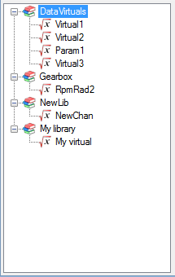

*Created with the Personal Edition of HelpNDoc:* [*Write eBooks for the Kindle*](http://www.helpndoc.com/feature-tour/create-ebooks-for-amazon-kindle)

**Virtual channel library properties**

Click on the 'New library'  button of the tool bar to create a new virtual channels library or click on a library node  of the tree view to edit its properties.

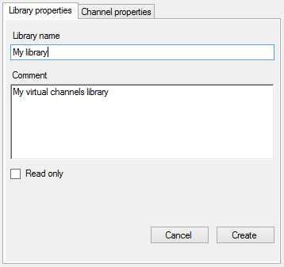

A library has actually very few properties:

* + Library name: Name of the library.
  + Comment: Description of the library.
  + Read only: Check this box if you want protect your library against unwanted change.

Once all properties set, just click the 'Create' button to add the library into the active libraries list.

In case of library edition, 'Create' button will become 'Modify', just click the 'Modify' button to apply changes.

Button 'Cancel' cancel the library creation or edition.

*Created with the Personal Edition of HelpNDoc:* [*Free iPhone documentation generator*](http://www.helpndoc.com/feature-tour/iphone-website-generation)

**Virtual channel properties**

Click on the 'New virtual channel'  button of the tool bar to create a new virtual channels or click on a virtual channel node  of the tree view to edit its properties.

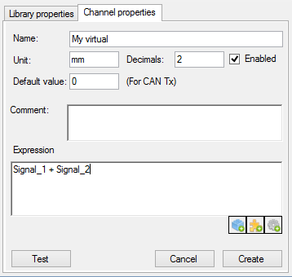

A virtual channel has the following properties:

* + Name: Name of the virtual channel.
  + Unit: Unit of the virtual channel value.
  + Decimal: Number of decimal.
  + Default value: Virtual channel default value (used only if the virtual channel is used as source of a virtual CAN parameter).
  + Comment: Description of the virtual channel.
  + Expression: Mathematical expression of the virtual channel.

 ***The string characters of an expression element should not contain any space character !***

Space character being an expression element separator, an element containing a space character will be considered as two different elements, leading to a likely wrong result or an expression evaluation error.

There are three buttons at the bottom of the mathematical expression text box .

Those buttons permit to ease and accelerate edition of the virtual channel expression. Click on one of those buttons to open a list containing different items that can be used in the virtual channel expression. Double click an item of list to insert it into the expression.

It is possible to insert three kinds of item

 Virtual channel objects: List of variable (CAN signal, built-in signal, logging channel or another virtual channel).

 Virtual channel functions: List of built-in virtual channel function (abs, cos, sin, ...).

 Virtual channel operators: List of operators (+, -. *, /).

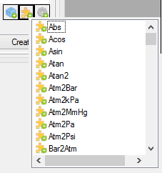

Regarding virtual channel objects, click the 'Load an object file'  button of the tool bar to load an object file and retrieve all names that can be used in a virtual channel expression.

: ***For virtual channels functions using multiple arguments, such as*** IFGT, ***the argument separator character is ' ; '.***

Thus, expression "IFGT(4 **;** 2)" will be correctly evaluated while the expression "IFGT(4 **,** 2)" will lead to a raise of an expression evaluation error.

While writing the virtual channel expression, it is possible to test it by simulating a computation. To do so, click on 'Test'  button.

Check the 'Virtual channel testing' section for more details.

*Created with the Personal Edition of HelpNDoc:* [*Free CHM Help documentation generator*](http://www.helpndoc.com)

**Virtual channel testing**

While writing the virtual channel expression, it is possible to test it by simulating a computation. To do so,  button of the virtual channel properties panel.

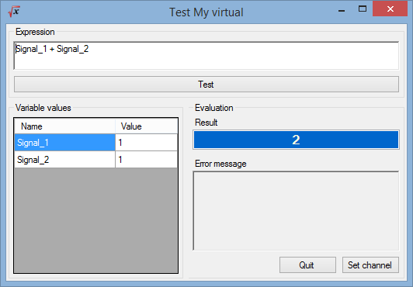

On the form opening, the virtual channel expression is evaluated using default values for expression variables.

The evaluation result is shown the 'Result' text box of the 'Evaluation' panel. The 'Variable values' grid, on the left, contains all variables of the virtual channel to test.

Change values in the grid to make a new calculation and verify the expression with different values.

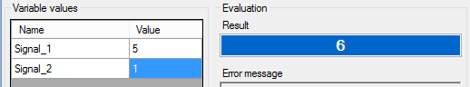

The mathematical expression itself can be modified. Simply change the expression written in the 'Expression' text box and click the 'Test' button to evaluate the modified expression.

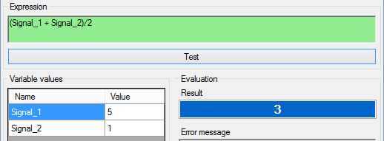

If the modified expression is mathematically correct, 'Expression' text box goes green. If an error occurs

during the evaluation, text box goes red.

In order to easily identify the error, the 'Error message' text box indicated what is the error and where it is.

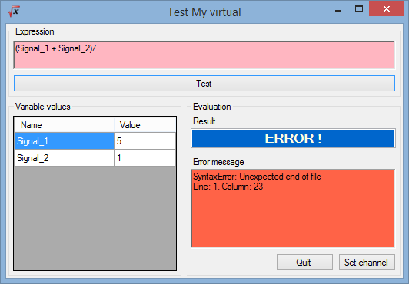

Once the expression is working, click on the 'Set channel' button to set the test expression in the 'Expression' text box of the virtual channel properties panel.

*Created with the Personal Edition of HelpNDoc:* [*Easily create Help documents*](http://www.helpndoc.com/feature-tour)

**Virtual channel built-in functions**

Here is the list of CANStream built-in function for virtual channel.

|  |  |
| --- | --- |
| ***Function*** | ***Description*** |
| Abs (A) | Returns the absolute value of a A number. |
| Acos (A) | Returns the angle whose cosine is the A number. |
| Asin (A) | Returns the angle whose sine is the A number. |
| Atan (A) | Returns the angle whose tangent is the A number. |
| Atan2 (A; B) | Returns the angle whose tangent is the quotient of specified A and B numbers. |
| Atm2Bar (A) | Return pressure A converted from atmosphere to bar |
| Atm2kMmHg (A) | Return pressure A converted from atmosphere to mercure millimeter |
| Atm2kPa (A) | Return pressure A converted from atmosphere to kilo Pascal |
| Atm2Pa (A) | Return pressure A converted from atmosphere to Pascal |
| Atm2Psi (A) | Return pressure A converted from atmosphere to psi |
| Bar2Atm (A) | Return pressure A converted from bar to atmosphere |
| Bar2kPa (A) | Return pressure A converted from bar to kilo Pascal |
| Bar2MmHg (A) | Return pressure A converted from bar to mercure millimeter |
| Bar2Pa (A) | Return pressure A converted from bar to Pascal |
| Bar2Psi (A) | Return pressure A converted from bar to psi |
| BigMul (A; B) | Produces the full product of two 32-bit A and B numbers. |
| Cal2Joule (A) | Return energy A convered from calorie to Joule |
| Cal2kCal (A) | Return energy A convered from calorie to kilo calorie |
| Cal2kJ (A) | Return energy A convered from calorie to kilo Joule |
| Ceiling (A) | Returns the smallest integral value that is greater than or equal to the specified A number. |
| Celcius2Fahrenheit (A) | Return temperature A converted from Celcius degree to Fahrenheit degree |
| Celcius2Kelvin (A) | Return temperature A converted from Celcius degree to Kelvin degree |
| Cos (A) | Returns the cosine of the specified angle. |
| Cosh (A) | Returns the hyperbolic cosine of the specified angle. |
| Deg2Grad (A) | Return value of angle 'A" converted from degree to gradian |
| Deg2Rad (A) | Return value of angle 'A" converted from degree to radian |
| DivRem (A; B; out C) | Calculates the quotient of A and B numbers and also returns the remainder in an output parameter C. |
| Exp (A) | Returns e raised to the A power. |
| Fahrenheit2Celcius (A) | Return temperature A converted from Fahrenheit degree to Celcius degree |
| Fahrenheit2Kelvin (A) | Return temperature A converted from Fahrenheit degree to Kelvin degree |
| Feet2Km (A) | Return length A converted from feet to kilometer |
| Feet2Meter (A) | Return length A converted from feet to meter |
| Feet2Mile (A) | Return length A converted from feet to mile |
| Feet2Yard (A) | Return length A converted from feet to yard |
| Floor(A) | Returns the largest integer less than or equal to the specified A number. |
| Floor(A) | Returns the largest integer less than or equal to the specified A number. |
| Grad2Deg (A) | Return value of angle 'A" converted from gradian to degree |
| Grad2Rad (A) | Return value of angle 'A" converted from gradian to radian |
| Gram2Kg (A) | Return weigth A converted from gram to kilogram |
| Gram2Ounce (A) | Return weigth A converted from gram to ounce |
| Gram2Pound (A) | Return weigth A converted from gram to pound |
| Gram2Tonne (A) | Return weigth A converted from gram to tonne |
| IEEERemainder (A; B) | Returns the remainder resulting from the division of a the A number by the B number. |
| IFEQ (A; B) | Return 1 if value of argument 'A' is equal to value of argument 'B' |
| IFGE (A; B) | Return 1 if value of argument 'A' is greater or equal to value of argument 'B' |
| IFGT (A; B) | Return 1 if value of argument 'A' is greater than value of argument 'B' |
| IFLE (A; B) | Return 1 if value of argument 'A' is smaller or equal to value of argument 'B' |
| IFLT (A; B) | Return 1 if value of argument 'A' is smaller than value of argument 'B' |
| IFNE (A; B) | Return 1 if value of argument 'A' is not equal to value of argument 'B' |
| INRG (A; Min; Max) | Return 1 if value of argument 'A' is contained within the 'Min/Max' range |
| Joule2Cal (A) | Return energy A convered from Joule to calorie |
| Joule2kCal (A) | Return energy A convered from Joule to kilo calorie |
| Joule2kJ (A) | Return energy A convered from Joule to kilo Joule |
| KCal2Cal (A) | Return energy A convered from kilo calorie to calorie |
| KCal2Joule (A) | Return energy A convered from kilo calorie to Joule |
| KCal2kJ (A) | Return energy A convered from kilo calorie to kilo Joule |
| Kelvin2Celcius (A) | Return temperature A converted from Kelvin degree to Celcius degree |
| Kelvin2Fahrenheit (A) | Return temperature A converted from Kelvin degree to Fahrenheit degree |
| Kg2Gram (A) | Return weigth A converted from kilogram to gram |
| Kg2Ounce (A) | Return weigth A converted from kilogram to ounce |
| Kg2Pound (A) | Return weigth A converted from kilogram to pound |
| Kg2Tonne (A) | Return weigth A converted from kilogram to tonne |
| Kj2Cal (A) | Return energy A convered from kilo Joule to calorie |
| Kj2Joule (A) | Return energy A convered from kilo Joule to Joule |
| Kj2kCal (A) | Return energy A convered from kilo Joule to kilo calorie |
| Km2Feet (A) | Return length A converted from kilometer to feet |
| Km2Meter (A) | Return length A converted from kilometer to meter |
| Km2Mile (A) | Return length A converted from kilometer to mile |
| Km2Yard (A) | Return length A converted from kilometer to yard |
| kPa2Atm (A) | Return pressure A converted from kilo Pascal to atmosphere |
| kPa2Bar (A) | Return pressure A converted from kilo Pascal to bar |
| kPa2MmHg (A) | Return pressure A converted from kilo Pascal to mercure millimeter |
| kPa2Pa (A) | Return pressure A converted from kilo Pascal to pascal |
| kPa2Psi (A) | Return pressure A converted from kilo Pascal to psi |
| kph2mph (A) | Return speed A converted from kilometer per hour to mile per hour |
| kph2ms (A) | Return speed A converted from kilometer per hour to meter/second |
| Log (A) | Returns the natural (base e) logarithm of a A number. |
| Log (A; B) | Returns the logarithm of a A number in the specified B base. |
| Log10 (A) | Returns the base 10 logarithm of a A number. |
| Max (A; B) | Returns the larger of A and B numbers |
| Meter2Feet (A) | Return length A converted from meter to feet |
| Meter2Km (A) | Return length A converted from meter to kilometer |
| Meter2Mile (A) | Return length A converted from meter to mile |
| Meter2Yard (A) | Return length A converted from meter to yard |
| Mile2Feet (A) | Return length A converted from mile to feet |
| Mile2Km (A) | Return length A converted from mile to kilometer |
| Mile2Meter (A) | Return length A converted from mile to meter |
| Mile2Yard (A) | Return length A converted from mile to yard |
| Min (A; B) | Returns the smaller of A and B numbers |
| MmHg2Atm (A) | Return pressure A converted from mercure millimeter 2 kilo atmosphere |
| MmHg2Bar (A) | Return pressure A converted from mercure millimeter 2 bar |
| MmHg2kPa (A) | Return pressure A converted from mercure millimeter 2 kilo Pascal |
| MmHg2Pa (A) | Return pressure A converted from mercure millimeter 2 Pascal |
| MmHg2Psi (A) | Return pressure A converted from mercure millimeter 2 psi |
| mph2kph (A) | Return speed A converted from mile per hour to kilometer per hour |
| mph2ms (A) | Return speed A converted from mile per hour to meter/second |
| ms2kph (A) | Return speed A converted from meter/second to kilometer per hour |
| ms2mph (A) | Return speed A converted from meter/second to mile per hour |
| OOR (A; Min; Max) | Return 1 if value of argument 'A' is not contained within the 'Min/Max' range |
| Ounce2Gram (A) | Return weigth A converted from ounce gram |
| Ounce2Kg (A) | Return weigth A converted from ounce kilogram |
| Ounce2Pound (A) | Return weigth A converted from ounce pound |
| Ounce2Tonne (A) | Return weigth A converted from ounce tonne |
| Pa2Atm (A) | Return pressure A converted from Pascal to atmosphere |
| Pa2Bar (A) | Return pressure A converted from Pascal to bar |
| Pa2kPa (A) | Return pressure A converted from Pascal to kilo Pascal |
| Pa2MmHg (A) | Return pressure A converted from Pascal to mercure millimeter |
| Pa2Psi (A) | Return pressure A converted from Pascal to psi |
| Pound2Gram (A) | Return weigth A converted from pound to gram |
| Pound2Kg (A) | Return weigth A converted from pound to kilogram |
| Pound2Ounce (A) | Return weigth A converted from pound to ounce |
| Pound2Tonne (A) | Return weigth A converted from pound to tonne |
| Pow (A; B) | Returns the A number raised to the B power. |
| Psi2Atm (A) | Return pressure A converted from psi to atmosphere |
| Psi2Bar (A) | Return pressure A converted from psi to bar |
| Psi2kPa (A) | Return pressure A converted from psi to kilo Pascal |
| Psi2MmHg (A) | Return pressure A converted from psi to mercure millimeter |
| Psi2Pa (A) | Return pressure A converted from psi to Pascal |
| Rad2Deg (A) | Return value of angle 'A" converted from radian to degree |
| Rad2Grad (A) | Return value of angle 'A" converted from radian to gradian |
| Round (A) | Rounds the value A to the nearest integral value. |
| Sign (A) | Returns the value indicating the sign of a A number. |
| Sin (A) | Returns the sine of the A angle. |
| Sinh (A) | Returns the hyperbolic sine of the A angle. |
| Sqrt (A) | Returns the square root of a A number. |
| Tan (A) | Returns the tangent of the A angle. |
| Tanh (A) | Returns the hyperbolic tangent of the A angle. |
| Tonne2Gram (A) | Return weigth A converted from tonne to gram |
| Tonne2Kg (A) | Return weigth A converted from tonne to kilogram |
| Tonne2Ounce (A) | Return weigth A converted from tonne to ounce |
| Tonne2Pound (A) | Return weigth A converted from tonne to pound |
| Truncate(Decimal) | Calculates the integral part of a specified A number. |
| Yard2Feet (A) | Return length A converted from yard to feet |
| Yard2Km (A) | Return length A converted from yard to kilometer |
| Yard2Meter (A) | Return length A converted from yard to meter |
| Yard2Mile (A) | Return length A converted from yard to mile |

*Created with the Personal Edition of HelpNDoc:* [*Free iPhone documentation generator*](http://www.helpndoc.com/feature-tour/iphone-website-generation)

**Built-in signals**

Built-in signals are a tool used for cycle creation. Instead of making a cycle based on real data contained into a text file or an Excel file, CANStream can generate data of a periodic signal that will be used as a source of data in the cycle.

*Created with the Personal Edition of HelpNDoc:* [*Free EPub producer*](http://www.helpndoc.com/create-epub-ebooks)

**Built-in signals edition**

As per virtual channels, built-in signals are organized by libraries. A library can contain several signals and multiple libraries can loaded together at the same time.

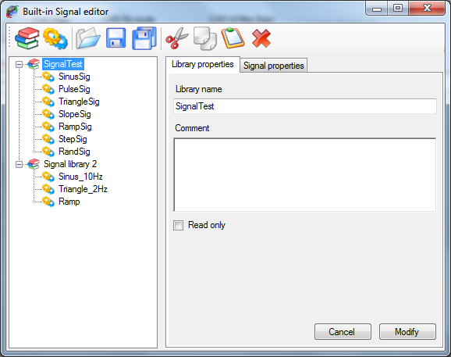

The built-in signal editor is composed of:

* + A tool bar, on the top, containing signals and libraries control commands.
  + A tree view, on the left, in which appears all signal libraries loaded.
  + A multi-tab panel, on the right, for signal and library properties edition.

In the tree view, each built-in signal library is represented by the  node. All built-in signals contained in a library are child node (or branch) of the library and are represented by the  node.

The tool bar contains the following commands:

 New signals library: Create a new built-in signals library.

 New signal: Create a new built-in signal into the current library.

 Open library: Load an existing built-in signals library.

 Save library: Save the current built-in signals library.

 Save all libraries: Save all loaded built-in signals libraries.

 Cut: Cut an item an place it onto the clipboard.

 Copy: Copy an item an place it onto the clipboard.

 Past: Paste an item from the clipboard.

 Delete: Delete the selected item.

*Created with the Personal Edition of HelpNDoc:* [*Produce electronic books easily*](http://www.helpndoc.com/create-epub-ebooks)

**Built-in signals library**

Click on a library item  of the tree view to edit its properties or click the ‘Create new signals library’  button to create a new signal.

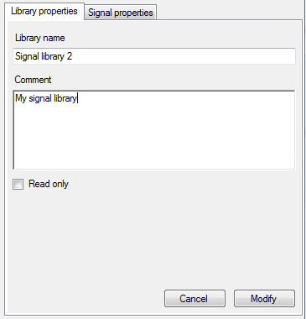

A built-in signals library has very few properties:

* + Library name: Name of library.
  + Comment: Description of the library.
  + Read only: Check that box if you want prevent unwanted changes in the library.

Make all changes you want and then click the ‘Modify’ button to apply your changes. In the case of the creation of a new library, ‘Modify’ button will become ‘Create’, just click it to create the library.

*Created with the Personal Edition of HelpNDoc:* [*Easily create HTML Help documents*](http://www.helpndoc.com/feature-tour)

**Built-in signals properties**

Click a signal node  to edit its properties or click the ‘Create new signal’  button to create a new signal.

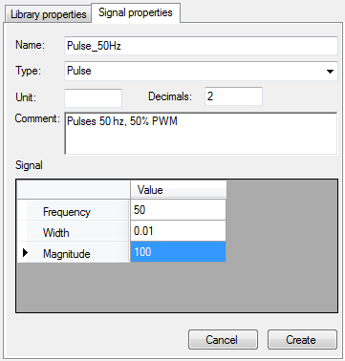

A built-in signal has several properties:

* + Name: Name of the signal.
  + Type: Kind of periodic signal to be generated. Check 'Built-in signals types' section for more details.
  + Unit: Unit of the signal.
  + Decimal: Number of signal decimal digits.
  + Comment: Signal description.
  + Signal math properties grid: Content of this grid depends of the type of signal selected. Check built-in signals type section for more details.

Set, at least, the signal name and type as well as its math properties and then click the ‘Create’ button to create the signal. In case of signal edition, this button will become ‘Modify’, just click it to apply all changes you may have done.

*Created with the Personal Edition of HelpNDoc:* [*Free EPub and documentation generator*](http://www.helpndoc.com)

**Built-in signals types**

There are seven signal types available; each of them has its own math properties.

*Created with the Personal Edition of HelpNDoc:* [*Full-featured EPub generator*](http://www.helpndoc.com/create-epub-ebooks)

**Sinus**

Generate a sinusoidal waveform.

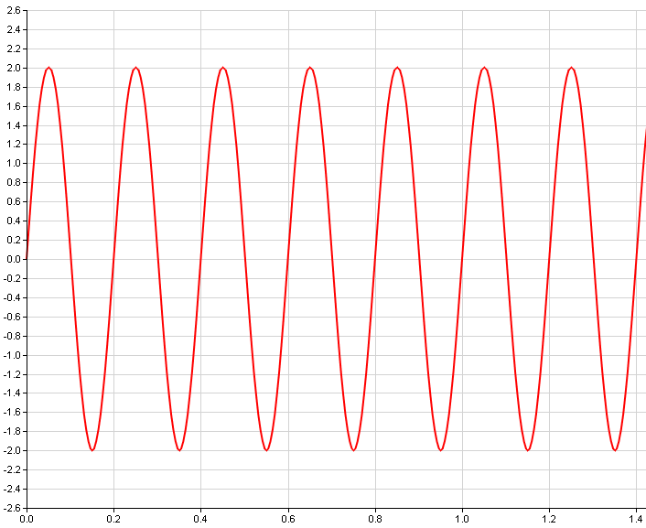

Uses the following math properties

* + Frequency: Sinusoid frequency in Hertz.
  + Magnitude: Peak to peak signal magnitude.
  + Offset: Signal offset with respect to zero.
  + Phase: Sinusoid phase offset.

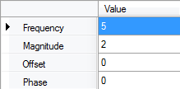

*Created with the Personal Edition of HelpNDoc:* [*Easily create Help documents*](http://www.helpndoc.com/feature-tour)

**Pulses**

Generate multiple pulses waveform.

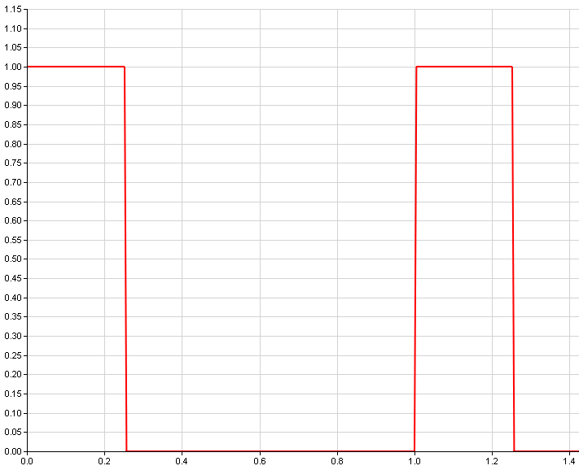

Uses the following math properties:

* + Frequency: Pulses frequency in Hertz.
  + Width: Pulse width with respect to the signal period in second.
  + Magnitude: Peak to peak signal magnitude.

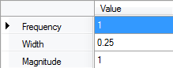

*Created with the Personal Edition of HelpNDoc:* [*Easily create HTML Help documents*](http://www.helpndoc.com/feature-tour)

**Triangle**

Generate a triangle waveform.

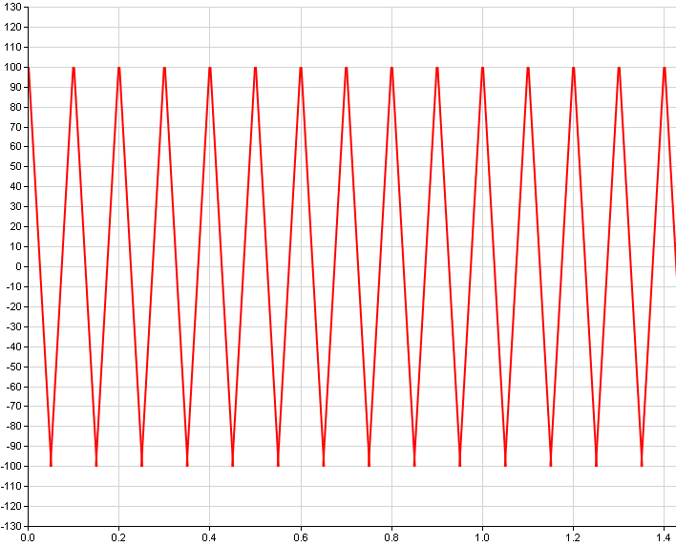

Uses the following math properties:

* + Frequency: Triangle frequency in Hertz.
  + Magnitude: Peak to peak signal magnitude.
  + Offset: Signal offset with respect to zero.
  + Phase: Triangle phase offset.

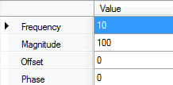

*Created with the Personal Edition of HelpNDoc:* [*iPhone web sites made easy*](http://www.helpndoc.com/feature-tour/iphone-website-generation)

**Slopes**

Generate multiple slopes waveform.

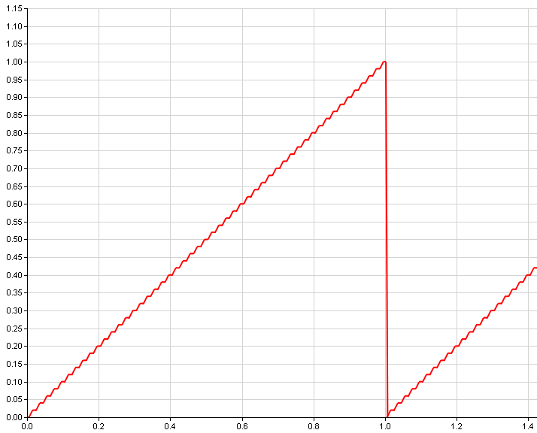

Uses the following math properties:

* + Frequency: Slopes frequency in Hertz.
  + Start value: Slope starting value.
  + End value: Slope ending value.

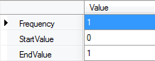

*Created with the Personal Edition of HelpNDoc:* [*Free Kindle producer*](http://www.helpndoc.com/feature-tour/create-ebooks-for-amazon-kindle)

**Ramp**

Generate a ramp waveform.

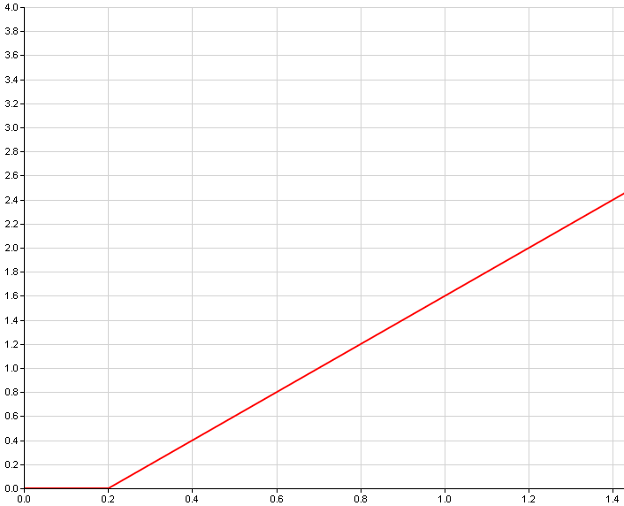

Uses the following math properties:

* + Slope: Ramp gradient.
  + Start value: Ramp starting value.
  + End value: Ramp starting time in second.

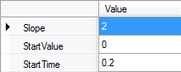

*Created with the Personal Edition of HelpNDoc:* [*Write EPub books for the iPad*](http://www.helpndoc.com/create-epub-ebooks)

**Step**

Generate a single step waveform.

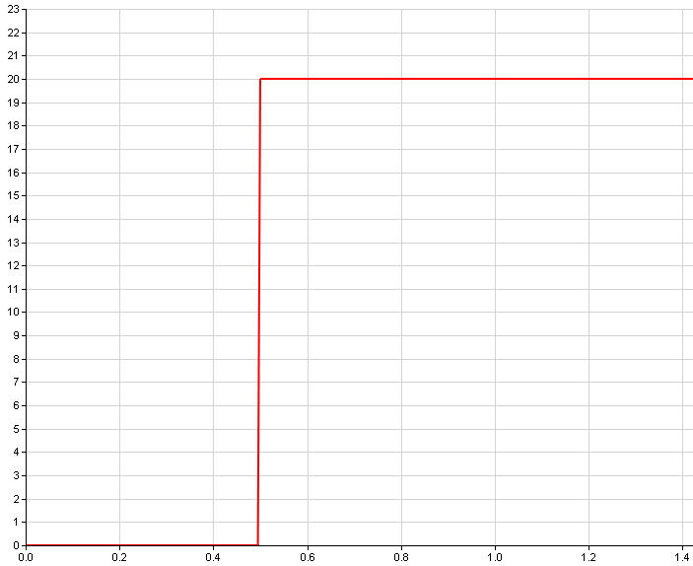

Uses the following math properties:

* + Start value: Step starting value.
  + End value: Step ending value.
  + Start time: Stepping time in second.

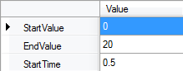

*Created with the Personal Edition of HelpNDoc:* [*Easy EBook and documentation generator*](http://www.helpndoc.com)

**Random**

Generate a random values waveform.

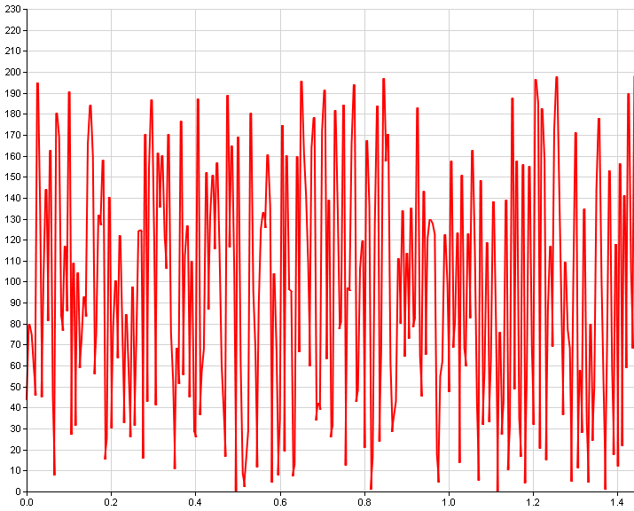

Uses the following math properties:

* + Min value: Signal minimum value.
  + Max value: Signal maximum value.

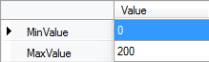

*Created with the Personal Edition of HelpNDoc:* [*Free HTML Help documentation generator*](http://www.helpndoc.com)